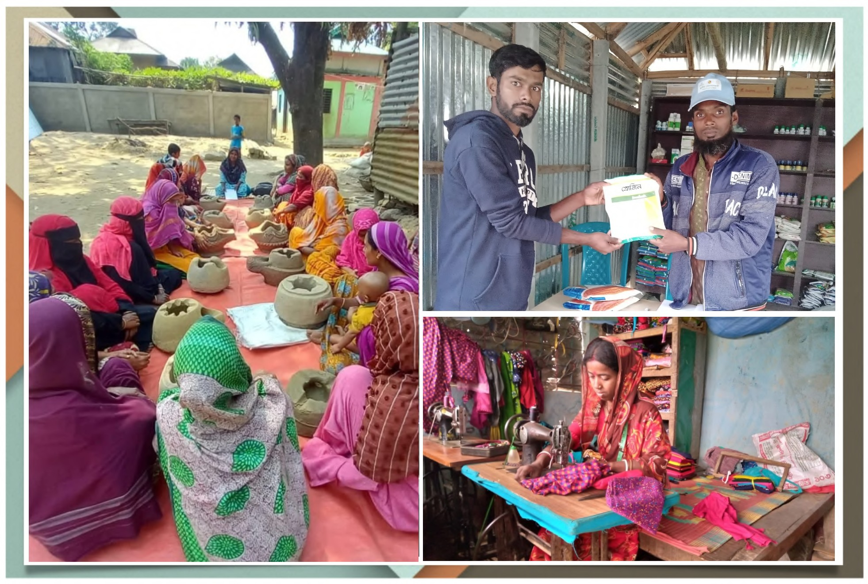;

Final Report

**Entrepreneurship Development Training & Coaching for Local Service Providers (SHOUHARDO III plus Activity)**



**Description of Services: Entrepreneurship Development Training for LSPs**

**Title of the Report: Final Training Report for Entrepreneurship Development Training**

Submitted to: Submitted by



## Table of Contents

We are thrilled to present the **ﬁnal report on the Entrepreneurship Develop** oﬀered by Kuza Biashara to **Care Bangladesh**. This report is a testament to the incredible journey of empowerment and transformation undertaken by the **Local Service Providers**, encapsulating their remarkable achievements, inspiring stories, and invaluable lessons learned throughout this groundbreaking initiative.

Acronyms 3

1.0 Background 5

2.0 Executive Summary 6

* 1. Core Program components 8
  2. Demographic proﬁle of LSPs 11
  3. Implementation Structure 12
  4. Notable Program achievements 14

3.0 Program Components 17

* 1. Leadership Academy for Entrepreneurship Training 17
  2. Kuza Agribytes for Good Agricultural Practices 24
  3. Kuza One Network for Digital record keeping 29
  4. Setting up Business Networks 31
  5. Strengthening Business Ecosystem 41
  6. Piloting Livestock Farmer Field & Business School 45

4.0 Program Learnings 49

* 1. Key Learnings & Takeaways 49
  2. Challenges 51

4.3 Program Recommendations 53

4.4. Program Sustainability 55

5.0 Conclusion 57

6.0 Acknowledgements 58

7.0 Annexure I: Stories of Impact 59

8.0 Annexure II: BNL Meetings 72

9.0 Annexure III: Ecosystem Actor Meetup 83

## Acronyms

|  |  |
| --- | --- |
| AI | Artiﬁcial Insemination |
| BDT | Bangladesh Taka |
| BNL | Business Network Leader |
| BSP | Blue Star Provider |
| CARE | Cooperative for Assistance and Relief Everywhere |
| CoP | Chief of Party |
| DAM | Dhaka Ahsania Mission |
| DC | Dedicated Coach |
| DLO | District Livestock Oﬃcer |
| ESDO | Eco-Social Development Organisation |
| FF | Field Facilitator |
| FFBS | Farmer Field Business School |
| FFH | Fish Fry Hawker |
| FMD | Foot and Mouth Disease |
| GAP | Good Agricultural Practice |
| GSM | Group Mentorship Session |
| ICT | Information and Communication Technology |
| IPs | Implementing Partners |
| LSD | Lumpy Skin Disease |
| LSPs | Local Service Providers |
| MBA | Masters in Business Administration |
| MFIs | Micro Finance Institutions |
| MJSKS | Mahideb Jubo Somaj Kallayan Somity |
| NGO | Non-Governmental Organization |
| PCSBA | Private Community Skilled Birth Attendants |
| PEP | Poor and Extreme Poor |
| PHHS | Post Harvesting & Handeling Services |
| PLW | Pregnant and lactating women |
| PM | Project Manager |

|  |  |
| --- | --- |
| PNGO | Partner Non-Governmental Organization |
| PO | Project Oﬃcer |
| POPI | People’s Oriented Program Implementation |
| RDA | Rural Development Academy |
| SHOUHARDO /SHO | Strengthening Household Ability to Respond to Development Opportunities |
| SKS | Samaj Kallyan Sangstha |
| SMC | Social Marketing Company |
| TM-SR | Technical Managers- Support & Retention |
| UAAO | Upazila Assistant Agriculture Oﬃcer |
| ULOs | Upazila Livestock Oﬃcers |
| UP | Union Parishad |
| USAID | United States Agency for International Development |

Disclaimer: The information presented in this report is based on the data and details provided by the LSPs to the Kuza Dedicated Coaches and reﬂects the progress observed during the SHO III Plus Leadership Academy program. While every eﬀort has been made to ensure accuracy and reliability, any factual corrections or updates required should be promptly communicated to us by the Onground Care Bangladesh Field staﬀ. The report is intended for informational purposes only and should not be considered as oﬃcial or exhaustive without verifying the information with relevant stakeholders.

## 1.0 Background

Strengthening Household Ability to Respond to Development Opportunities SHOUHARDO III Plus is a two-year program (2022-2024) funded by the United States Agency for International Development (USAID), aimed at delivering improved gender-equitable food and nutrition security and resilience for 168,521 Poor and Extreme Poor (PEP) households in the Char and Haor regions of northern Bangladesh. Building on the success of the predecessor program, SHOUHARDO III Plus has worked with participants to pursue diversiﬁed sources of income, support inclusive and sustainable agricultural-led growth, enhance access to markets, especially for women and girls, and improve access to ﬁnancial services for PEP participants. The program also promotes increased consumption of nutritious foods and micro-nutrients for children under ﬁve years of age, pregnant and lactating women, and adolescent girls. The program engages and links the program-facilitated Local Service Providers (LSP) with the public and private sectors to achieve its aim. SHOUHARDO III Plus integrates gender, governance, Disaster Risk Reduction (DRR), environment, and private sector as cross-cutting components to maximise the program's impacts

Kuza Biashara is a Kenyan social technology enterprise working with smallholder farmers, health workers, sanitation workers, youth and women groups providing them opportunities to Learn, Connect & Grow. Kuza's digital platform oﬀers an innovative bundled solution that provides personalised micro-learning, micro-distribution & micro-mentorship services to these communities on-their-own-terms and at-their-own-convenience. Over the past decade, Kuza has directly impacted over 6 million youth, women and micro-entrepreneurs - from urban slums, rural areas and refugee camps - across 10 African countries and India providing incubation and business support services, mentoring and coaching and linking them to livelihood opportunities. Kuza's investment in creating a robust digital infrastructure, innovative capacity-building content, mentorship and coaching programs, and community engagement strategies has empowered users living in even the most challenging conditions. By supporting them in creating sustainable livelihood opportunities within their own communities, Kuza is fostering lasting change.

Both SHOUHARDO III Plus and Kuza Biashara are mission-aligned in their commitment to improving livelihoods, fostering sustainable development, and empowering marginalised communities through innovative and inclusive approaches. This alignment in mission has led them to collaborate on the LSP entrepreneurial development skills. Further, the collaboration on the LSP entrepreneurial development skills stems from their shared objectives. SHOUHARDO III Plus seeks to improve access to diversiﬁed income sources and ﬁnancial services, while Kuza provides innovative, personalised learning and mentorship platforms. Together, they have designed this program with an aim to strengthen the entrepreneurial skills of LSPs, enabling them to better serve their communities and enhance sustainable development outcomes. This partnership leverages SHOUHARDO III Plus’s on-the-ground experience and Kuza’s digital solutions to create a comprehensive support system for local service providers, ultimately fostering resilient and empowered communities.

## Executive Summary

The primary objective of the program has been to empower and strengthen the **450 LSPs** across **Char & Haor regions** and **08 districts**, through targeted coaching and mentorship, fostering sustainable entrepreneurship Development. This was accomplished by:

* + 1. Delivering targeted training on essential aspects of business development, entrepreneurship, and leadership, enabling the LSPs to enhance their skills and knowledge.
    2. Cultivating a supportive and collaborative network, facilitating peer-to-peer learning among the LSPs. This cooperative environment encouraged the sharing of best practices and innovative ideas.
    3. Equipping the LSPs with practical skills and tools necessary to optimise their enterprises.

**Target audience & districts**: 450 LSPs from 8 districts of 4 regions: Dhaka (72), Mymensingh (88), Rajshahi (58) Rangpur(148) & Sylhet (48) divisions.

|  |  |  |  |
| --- | --- | --- | --- |
| **District** | **Total LSPs** | **Cohort 1** | **Cohort 2** |
| Gaibandha | 76 | 38 | 38 |
| Habiganj | 48 | 24 | 24 |
| Jamalpur | 36 | 18 | 18 |
| Kishoreganj | 72 | 36 | 36 |
| Kurigram | 72 | 36 | 36 |
| Netrakona | 52 | 28 | 24 |
| Sirajganj | 58 | 32 | 26 |
| Sunamganj | 36 | 18 | 18 |
|  | **450** | **230** | **220** |

The Shouhardo III Plus Leadership Academy Cohort 1 was oﬃcially launched in October 2023 and Cohort 2 in December 2023, across 8 districts. Throughout the program, the LSPs have wholeheartedly embraced the opportunity for personal and professional development.

The key highlights of the program includes

1. **Leadership Academy:** 99.3% of LSPs completed the 15-week business development and entrepreneurship program, engaging in peer-to-peer learning and practical application.
2. **Digital Extension:** LSPs utilised the Kuza Agri Bytes app for Good Agricultural Practices (GAP) training across various crops and livestock, using tablets for personal learning and community education.
3. **Digital Record Keeping:** LSPs recorded proﬁles of 15,094 farmers and business transactions worth BDT 4.05 billion, enhancing their engagement and operational transparency.





1. **Business and Leadership Skills:** The program enhanced LSPs' business acumen,

leadership skills, and self-conﬁdence, empowering them as community leaders.

1. **Empowerment and Growth:** LSPs experienced personal and professional growth, overcoming gender barriers, and planning for business scalability through strategic partnerships.
2. **Community Engagement:** LSPs became advocates for sustainable practices, signiﬁcantly impacting their communities through training and outreach.

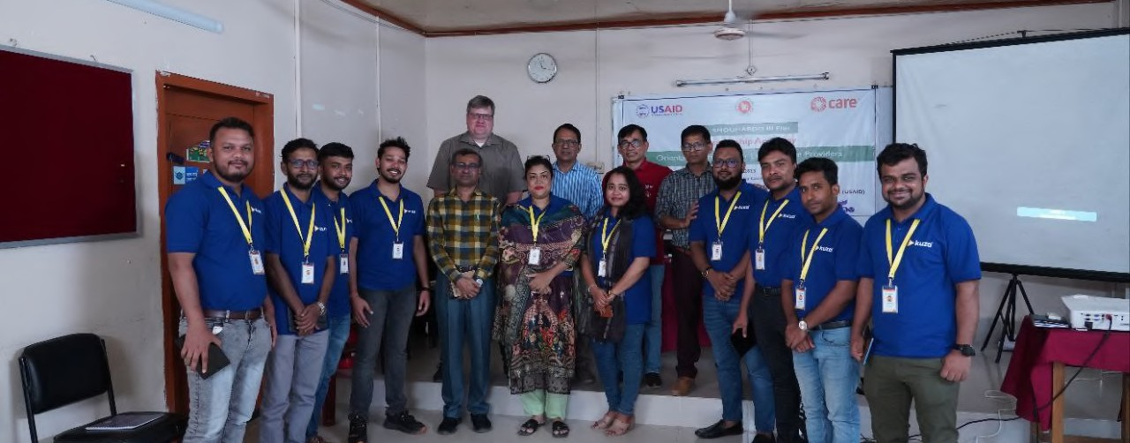

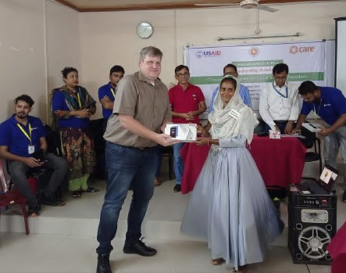 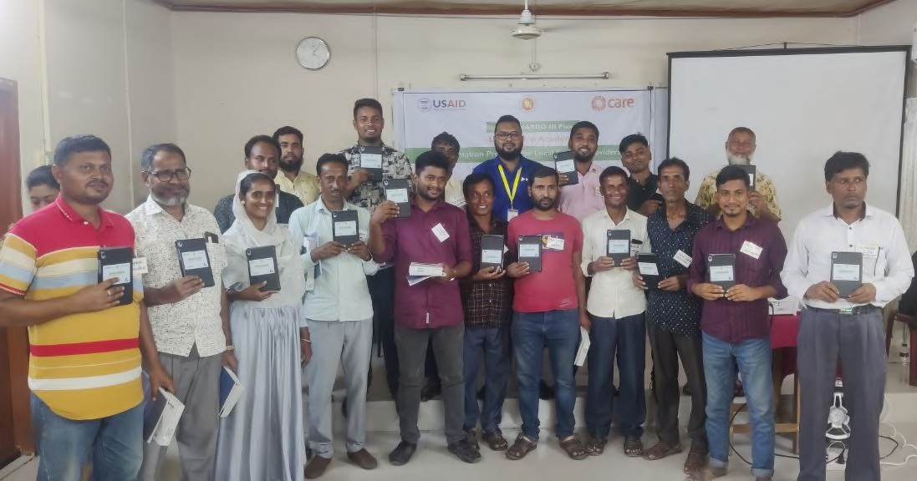

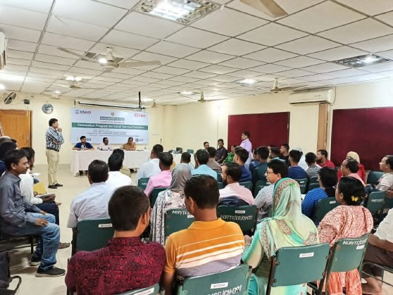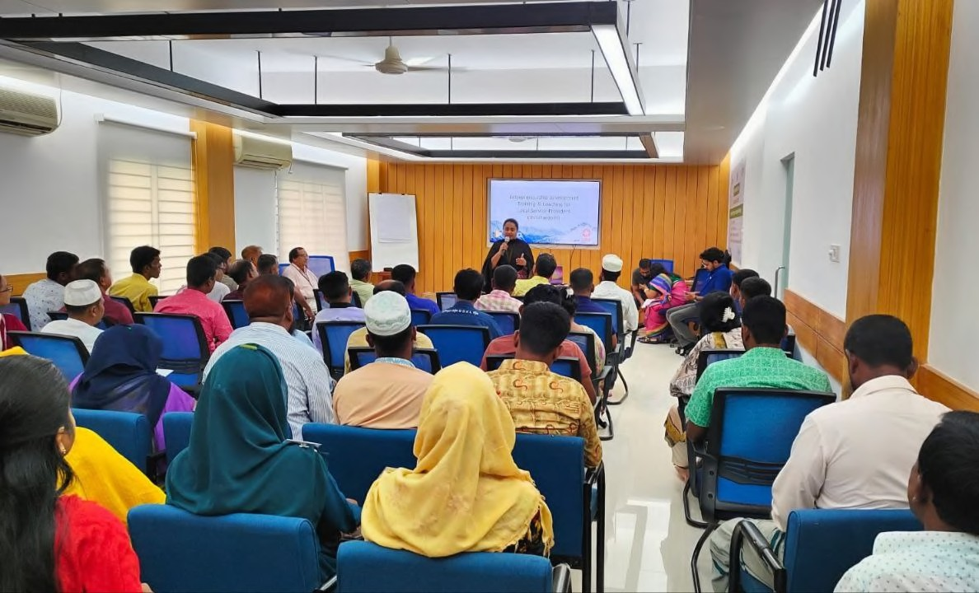

Orientation workshops held across 8 district locations where LSPs, Teams from the Implementing NGO Partners and CARE Teams were present





### Core Program components

* + 1. Entrepreneurship training and coaching for selected LSPs
    2. Digital platform to access Good Agricultural Practices on various value chains
    3. Digital record keeping tools that will help them in capturing the proﬁle of their farmers, service providers; record the demand for products and services from their customers (farmers); record their income and expenses; generate ﬁnancial statements to build their credit history
    4. Creation of Local networks of LSPs, farmers, suppliers and buyers by forming Business Networks at the union level and supporting them to move towards self-sustainability
    5. Bridging the gap between LSPs and private sector and government sector actors through organising Ecosystem Actor meetup across 8 districts
    6. Piloting Livestock Farmer Field & Business School digital content through Model LSPs/ BNLs as part of community engagement and development

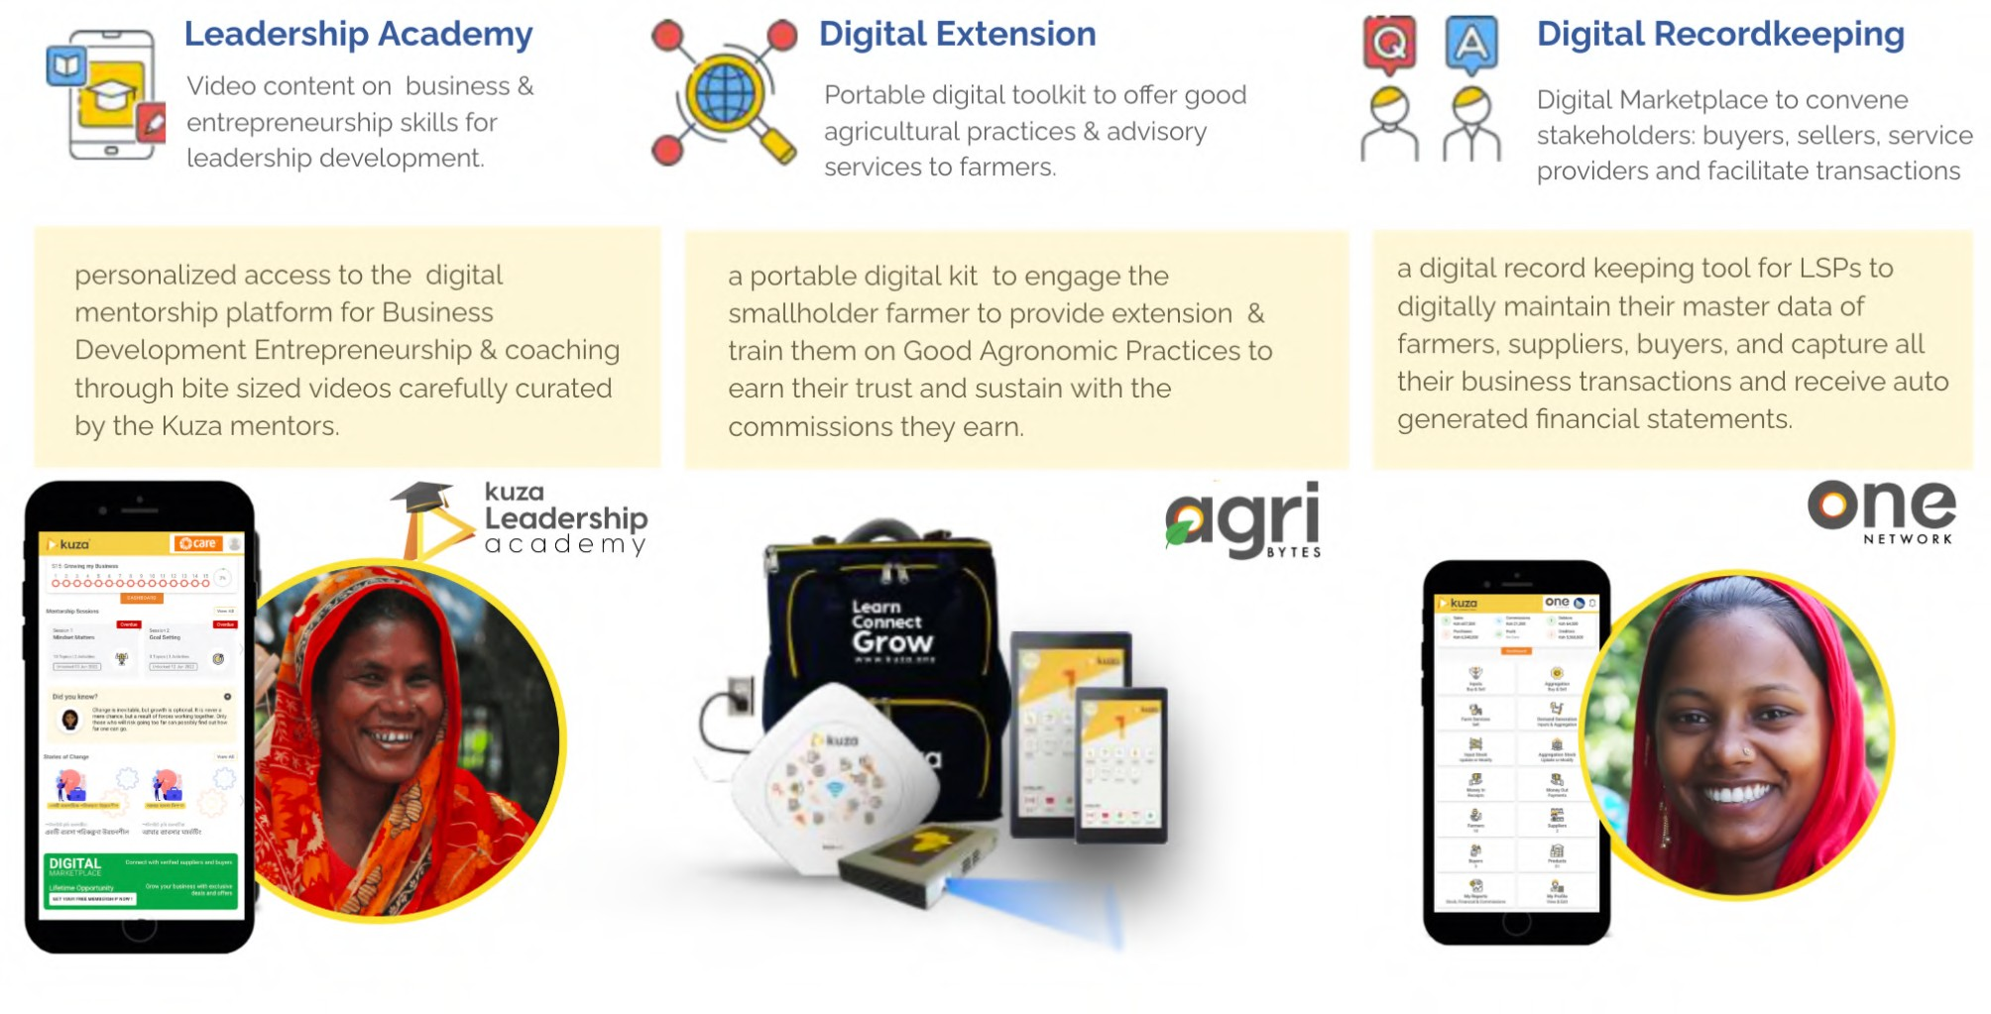

Towards this, the

1. LSPs underwent 15 weeks of Shouhardo Leadership Academy entrepreneurship training and were supported by the Kuza Dedicated Coaches. During this period, 7 Group Mentorship Sessions were conducted (4 for cohort 1 and 3 for cohort 2) across 8 districts.
2. Kuza Agribytes, a digital platform was set up for the LSPs to access Good Agricultural Practices on various value chains. LSPs were provided access to 44 resourceful videos across 6 value chains including Agriculture, Business of Agriculture, Pest & Diseases, Livestock, Fisheries and Financial Inclusion, which the LSPs took advantage of to improve their current understanding and also to engage their farmers/ communities.
3. Kuza One Network was set up for the LSPs to enrol farmers, service providers including buyers and sellers. The LSPs recorded a total of 115,094 farmers and recorded





transactions worth BDT 4.05 billion of which BDT 4.04 billion was purchases, 9.1 million

was sales, 26 million was money in and 93 million was money out.

1. 93 Business Networks across 8 districts were formed through a rigorous, participatory process of selection which included review of individual LSP proﬁling, feedback from Kuza Dedicated Coaches, Field Facilitators & Project Managers from the respective PNGO and TMSRs from CARE. The objective of these Business Networks is to facilitate the creation of local networks of LSPs, farmers, suppliers and buyers at the union level and support them to move towards self-sustainability
2. 8 Ecosystem partner meet ups were facilitated across 8 districts to bridge the gap between LSPs and private sector/ government sector actors. Partners attending these meet ups included ACI, Lal Teer, A R Malik Seeds, ACME, Brac Seed, SMC, DLO,DD-AI, DD-DAE, District Youth Development Oﬃcer, Assistant Director Social Service, AFAD, ACI-Health, BRAC, Metal Seed, Aftab Seed, Ispahani Agro limited, Renata Animal health, Bengal meat, Syngenta, Tensa, NDP, SUS, World Vision, SDRS, TMSS, NRBC Bank, Madhumati Bank, Bank Asia, Chamber of commerce who pledged their commitment to support the LSPs and committed to providing better training, improving product quality, facilitating loan accessibility, and enhancing coordination.
3. As part of the Scaling up of Livestock Farmer Field & Business School, 39 priority modules across Facilitation, Gender, Livestock, Marketing and Nutrition were digitized by Kuza and piloted in the Shouhardo III Plus program, through the Model LSPs/ BNLs to promote their community engagement and development. So far, the selected 10 BNLs have provided 50 trainings across various topics in Gender, Livestock, Nutrition and Marketing.

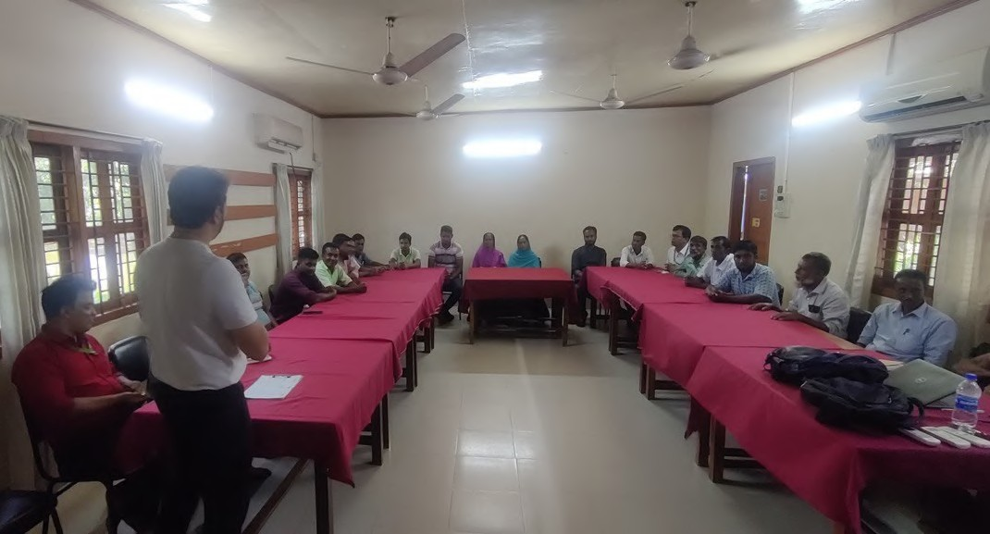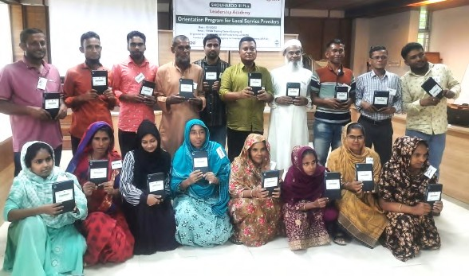

Field Visit for program designing to Jamalpur Model LSPs with their personalised tabs at Sunamganj

|  |  |
| --- | --- |
|  |  |
| Group activities by LSPs during GSM 1 in Sirajganj | Handholding support to LSPs struggling in using devices |
|  |  |
| Ecosystem partner meet up in progress | Field visits by DCs for LSP Proﬁling |

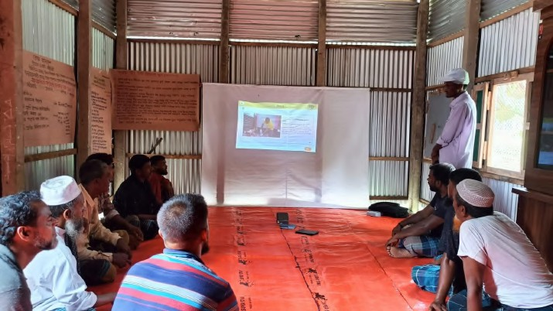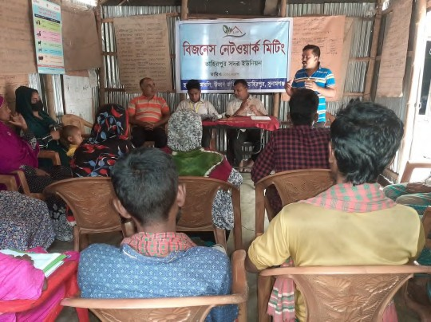

FFBS Training in progress BNL Meeting in progress

### Demographic proﬁle of LSPs

* 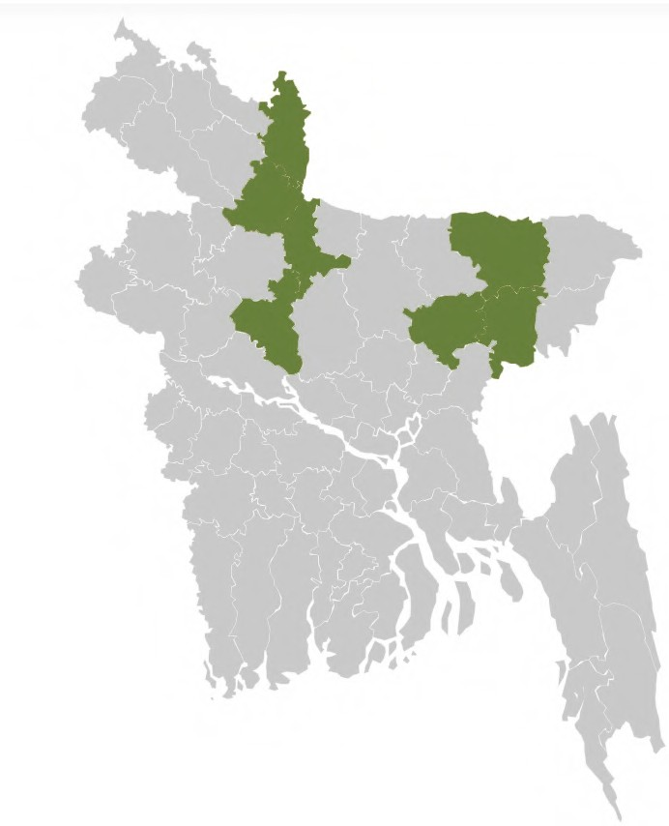450 LSPs participated in the SHO III+ Leadership Academy
* 72 from Dhaka, 88 from Mymensingh, 58 from Rajshahi, 148 from Rangpur & 84 from Sylhet Division
* 56% of the LSPs are Youth between the age group of 18-35 years
* 3 of the LSPs are above 60 years
* 18% of LSPs are women
* 43% LSPs are Vaccinator providing vaccination services to the livestock in the community
* 29% of the LSPs are Seed agents supplying seeds and other input products
* 28% LSPs comprise Collectors, Entrepreneurs, PCSBA, Sanchoy Sathi, FFH, BSP and ICT Champions.

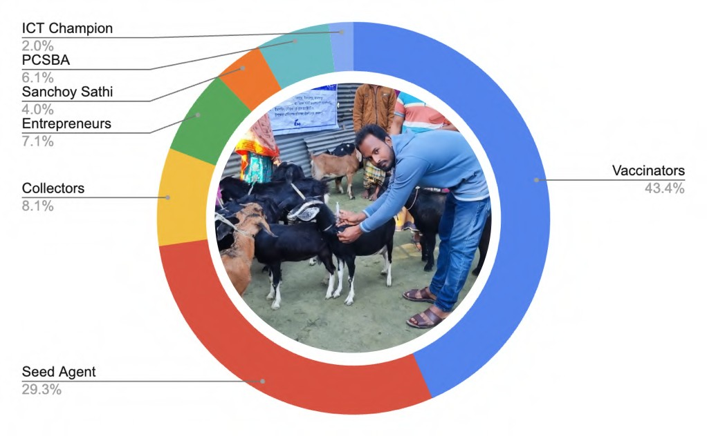

### Implementation Structure

The initiative was a collaborative eﬀort involving CARE Bangladesh, Kuza and the National Partner Non-Governmental Organizations (PNGOs), responsible for on-ground implementation and community mobilization of Shouhardo III Plus program, namely Dhaka Ahsania Mission (DAM), Eco-Social Development Organization (ESDO), Mahideb Jubo Somaj Kallayan Somity (MJSKS), People’s Oriented Program Implementation (POPI) and SKS Foundation. CARE contributed by developing overall strategies, coordinating activities, and setting up monitoring and evaluation frameworks. Kuza provided digital platforms focussed on providing entrepreneurship training, and market linkages to enhance LSPs' eﬃciency and productivity and the Coaching through the Dedicated Coaches, while the PNGOs facilitated engagement with LSPs, organized and managed resource distribution. Together, these organizations combined their strengths to create a comprehensive and sustainable support system for LSPs, promoting long-term resilience and growth in the agricultural sector of Bangladesh.

##### CARE:

* + - 1. **Overall Coordination and Strategy Development**
         1. Lead the overall coordination of the initiative, ensuring alignment with the project's goals and objectives.
         2. Develop and reﬁne strategies based on ﬁeld insights to address the challenges faced by LSPs.

##### Capacity Building:

* + - * 1. Design and implement training programs to enhance digital literacy, ﬁnancial literacy, and market intelligence among LSPs
        2. Provide guidance on ecosystem development to support LSPs' diversiﬁed income-generating activities

##### Monitoring and Evaluation:

* + - * 1. Establish monitoring and evaluation frameworks to track progress, measure impact, and make necessary adjustments

##### Kuza:

* + - 1. **Capacity Building and Technology support:**
         1. Provide Entrepreneurship and Leadership Development training program to the LSPs
         2. Provide digital tools and platforms to support LSPs in record-keeping
         3. Oﬀer training on the use of digital solutions to improve eﬃciency and productivity among LSPs

##### Provide Mentorship support:

* + - * 1. Kuza's Dedicated Coaches oﬀered emotional, functional, and technical support to the LSPs, helping them navigate challenges, optimize their business operations, and leverage technology eﬀectively

##### Market Linkages:

* + - * 1. Facilitate connections between LSPs and broader markets to enhance market accessibility and opportunities for higher income

##### PNGO:

* + - 1. **Field Implementation and Local Engagement** (Dhaka Ahsania Mission (DAM), Eco-Social Development Organization (ESDO), Mahideb Jubo Somaj Kallayan Somity (MJSKS), National Development Programme (NDP), People’s Oriented Program Implementation (POPI) and SKS Foundation )
         1. Execute on-ground activities, including organizing meetings and training sessions with LSPs.
         2. Facilitate direct engagement with LSPs to understand their needs and provide immediate support

##### Community Mobilization:

* + - * 1. Mobilize LSPs and stakeholders to participate in the program.
        2. Ensure LSPs' feedback and suggestions are communicated back to CARE and Kuza for continuous improvement.

##### Resource Distribution:

* + - * 1. Manage the distribution of necessary resources, such as digital devices and other allocated resources to LSPs.

##### Collaborative Eﬀorts:

* + - 1. **Joint Planning and Review Meetings:**
         1. Regularly conduct joint planning and review meetings involving CARE, PNGO, and Kuza to ensure cohesive implementation and address any emerging issues promptly

##### Feedback Loops:

* + - * 1. Establish robust feedback mechanisms to continuously gather insights from LSPs and other stakeholders, ensuring that interventions remain relevant and eﬀective

##### Sustainability Focus:

* + - * 1. All partners worked towards creating a sustainable model that empowers LSPs, ensuring ongoing community engagement, and fostering long-term development.

Through a well-coordinated and comprehensive approach, the initiative has successfully empowered LSPs to promote sustainable community development, and foster long-term resilience and growth.

### Notable Program achievements

* + 1. **Leadership Academy: 99.3%** of the LSPs successfully completed the 15 week business development entrepreneurship and coaching program. LSPs are engaged in peer to peer learning and learning by doing.
    2. **Digital Extension:** LSPs have undertaken Good Agricultural Practice (GAP) training via Kuza Agri Bytes app for Cucumber, mushroom, rice, mustard, potato, turmeric, drumstick, homestead vegetable gardening, goatery, poultry, ﬁsheries, etc. The self learning mobile app, empowered the LSPs to understand the GAP practices and assess themselves. Some of the LSPs are using their tablets to engage and educate their farmers on some of the GAP practices.
    3. **Digital Record Keeping:** As part of the farmer engagement, LSPs have been recording their farmer proﬁling. 15,243 farmers have been registered and business transactions worth BDT 9.04 million have been recorded - inputs, aggregation and farm services.
    4. **Increased knowledge and understanding of business development and entrepreneurship**: Through the program, the LSPs gained comprehensive knowledge and practical insights into business development, including ﬁnancial planning, marketing strategies, and market analysis, enabling them to make informed decisions and eﬀectively manage their businesses.
    5. **Enhanced leadership skills and self-conﬁdence:** The program nurtured leadership skills in fostering their self-conﬁdence and empowering them to take charge of their businesses. They developed eﬀective communication, problem-solving, and decision-making skills, positioning them as inﬂuential leaders within their communities and the agricultural sector. And these skills are evident in their progress observed through mentorship sessions.
    6. **Empowerment of the LSPs**: The program has played a vital role in empowering the LSPs, fostering their personal and professional growth. gain conﬁdence, resilience, and a sense of empowerment through mentorship, peer learning, and exposure. The program's focus on fostering a growth mindset has helped them overcome gender-related barriers and emerge as inﬂuential leaders in their communities as well as developed an entrepreneurial mindset.
    7. **Business expansion and scalability**: Many of the LSPs have successfully planned for expanding their businesses to achieve scalability. They utilised the skills and knowledge gained from the program to identify new market opportunities, diversify their product oﬀerings, and establish strategic partnerships. The program played a crucial role in helping the LSPs overcome challenges associated with business growth and provided them with the tools to navigate scaling their ventures eﬀectively.





* + 1. **Increased business performance and proﬁtability:** As a direct result of the program, the

LSPs experienced increased revenue and improved proﬁtability in their businesses. The adoption of eﬀective marketing strategies, eﬃcient operational practices, and enhanced ﬁnancial management techniques enabled the LSPs to optimise their business performance. The program's emphasis on market research and customer-centric approaches contributed to higher customer acquisition, retention, and overall business success.

* + 1. **Community engagement and social impact**: The LSPs actively engaged with their communities, sharing their knowledge, experiences, and success stories. They have become advocates for sustainable agricultural practices, inspiring farmers to improve productivity and yields. Through initiatives such as training, demonstrations and community outreach activities, they have positively impacted the lives of farmers, promoting inclusive economic growth and sustainability.

LSPs dedication to learning and self-improvement remained steadfast throughout and their commitment to their growth journey has been very inspiring. LSPs have consistently shown up, ready to learn, connect, and grow with their peers, making the most out of every learning opportunity. Not only have they embraced their own development, but they have also provided outstanding support and peer to peer mentorship to their fellow LSPs, highlighting the collaborative spirit within the program. LSPs commitment to learning, drive to excel, and camaraderie is shaping them as role models within the program and beyond. As they continue on their growth trajectory, there is no doubt that these LSPs will make a signiﬁcant impact in their businesses and communities, leaving a lasting legacy of success and inspiration. As we delve into the report, you will discover stories of perseverance, resilience, and innovation. LSPs seized every opportunity to enhance their business acumen, embracing new concepts and strategies with unwavering determination. Witnessing their growth, both as individuals and as a united force, has been an awe-inspiring experience for all involved.

However, the journey was not without its hurdles. The LSPs faced geographical barriers, limited resources, and personal commitments that tested their resolve. Yet, their unwavering spirit and unwavering belief in their dreams propelled them forward. Their stories of overcoming challenges will leave you inspired, reminding us all of the indomitable strength within each one of us. In the face of adversity, we have identiﬁed valuable recommendations to pave the way for future initiatives. By broadening their range of services, collaborating as clusters, and engaging in building stronger relations with their customers, the LSPs can signiﬁcantly enhance the scope and impact of their businesses. When the program brings together the strategic partnerships with the private sector partners and creates an enabling environment for them to collaborate, the LSPs can unlock new opportunities for growth and development. By embracing these initiatives, they can not only empower themselves but also contribute to the overall advancement and prosperity of their communities.

|  |  |
| --- | --- |
|  |  |
| Aklima from Sunamganj district training 18 farmers from Kaukandi village on homestead vegetable farming and goat rearing practices | With the help of LSP Subas Chandra from Gazaria fulchari, 20 households received various kinds of vegetable seed from upazila agriculture oﬃce. He also trained them on plantations. |
|  |  |
| Nobi Hossain from Sirajganj district training farmers on cows, goats, sheeps and chickens rearing | A free vaccination camp was organized by ESDO at Panchbaria, Islampur on the World Women's Day led by our Model LSP Raju Mia. In this camp, anthrax vaccines were provided to local livestock farmers |

## 3.0 Program Components

### Leadership Academy for Entrepreneurship Training

The Leadership Academy is an MBA inspired executive education program spread over 15 weeks allowing the entrepreneurs to learn at their own pace, practise what they learn (in their day to day business) and work with their Dedicated Coaches to reﬁne their goals & plans for running & growing their business.

The program design is modelled to support entrepreneurs to Learn, Connect, and Grow on their terms and at their own pace in a personalised learning environment with bite-sized mentorship videos and interactive exercises, with the support from the Kuza Dedicated Coaches.

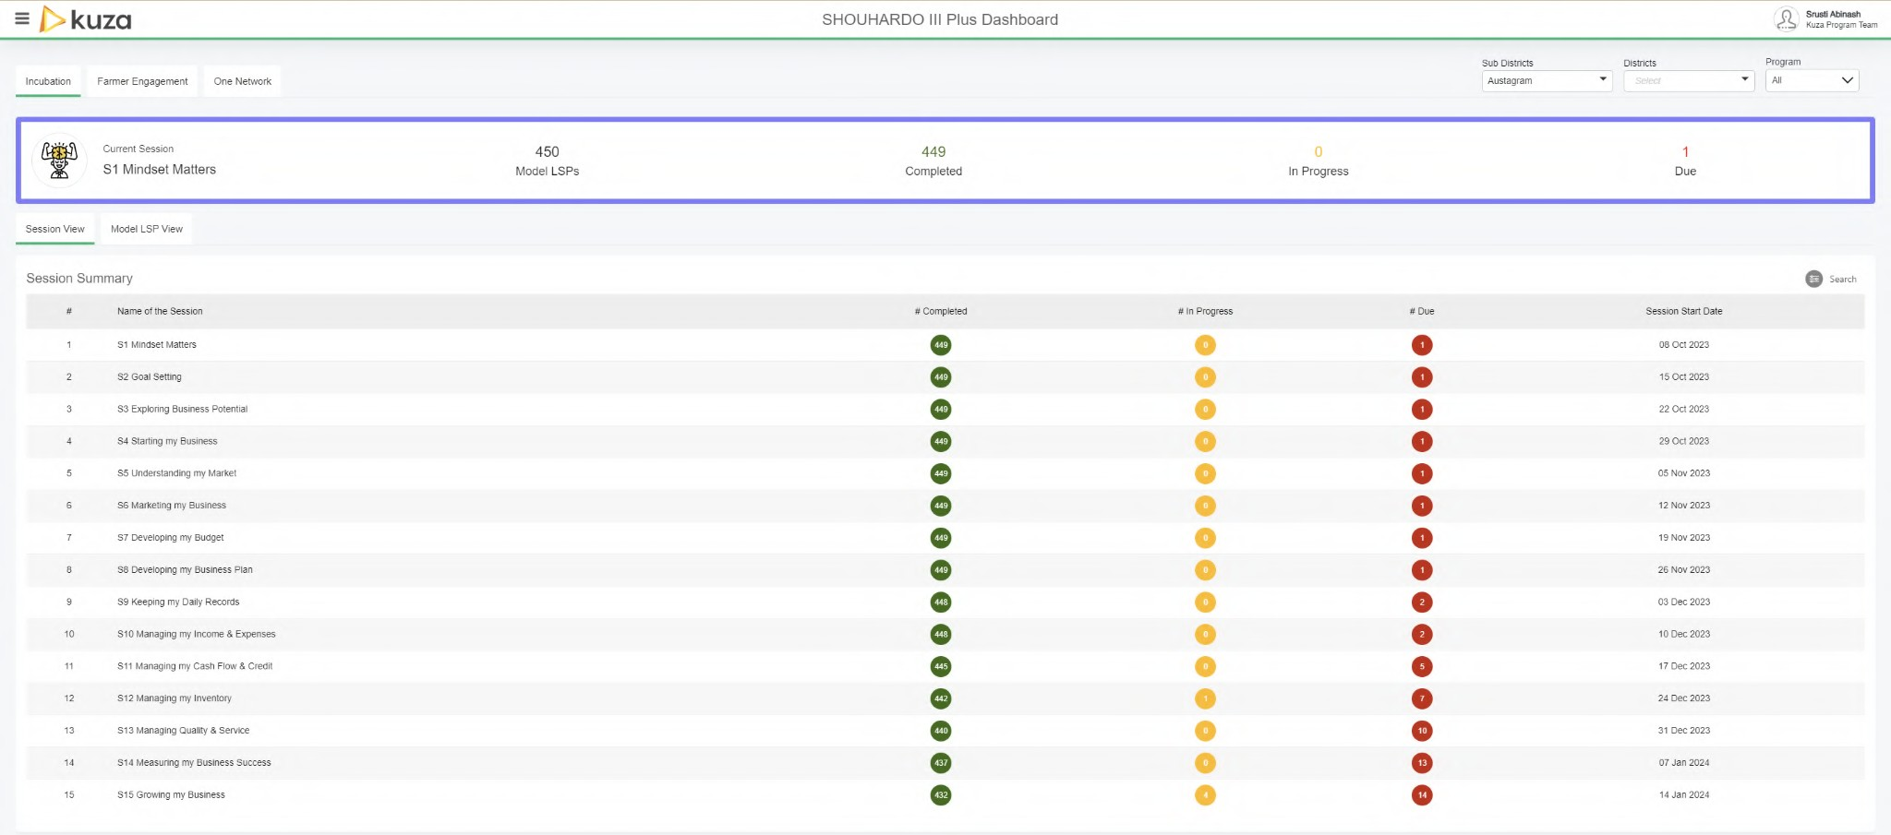

The **Leadership Academy** sessions kicked oﬀ with a burst of energy on 08 October 2023, and the sessions have an overall completion rate of 99% (99% in Cohort 1 and 99% in Cohort 2). The sessions received an overwhelmingly positive feedback from the LSPs on how it left a profound impact on a personal and professional level. LSPs expressed genuine appreciation for the session, emphasising how it challenged their preconceived notions and opened their minds to new possibilities.

Overall, the 15-week program equips LSPs with the necessary tools and perspectives to not only succeed in their current operations but also to embrace future challenges and opportunities in the dynamic agricultural landscape. The greatest beneﬁt as the LSPs see is the holistic growth and development of LSPs, positioning them for sustained success and impact in their communities.





The insights gained from the interactions with the LSPs, both individually and in groups, during

the program implementation provide valuable information for the program evaluation and future planning. They highlight the program's success in attracting talented and motivated LSPs with the potential to drive positive change in the agricultural sector.

|  |  |
| --- | --- |
|  | **Hadis Mia**  LSP, Netrokona  Completed 15 weeks of SHO III+ Entrepreneurship Training Completed 01 Value Chain (Livestock)  Registered 343 Farmers  Conducting farmer trainings with the Tablet received Recording Transactions using One Network |
| “The past 15 weeks in the Business Development, Entrepreneurship, and Coaching Program have been a game-changer for us as Local Service Providers (LSP). The training sessions equipped us with practical skills, helping us improve our operations, engage with customers better, and explore new agribusiness opportunities. The coaching sessions were personalised and guided us through challenges, reﬁning our strategies. The focus on a growth mindset has been transformative, boosting our conﬁdence and inspiring positive changes in how we operate. We are grateful for this journey, and the program has made us more resilient, adaptable, and committed to excellence. The sessions gave me a realisation that I need to focus on marketing and record keeping. I have already started registering my farmers on the One Network platform to keep a track of my customer base and plan better on marketing. We look forward to continued growth and success with the lessons we've learned.” | |

**Group Mentorship Sessions**

Group Mentorship Sessions (GSMs) are in-person one-day district-level/ cluster level events organised and facilitated by the Kuza Dedicated Coaches (DC) in collaboration with the Care TM-SRs, and the Implementing Partners (IPs) on a monthly basis.

**Objectives of a GSM**

* + 1. Create and nurture a collaborative learning and networking platform where LSPs convene under Kuza Dedicated Cocah’s guidance to share insights, challenges, experiences, and knowledge.
    2. Promote peer-to-peer learning, enabling LSPs to draw from each other's expertise, reﬁne business strategies, and receive mentor-led guidance.
    3. Conduct refresher training to the LSPs on the Kuza tools for digital record keeping, Agribytes or leadership academy
    4. Create a safe space for LSPs to engage in honest conversations, and deliberations creating a sense of camaraderie and forming trusted relations that provide a collective source of encouragement and diverse perspectives.
    5. Create networking opportunities for LSPs to establish meaningful connections, explore potential collaborations amongst themselves at a local level, and access opportunities via a broader business community, fostering an environment of shared learning and growth.

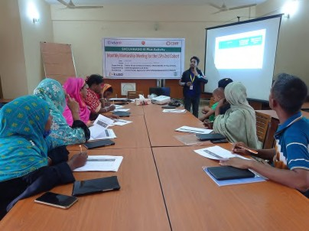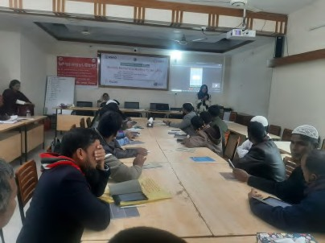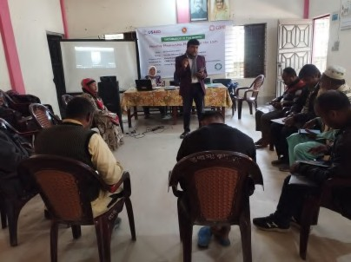

The GSMs conducted between November 2023- April 2024, with LSPs proved to be insightful and transformative. The LSPs actively engaged in sharing experiences, challenges, and success stories, fostering a collaborative learning environment. The session provided a platform for collective problem-solving, enabling participants to draw from each other's diverse perspectives. The Kuza Dedicated Coaches facilitated discussions on various topics, ranging from market strategies to ﬁnancial management, tailoring guidance to meet the speciﬁc needs of the LSPs. This collaborative approach not only enhanced the LSPs' understanding of key concepts but also built a strong sense of community and camaraderie among them. The Group Mentorship Session emerged as a dynamic forum for knowledge exchange, peer support, and collective growth, contributing signiﬁcantly to the LSPs' entrepreneurial journey. During Cohort 1, a comprehensive series of 39 GSMs were conducted across diverse locations, ranging from single venues to those spanning two diﬀerent locales. These engagements were strategically distributed across various districts, including Sirajganj, Gaibandha, Kurigram, Kishoreganj, Netrokona, Jamalpur, Habiganj, and Sunamganj.

The locations included:

* **Sirajganj:** Belkuchi (03), Chauhali (03)
* **Gaibandha:** 03
* **Kurigram:** Char Rajibpur (03), Nageshwari, Phulbari (03)
* **Kishoreganj:** Nikli (03), Mithamain (03),
* **Netrokona**: SUS (03), Khaliajuri UHC (03),
* **Jamalpur:** Bakshiganj (03)
* **Habiganj**: Baniachong (03)
* **Sunamganj:** Tahirpur (03), Dowarabazar (03)

The agenda for each GSM was meticulously curated to address key objectives and topics.

For instance, **GSM 1** focused on providing a thorough understanding of the Leadership Academy program sessions, facilitating engaging activities, and creating a platform for participants to share their experiences. Noteworthy discussions revolved around problem mapping to identify challenges faced by LSPs and their interconnectivity. This was coupled with an emphasis on active participation in the Kuza One Network.

Similarly, **GSM 2** delved into the Leadership Academy program sessions, oﬀering insights into speciﬁc sessions while encouraging collaboration among participants to tackle implementation hurdles collectively. The GSM aimed to encourage LSPs' to think creatively to address the identiﬁed challenges, encourage collaboration, and identify business opportunities and aspirations.

**GSM 3** was dedicated to empowering LSPs to craft their One Page Business Plan, an essential tool for attracting ﬁnancial support and fostering business growth. The emphasis was on empowering LSPs to create their own One one-page business Plan and presenting the same conﬁdently.

Furthermore, all GSM sessions included informative discussions on the safeguarding policies of CARE Bangladesh, underscoring the importance of adherence to ethical practices and active involvement for sustainable business growth.

Transitioning to Cohort 2, the GSM format remained consistent, albeit with a reduction in the number of sessions to two per location. However, the overarching themes and objectives mirrored those of Cohort 1, ensuring continuity and alignment with the program's objectives across all engagements.

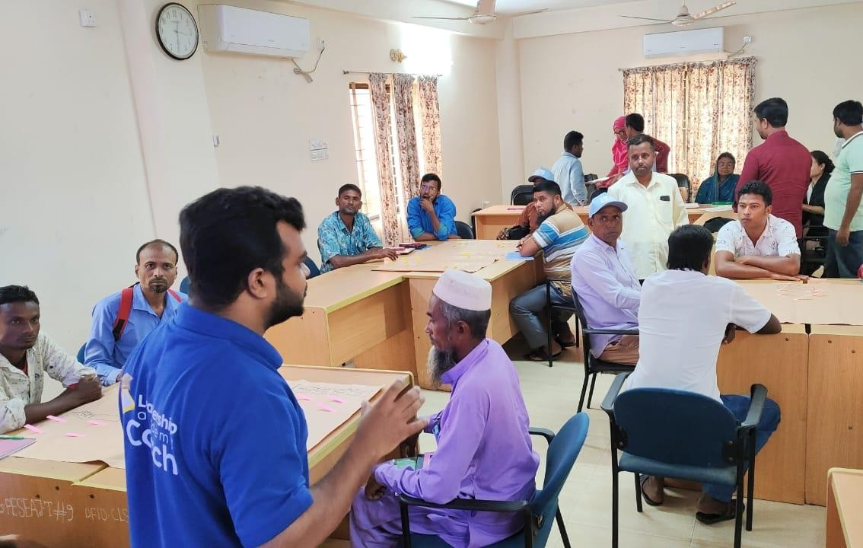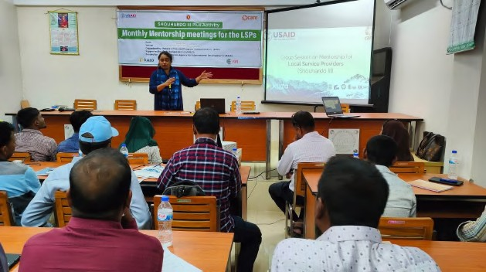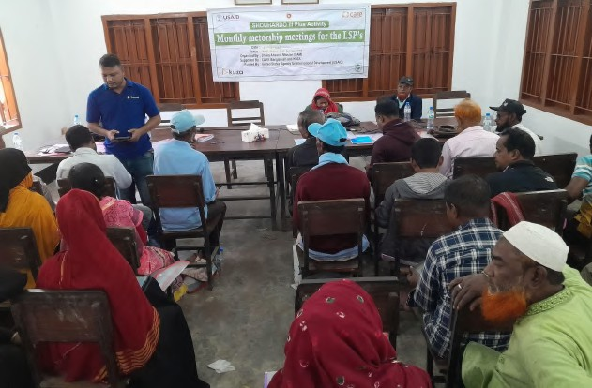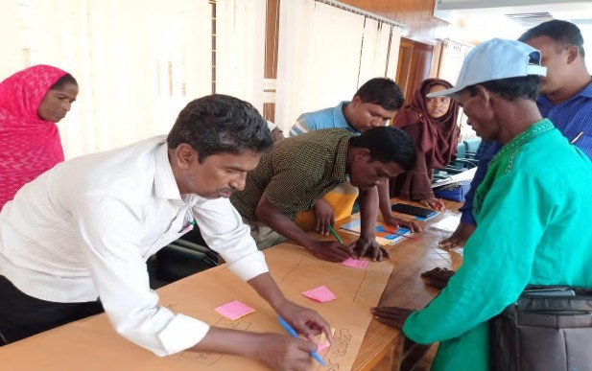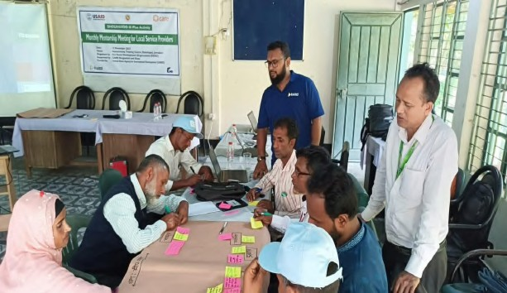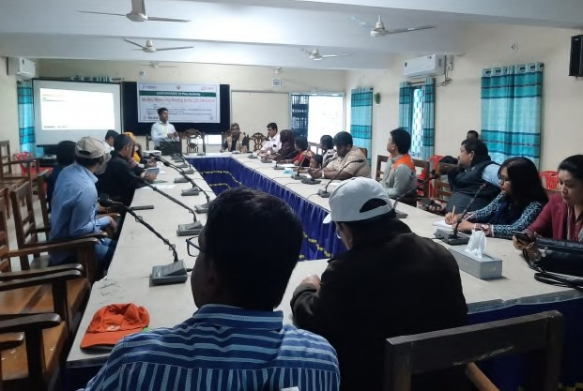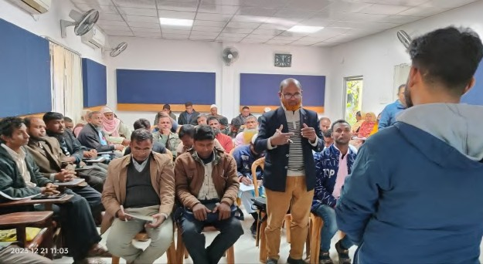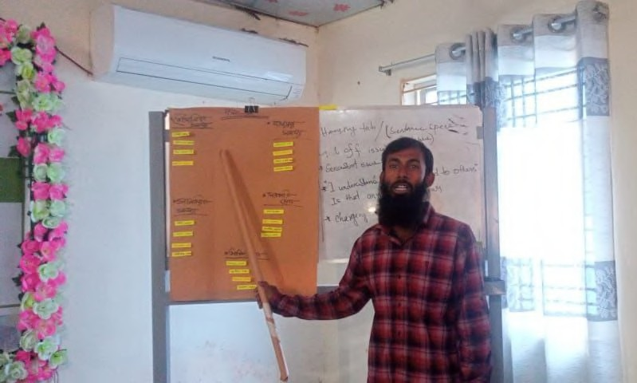

|  |  |
| --- | --- |
|  |  |
|  |  |
|  |  |

"As LSPs, we truly appreciate the program's support in providing us access to business skills, digital devices and continued support from the Care team, POPI and the Kuza Dedicated Coaches. We would like to request the Program to establish crucial market linkages and ﬁnance connections. This will signiﬁcantly improve our access to reliable markets, ensure fair pricing, timely availability of products and oﬀer valuable insights into value addition. We kindly request ongoing assistance in exploring diverse ﬁnancing avenues to provide the necessary capital for scaling our veterinary business. Your continuous support is vital in guiding us through the complexities of market dynamics and ﬁnancial landscapes, helping transform our business journey into a thriving and sustainable venture. Thank you for considering us to be an

integral part of the community development initiative."

-

Nur Mohammad, LSP, Netrokona

### Kuza Agribytes for Good Agricultural Practices

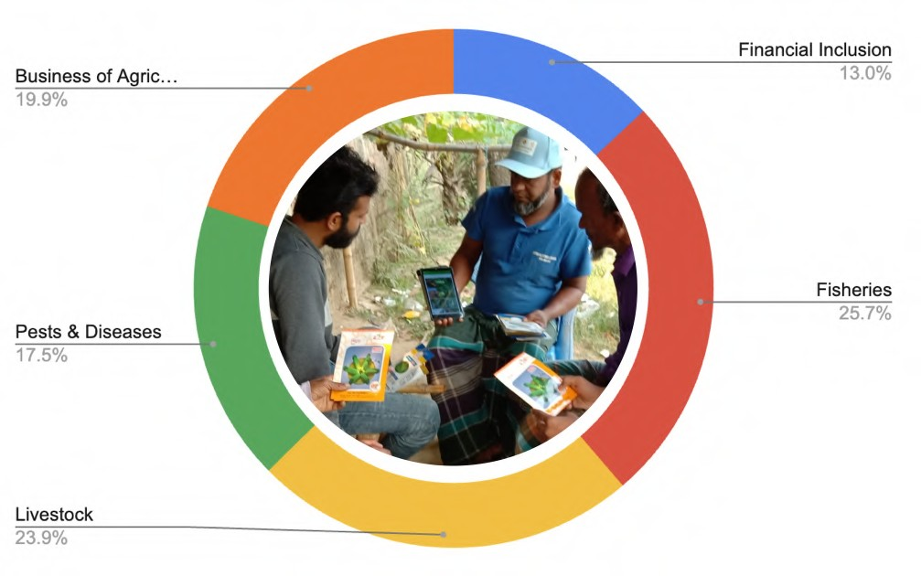The LSPs are engaged in various value chains, showcasing their diversity and commitment to agricultural entrepreneurship. Kuza Agribytes supported the LSPs, helping them to learn and adopt good Agricultural practices in Cucumber, mushroom, rice, mustard, potato, turmeric, drumstick, homestead vegetable gardening, goatery, poultry, ﬁsheries value chains and skills on the value chains of interest. The platform provided accessible and relevant agricultural information and best practices that were speciﬁc to their local context, enabling the LSPs to enhance their farming knowledge for a better customer engagement and improve productivity.

By accessing Kuza Agribytes, the LSPs gained valuable insights into modern and sustainable farming methods for Cucumber, mushroom, rice, mustard, potato, turmeric, drumstick, homestead vegetable gardening, goatery, poultry, ﬁsheries, etc They learnt about optimal planting and harvesting times, eﬃcient water and resource management, pest and disease control, and eﬀective post-harvest handling techniques as well as best animal husbandry practices. These best practices would help them engage their customers better through disseminating the knowledge. The knowledge acquired through Kuza Agribytes empowers the LSPs to make informed decisions that can positively impact increased proﬁtability and economic stability. Beyond their individual growth, the LSPs recognized the importance of sharing their newfound knowledge with their communities. Some of the LSPs have become local champions and mentors, organising training sessions and workshops to pass on the skills they acquired through Kuza Agribytes. By disseminating these best practices, the LSPs play a crucial role in enhancing the overall agricultural practices within their communities.

Through this knowledge-sharing approach, more farmers would start to embrace improved Agricultural as well as livestock practices leading to a collective impact on food security, income generation, and community development. The LSPs' eﬀorts in disseminating information on Cucumber, mushroom, rice, mustard, potato, turmeric, drumstick, homestead vegetable gardening, goatery, poultry, ﬁsheries value chains further strengthened their position as respected leaders and catalysts for positive change in the region.

In conclusion, Kuza Agribytes facilitated the LSPs' access to valuable agricultural knowledge, empowering them to adopt good Agricultural practices. The acquired knowledge not only contributed to their individual growth and economic prosperity but also enabled them to become agents of change, passing on this valuable information to their communities and contributing to the overall development and prosperity of the smallholder farming community.

The completion rate for the Agribytes :

* 17% of the LSPs have completed Financial Inclusion sessions
* 34% completed Fisheries
* 32% completed Livestock
* 23% completed Pests & Diseases across value chains
* 26% completed Business of Agriculture

**\***LSPs choose the value chains based on their area of focus

|  |  |
| --- | --- |
|  | **Golam Mostofa**  LSP, Sirajganj  Completed 15 weeks of SHO III+ Entrepreneurship Training Completed 03 Value Chains (Fisheries, Livestock, Agriculture) Registered 28 Farmers  Conducting farmer trainings with the Tablet Recording Transactions using One Network |
| The "Agribytes' has been a great asset for me. The platform's comprehensive content on Paddy and maize agronomy practices has signiﬁcantly enhanced my knowledge base. The bite-sized, practical lessons are easy to grasp, allowing us to swiftly adopt and implement best practices. The impact has been profound as I, in turn, train the farmers I serve. I have watched all the videos in the agribyte application. The tablet has become an asset in our mission to empower farmers with the latest and most eﬀective Agricultural techniques as I show videos to LSPs on my Tablet. It has not only streamlined our learning process but has also changed the way we educate and support our farming community. As a result, I have observed positive responses from my customers after implementing this practice.`` | |

**Potential for LSPs as Agricultural Extensionists**

LSPs serve as invaluable extension agents, playing a pivotal role in supporting smallholder farmers and fostering sustainable agricultural practices. Their unique position as entrepreneurs immersed in the agricultural sector positions them as eﬀective conduits of knowledge and innovation. With a hands-on understanding of livestock/ crop farmer challenges, these entrepreneurs can bridge the gap between traditional practices and modern, eﬃcient techniques.

LSPs bring practical insights and real-world experiences, making them relatable mentors for smallholder farmers. Their entrepreneurial spirit enables them to adapt swiftly to changing agricultural landscapes, oﬀering tailored solutions that align with the speciﬁc needs of local communities. Being embedded in the farming community, agripreneurs facilitate the dissemination of crucial information on best practices, crop management, and market trends.

LSPs leverage the access to the digital content available on their tabs to elevate farmer training. Through the Agribytes content on the tabs, some of the LSPs showcase digital content, making training sessions engaging and informative. This combination enhances the impact of extension services, enabling LSPs to visually convey best farming practices across crop & livestock value chains including pests & disease management. Farmers beneﬁt from a vivid, interactive learning experience, fostering better comprehension and retention. The digital toolkit becomes a catalyst for knowledge dissemination, allowing LSPs to reach a wider audience during community gatherings or training sessions. This innovative use of technology transforms traditional training methods, making them more accessible and impactful for farmers, thereby contributing to sustainable agricultural development.

Despite the many advantages, this model of using LSPs as extension agents also comes with its set of challenges:

* + 1. **Limited Resources:** LSPs face challenges due to limited resources, making it diﬃcult for them to reach all smallholder farmers eﬀectively, and limiting their ability to invest in training farmers eg: farmers expect ﬁnancial assistance to cover costs to attend the training.
    2. **Resistance to Change:** Some smallholder farmers are resistant to adopting new practices, especially those following traditional methods for a long time.
    3. **Market Dynamics**: LSPs face challenges in understanding and navigating market dynamics, especially if they are dealing with ﬂuctuating prices and demand and hence are reluctant to change
    4. **Climate Change Impact**: Unpredictable weather patterns due to climate change are aﬀecting farming practices, making it challenging for LSPs to provide consistent advice.
    5. **Lack of Training Opportunities:** LSPs themselves lack access to continuous training opportunities, hindering their ability to stay updated on the latest livestock/ agricultural practices.
    6. **Scale and Reach:** Scaling the model to reach a larger number of farmers can be a logistical challenge, requiring eﬀective coordination and support, sometimes from the district administration or district extension oﬃcers.
    7. **Data Privacy and Security**: The use of digital tools may raise concerns about data privacy and security, especially when LSPs try to collect sensitive information about farmers

Despite these challenges, addressing them through strategic planning, collaboration, and ongoing support can enhance the eﬀectiveness of the LSPs as extension agent models. These LSPs serving as extension agents for smallholder farmers can unlock various potentials and beneﬁts:

1. **Market Access:** By connecting with smallholder farmers, LSPs can establish a reliable customer base for their products or services, creating a mutually beneﬁcial market relationship.
2. **Income Diversiﬁcation:** Serving as extension agents allows LSPs to diversify their income streams. They can earn through consultations, training sessions, and the sale of agro-inputs or technology.
3. **Community Recognition:** LSPs play a crucial role in community development. As they contribute to the agricultural knowledge and success of local farmers, they gain recognition and trust within the community.
4. **Innovation and Technology Adoption:** Being on the frontline of agricultural practices, LSPs have the opportunity to introduce and promote innovative farming techniques and technologies, ensuring eﬃcient and sustainable practices.
5. **Capacity Building:** The role of an extension agent positions LSPs as educators, helping farmers enhance their skills and knowledge. This capacity-building role contributes to the overall improvement of agricultural practices in the community.
6. **Networking Opportunities**: Engaging with farmers provides LSPs with networking opportunities. Building relationships with farmers, local organisations, and other stakeholders can open doors for collaborations and partnerships.
7. **Resilience Building:** Through continuous engagement, LSPs can help farmers build resilience against challenges such as climate change, pests, and market ﬂuctuations, contributing to long-term sustainability.
8. **Government Support:** As key players in agricultural development, LSPs may attract government support and incentives for their contributions to community development and economic growth.
9. **Personal and Professional Growth:** Serving as extension agents allows LSPs to continually expand their knowledge and expertise. This continuous learning contributes to personal and professional growth.
10. **Positive Impact:** LSPs become agents of positive change in their communities, contributing to food security, poverty alleviation, and sustainable agricultural practices.

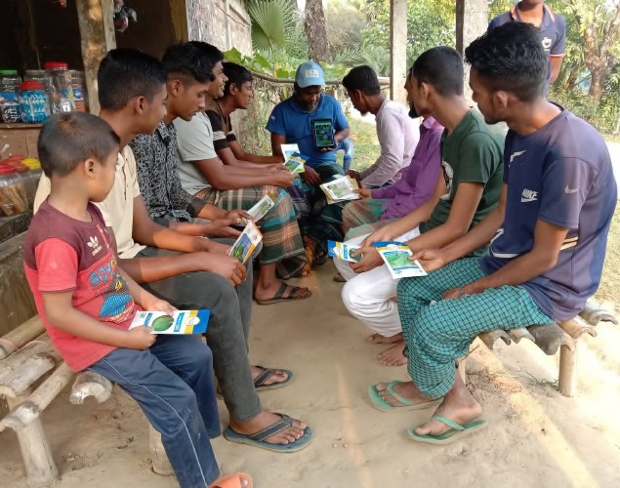 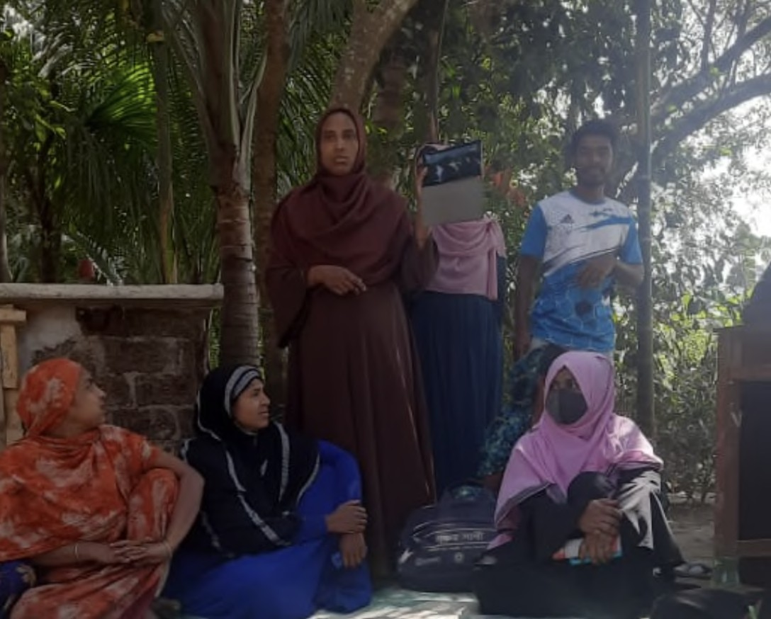

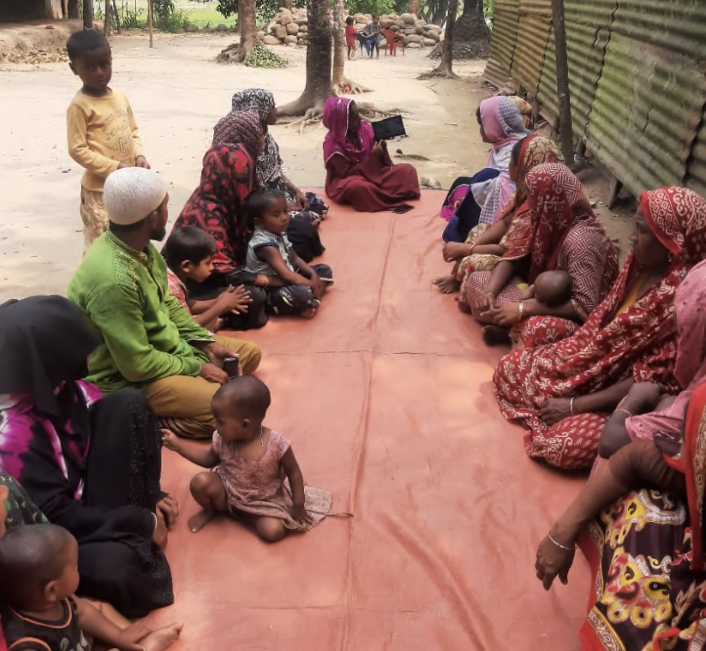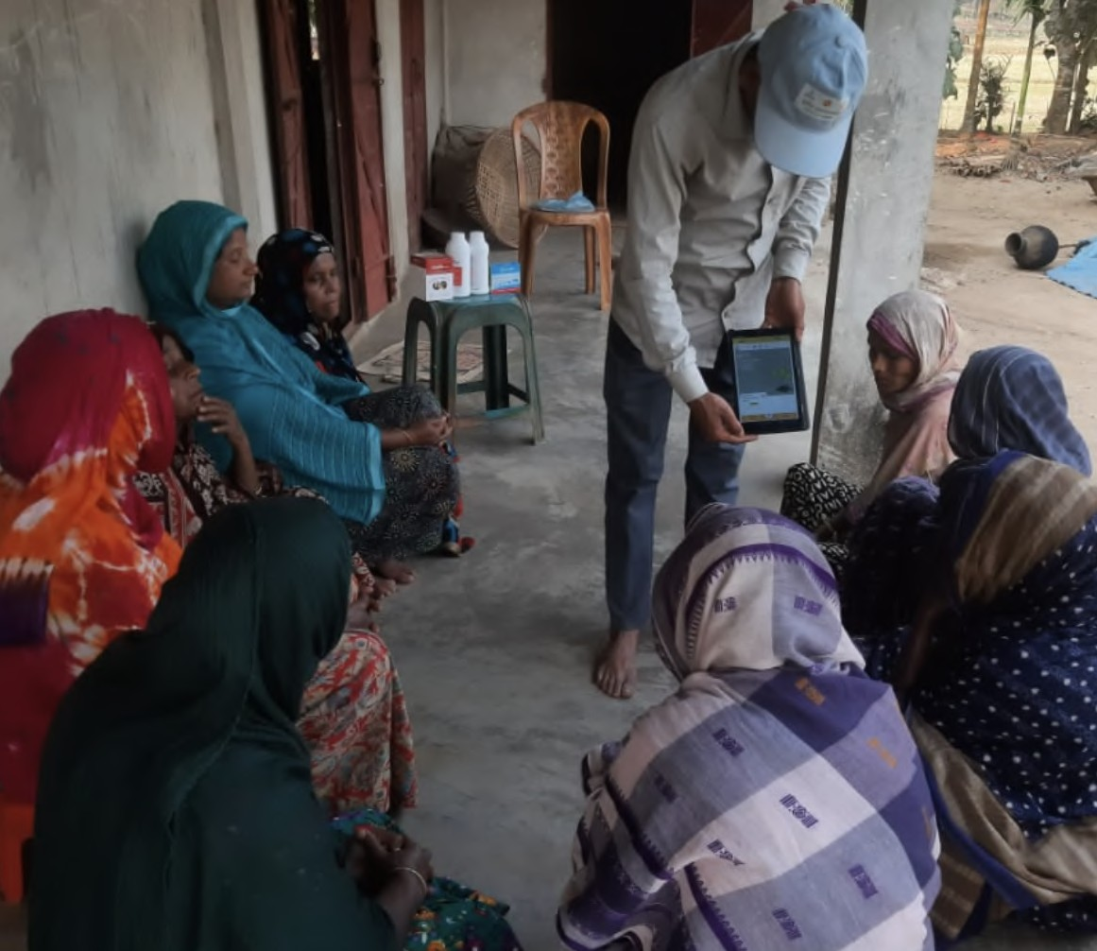

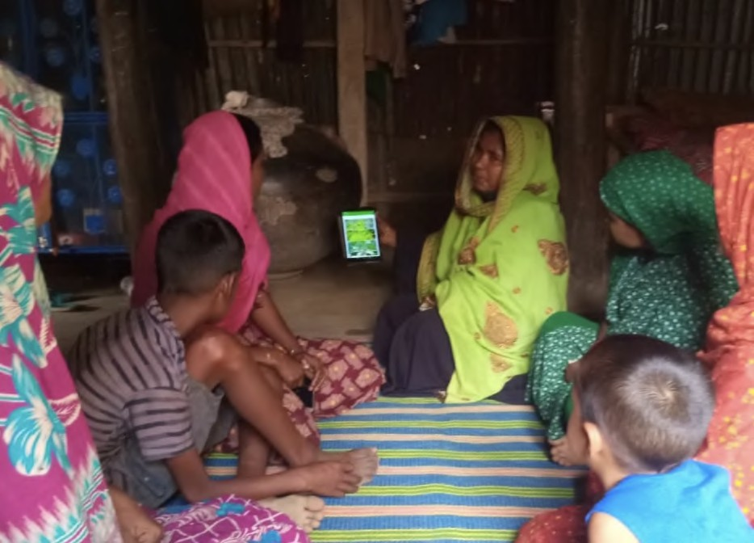 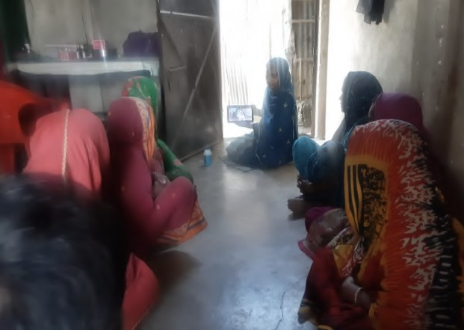

In summary, LSPs serving as extension agents not only beneﬁt ﬁnancially but also play a pivotal role in fostering agricultural development, innovation, and community well-being.

### Kuza One Network for Digital record keeping

LSPs maintain their digital record keeping and as they sync their tablets, the program team can see through their dashboard the performance of the entire cohort and also the individual performance of each of the LSPs. Here is a snapshot of the LSP dashboard where you can see the summary of their aggregation business, inputs & post harvest solutions (PHHS) business, Mechanization and Services business. The total farmers recorded on the platform stands at **15,243 farmers** with **197 farmers** being trained through **12 training sessions** with **35% female farmers.**

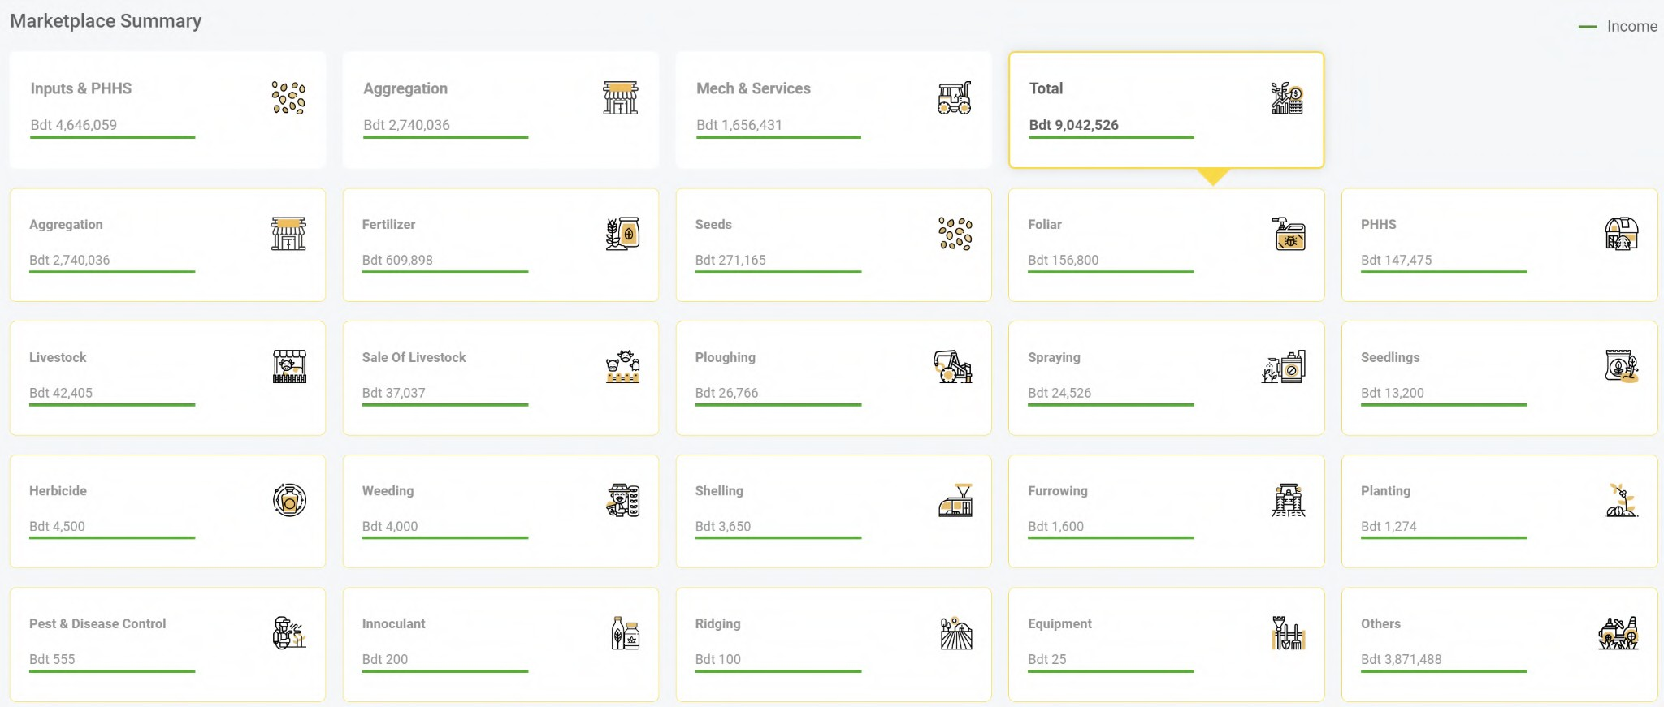**LSPs Business transaction summary as on 05 Jun 24**

|  |  |  |  |  |
| --- | --- | --- | --- | --- |
| **Province** | **Total** | **Inputs & PHHS\*** | **Farm Services** | **Aggregation** |
| Dhaka | 1,338,006 | 783,660 | 554,346 | 0 |
| Mymensingh | 3,003,207 | 282,099 | 574,383 | 2,146,725 |
| Rajshahi | 594,468 | 121,039 | 323,686 | 149,743 |
| Rangpur | 4,109,983 | 3,465,839 | 201,626 | 442,518 |
| Sylhet | 92,942 | 89,502 | 2,390 | 1.050 |
| **Total** | **9,138,606** | **4,742,139** | **1,656,431** | **2,740,036** |

* PHHS: Post Harvest Handling Solutions

|  |  |
| --- | --- |
|  | **Shahjalal LSP, Kurigram**  Completed 15 weeks of SHO III+ Entrepreneurship Training Completed 03 Value Chains (Livestock, Agriculture and Fisheries) Registered 215 Farmers  Recording Transactions using One Network Volume of transactions: BDT 13.67 million  Income streams: veterinary pharmacy and veterinary services |
| "The adoption of digital record-keeping through the Kuza One Network digital platform has been revolutionary. I wasn’t much aware of the importance of record keeping and the process looked very diﬃcult. After the ﬁnancial management sessions my DC helped me in understanding the application. Since then I have started practising at least 3-4 transactions per day as a practice. Now this has become a bit interesting. Previously, managing records was very diﬃcult. Now, with the user-friendly digital interface, the process has become streamlined and eﬃcient. Additionally, the real-time accessibility of information has empowered me to make informed decisions promptly. It is a powerful tool that aligns perfectly with our commitment to eﬃciency and excellence in serving our farming community." | |

|  |  |
| --- | --- |
|  | **Samima**  **LSP, Sunamganj**  Completed 15 weeks of SHO III+ Entrepreneurship Training Completed 03 Value Chains (Livestock, Agriculture and Fisheries) Registered 39 customers  Recording Transactions using One Network Income streams: Tailoring Business  Samima is a small Entrepreneur involved in tailoring business, doing Kuza one entry of product purchase vouchers. |

### Setting up Business Networks

A Business Network is a dynamic ecosystem comprising Local Service Providers (LSPs), Model LSPs, Private Sector Companies, Government Organizations, and other relevant entities, all collaborating to foster entrepreneurship, innovation, and sustainable growth. Through synergistic partnerships, knowledge sharing, and resource pooling, the network empowers its members to thrive in a competitive business environment, driving collective prosperity and societal impact.

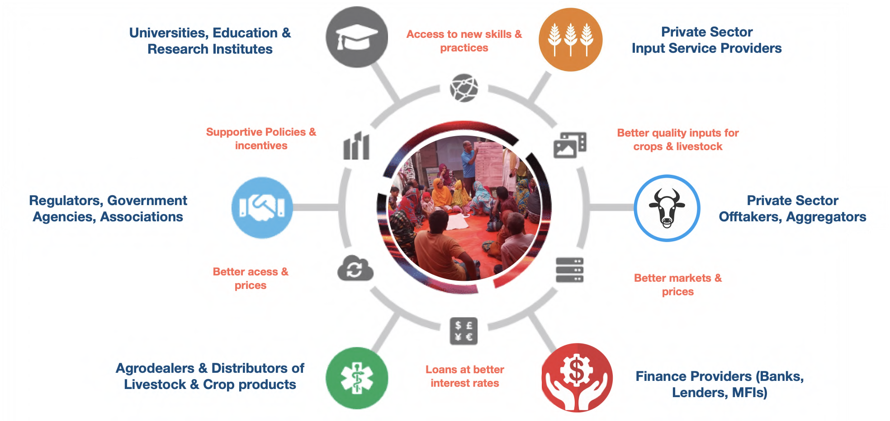

The concept of Business Network aims at strengthening the business ecosystem at a micro level through setting up business networks at Union Levels. Each group is headed by a **Business Network Leader (BNL)** whom the program team has selected after a thorough evaluation procedure. Some of the criterias were performance in the academy, business acumen, leadership and communication skill, last but not least his own motivation to drive a positive change in the community and support the ecosystem. These BNLs are responsible for setting up Business Networks in their community as well as managing it.

The main objective of a Business Network are:

1. To strengthen the business ecosystem in the union
2. To support the members by sharing knowledge and networks
3. Foster an entrepreneurial ecosystem
4. To serve the community with the quality products and services

The program aims to set up 115 Business Networks across all the unions in 8 program operating districts. Out of which 93 BNLs and Networks are identiﬁed through the evaluation and the plan is to identify the rest of the Network leaders from the Model LSPs based on their performance in the upcoming days.

### Insights on LSPs’ portfolio

1. Every LSP is unique and have diﬀerent portfolio of products and services that they oﬀer to their customers (farmers)
2. 131 out of the 450 LSPs are **Seed Agents**. Most of the LSPs have shops from which they avail their products and services. Motiur Rahman (Kishoreganj), Bablu Mia (Sunamganj), Makhon Lal (Kurigram) and Monju Mia (Gaibandha), Haﬁzul Sarker (Sirajganj) stand out among the Seed agents. The 4 have expanded their business by adding more products in their store as well as increased customer engagement by sharing best agricultural practices videos from agribytes app. This not only increased their sales but also improved their customer relation ultimately impacting customer retention as well as word of mouth promotion. Haﬁzul also installed pumps at his shop adding another product line to support the community in irrigation services.
3. 192 out of 450 LSPs are **Vaccinators** who deal in animal husbandry services to farmers. They primarily provide vaccination as well as Artiﬁcial Insemination services. Hadis Mia (Netrokona), Monoronjon Das (Kishoreganj) and Sahed (Jamalpur) are among the Vaccinators who penetrated their market through an improved marketing strategy. Where some of them applied the Place concept and rearranged their shops, some of them added new products making it one stop solutions for all kinds of animal needs.
4. Shahid from Jamalpur took an extra mile to promote his business. He started writing his contact number in front of houses where he provides veterinary services. This helped him acquire more customers by increasing service visibility in the community.
5. There are 34 **Collectors** who serve as a produce Collectors, primarily involved in availing the market access to the community. Most of them deal in collecting agricultural produce as well as animal products and sell them in the local market. Where as, Rashedul Islam from Gaibandha took a dealership from Mari gold agri science ltd this January to supply pesticides and fertiliser for agriculture doing a background integration also aims to supply fresh vegetables to Dhaka from his union; Zia Rahman from Sunamganj expanded his area of operations from 5 to 10 villages buying chickens. This gave him an opportunity to negotiate better with the traders due to scale in aggregation.
6. There are 25 **Private Community Skilled Birth Attendants (PCSBAs)** providing health services to pregnant and lactating women (PLW) at a low cost, right at their doorstep. In case of PCSBAs, whereas, Mahmuda (Netrokona) improved her sales by rearranging her products in her shop and an improved sales technique; Taslima (Sunamganj) aims to set up her own pharmacy for which she already interacted with the SMC representative; Understanding the need for multiple sources of income opportunity Joba Rani Das (Kishoreganj) started bottle gourd cultivation in addition to her tailoring business & is still working dedicatedly in her home pharmacy with ﬁrm plans to expand that.
7. 21 LSPs in the program working **Sanchay Sathis** promoting village level savings groups to promote community savings and loan options. Understanding the income limitation from the Sanchay Sathi service most of the LSPs are engaged in some other activities as well. Out of them some of the LSPs who stood out and becoming an example for other Sanchay Sathis in their communities are- Khadiza (Kurigram) who alongside her work as Sanchay Sathi also manages a tailoring shop and understanding the upcoming eid market she is starting her cloth store from where the customers can buy readymade cloths. In Sirajganj, Rehana Parvin, purchased a sewing machine with the help of her relatives and already started sewing ladies clothes in her area; now she wants to start a clothing business so that her customers can buy clothes from her for their dresses and "Nakshi Kathas"(She has a Nakshi katha printing business few years back) alongside sewing to increase her income. Lovely Begum, another Sanchay Sathi from Kishoreganj manages a cattle farm and after watching homestead gardening videos on agribyte started vegetable cultivation.
8. There are 32 **Entrepreneurs** in both the cohorts. Jannatul an Entrepreneur (Sunamganj) was a housewife before, started a duck farm with 20 ducks 3 months ago. Now she is involved in selling eggs for 200 taka each. Mizanur Rahman, another LSP from Kurigram, is going to start a veterinary medicine and cattle feed shop. He already prepared the shop. Besides, he is planning to take another pond as a lease for ﬁsh farming. Md.Babul Ahmed (Kurigram) is planning to start a decorator business as a new venture in addition to his existing online and photocopy shop. For that he has already rented a shop and is currently purchasing the inventory for the business.

### 3.4.2 Discovery Workshop with a Business Network, Jamalpur

On 28th April 2024, the SHOUHARDO leadership team, led by Mannan da, Mahfuz da, Ashraﬁz Apa, and Hedyat Da along with Kuza team - led by Abinash Puri and Farhan Akif conducted a ﬁeld visit to Jamalpur District, facilitated by the implementing partner, ESDO. The primary objective was to engage in an in-depth dialogue with 21 (Out of which 17 were present) Local Service Providers (LSPs) including 1 BNL and 3 Model LSPs from Goaler Char Union of Islampur Upazilas, to understand their challenges and explore potential areas for intervention.

All the participants were engaged in a focused group discussion to understand the various challenges faced by the LSPs and whether there is a need for setting up some structured committees for everyone’s beneﬁt. All the members participated actively in the discussion and suggested some important points. Below are some key insights from the session:

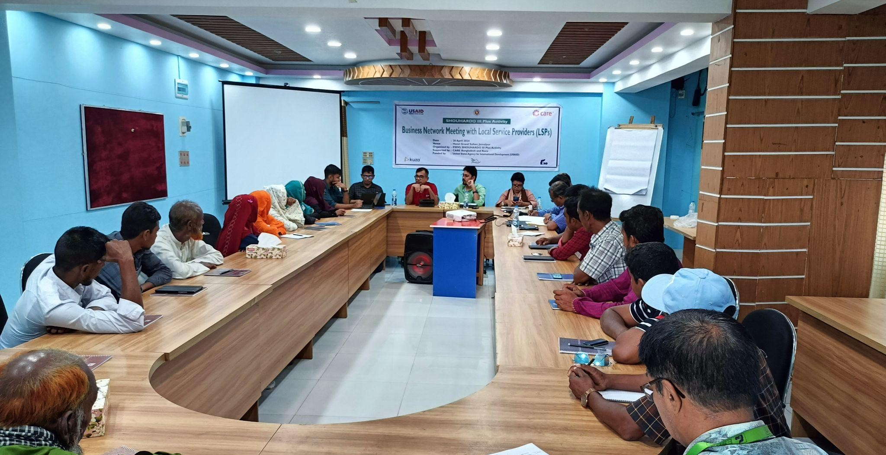

Focus Group Discussion with model LSPs at Jamalpur

### Key Findings

* + - 1. **Challenges:** Here are some of the challenges raised by the LSPs in the current scenario-
         1. As most of the LSPs are operating at a small scale and lower volume, the proﬁt margin is very less and sometimes loss making also, because of which it’s diﬃcult for them to negotiate with companies for a better deal
         2. Most of them doesn’t have a storage space to manage inventory
         3. Lack of capital is a major challenge in growing their business
         4. Aﬀordability and accessibility of quality products is also a challenge for the LSPs, restricting them to serve their customers better
         5. There’s a clear need of technical knowledge like artiﬁcial insemination for some of the Vaccinator
      2. **Existing non-structured network:** One of the Model LSPs Mofazzal Hossain, who is a vaccinator by profession, shared how he is getting leads from the 5 Sanchay Sathis of that network. The Sanchay Sathis, on the other hand, also shared that as Mofazzal provides a very good service, recommending him to the farmers also helps them a better engagement with them. This discussion not only shed light on an existing informal network but also paved the way for a discussion on the need of forming more such groups but with some structures to it.
      3. **Exploring a structured Business Network:** All the LSPs then engaged in a discussion to identify the need of a structured Business Network and how it can help them maximise their potential. The members then started sharing about what could be various roles and responsibilities, guidelines, etc. The LSPs also shared that it can also help them in demand aggregation, improve communication, knowledge sharing, cross promotion of products & services, connecting businesses with businesses and lastly a better networking between LSPs & customers.

#### Identiﬁed gaps and potential areas for Intervention:

* + - * 1. LSPs need support in initial days to setup the network and plan their activities
        2. As 75-80% LSPs in the network are non model LSPs their is a clear need of knowledge sharing
        3. Some of the LSPs has good network with some private sector companies, they can be guided on how to utilise that network
        4. The LSPs currently involved in customer engagement can encourage and guide other LSPs
        5. Although individually they have a limitation of products and services but together as a group they can have a wide range

##### Program Design

* + - * 1. The members agreed that there should be a leader or President of the network who will be responsible for overall management and to support him there should be a Vice President in the network.
        2. The members should meet at least once in a month to discuss and plan activities
        3. There should be a membership fee collected from all the members which can be utilised from team meetings and other group activities
        4. There should be a Treasurer in the network who will be responsible for any kind of monetary transactions as well as maintaining transparency
        5. The group should also be open to allow LSPs beyond the SHOUHARDO program, only if all the network members agrees
        6. The members agreed that there should be a name to the group and which can be kept as the ‘Union Name Business Network’
        7. The Model LSPs who were a part of the SHOUHARDO Leadership Academy will share their knowledge with the non-model LSPs

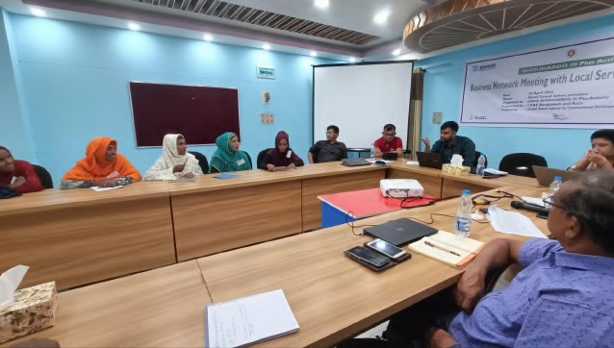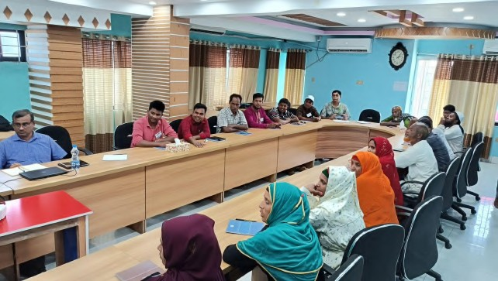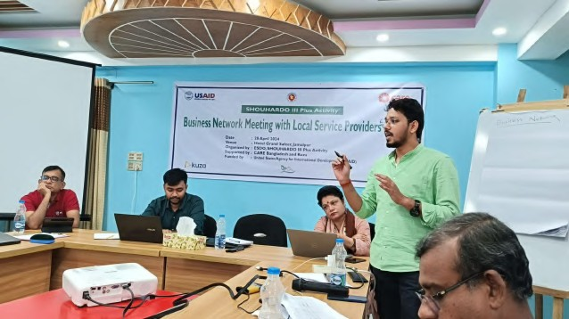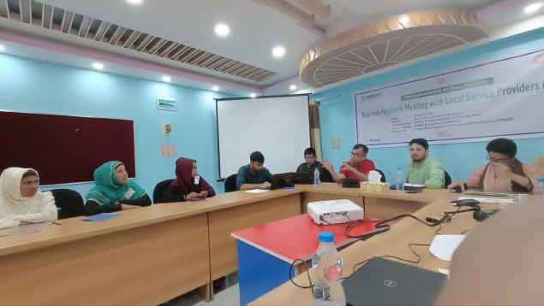

### Conclusion

The ﬁeld visit to Jamalpur gave invaluable insight to the challenges faced by both the Model and Non model LSPs. The discussion also made the whole design participatory through their active involvement. With the insights received from the participants the program team decided to develop a draft bylaw for the Network which can be customized later by the Networks as per their need.

### BNL Orientation across 8 districts

In-Person BNL Orientation Sessions were conducted across 8 districts with 93 Model LSPs in attendance.

|  |  |  |  |
| --- | --- | --- | --- |
| **Date** | **District** | **Venue** | **Attendees** |
| May 6, 2024 | Kishoreganj | POPI Part | **CARE**: Ashraﬁz Apa, Parvin Apa and Mitu Apa **Implementing Partner**: POPI- PM, POs and all FFs **Kuza**: Abinash, Zorna and Uhlayee |
| May 6, 2024 | Kurigram | TDH, Kurigram | **CARE**: Hedyat Da, Pavel Da and Susil Bhai **Implementing Partner**: MJSKS- PM, POs and all FFs  **Kuza**: Farhan, Masud and Taushik |
| May 7, 2024 | Sunamganj | FIVDB, Shantiganj, Sunamganj | **CARE**: Harunur Bhai  **Implementing Partner**: DAM- PM, POs and all FFs  **Kuza**: Kanik and Anup |
| May 9, 2024 | Jamalpur | US-DTRC,  Jamalpur | **CARE**: Aslam Bhai  **Implementing Partner**: ESDO- PM, POs and all FFs  **Kuza**: Abinash, Nahid, Saad |
| May 9, 2024 | Sirajganj | NDP Training  Centre, Bagbari, Sirajganj | **CARE**: Raﬁq Da, TM-SR  **Implementing Partner**: SKS- PM, POs, and all FFs  **Kuza**: Farhan, Nipun, Bonhi |
| May 15, 2024 | Netrokona | SUS Training Center, Netrakona | **CARE**: Mitu Apa  **Implementing Partner**: POPI- PM, POs and FFs  **Kuza**: Saad, Uhlayee, Zorna |
| May 15,2024 | Gaibandha | SKS Inn, Gaibandha | **CARE**: Laizu Apa  **Implementing Partner**: SKS- PM, POs and FFs  **Kuza**: Shadman, Taushik |
| May 19,2024 | Habiganj | Union Parishad Hall, Baniachong, Habiganj | **CARE**: Harun bhai  **Implementing Partner**: DAM- PM, POs and FFs  **Kuza**: Julhas, Anup |

Through these Orientation sessions, the LSPs were oriented on the

* + - 1. Concept of Business Network
      2. Objective of forming business networks
      3. Network Bylaw
      4. Roles & Responsibilities of the BNL, FF and DCs
      5. Action plan

### Group Discussion

To understand the BNL’s understanding of the concept and the potential challenges the Kuza facilitators in every location initiated a group discussion among the BNLs. Here are some of the queries raised by the BNLs:

1. What should be the age bracket for the Network members?
2. What is the maximum number of members can be added in a network?
3. Who will provide the cost of food and travel in the network meetings?
4. Will they be getting any additional devices?
5. Where can they conduct the meetings?
6. Will the IPs/Care/Kuza monitor their activities?

### Challenges highlighted

1. Diﬃculty in convincing especially the Non-model LSPs to be an active part of the Network.
2. Even if some of them are convinced the members might not come to the meeting due to the harvesting season.
3. The members might expect some kind of remuneration for attending the meetings.

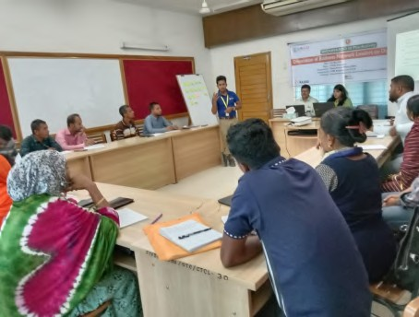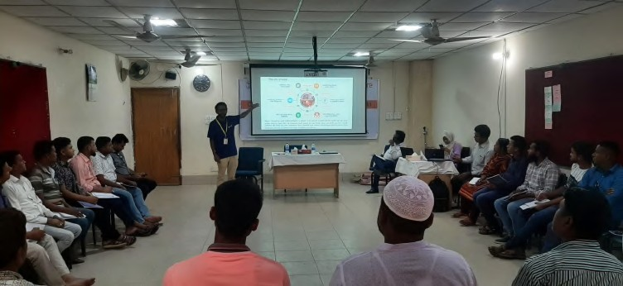

Sunamganj Sirajganj

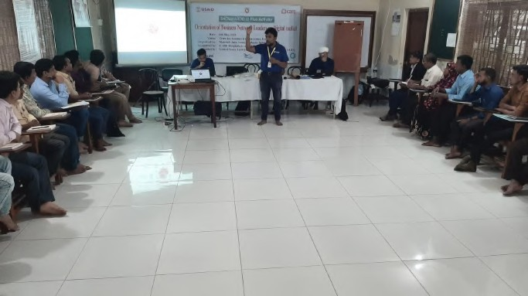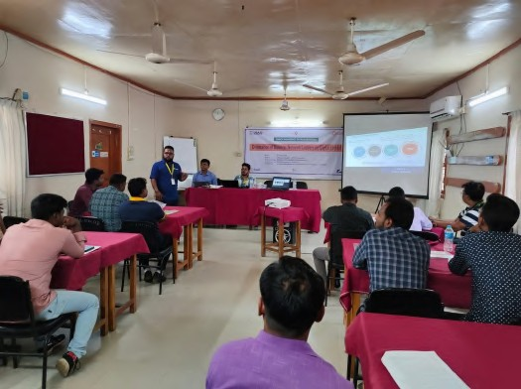

Kurigram Jamalpur

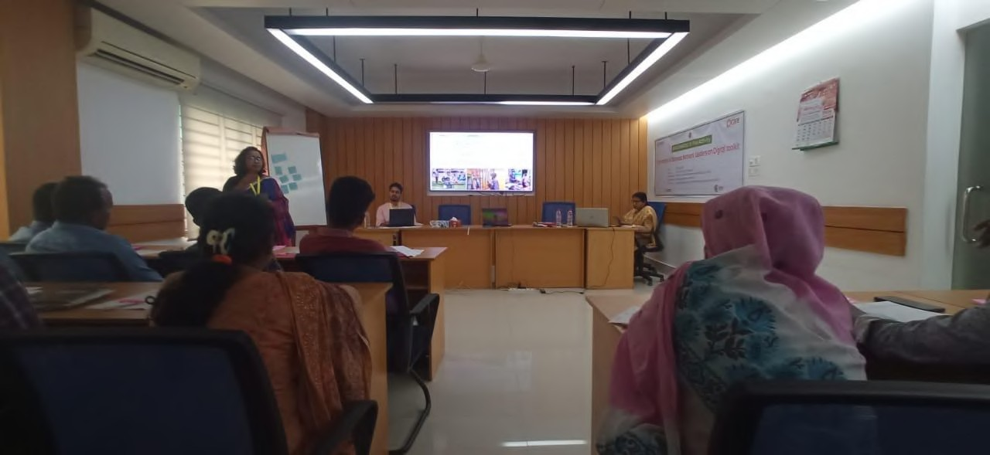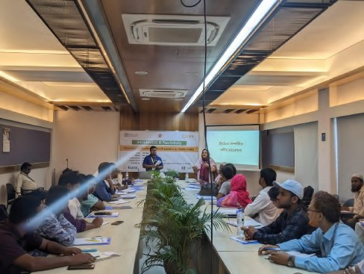

Kishoreganj Gaibandha

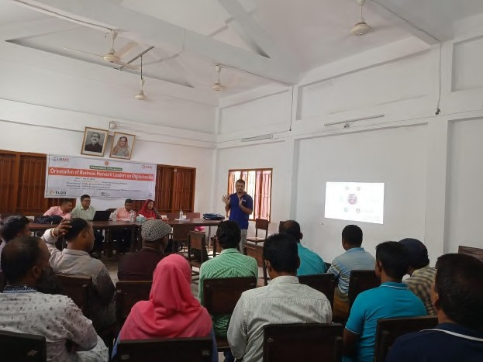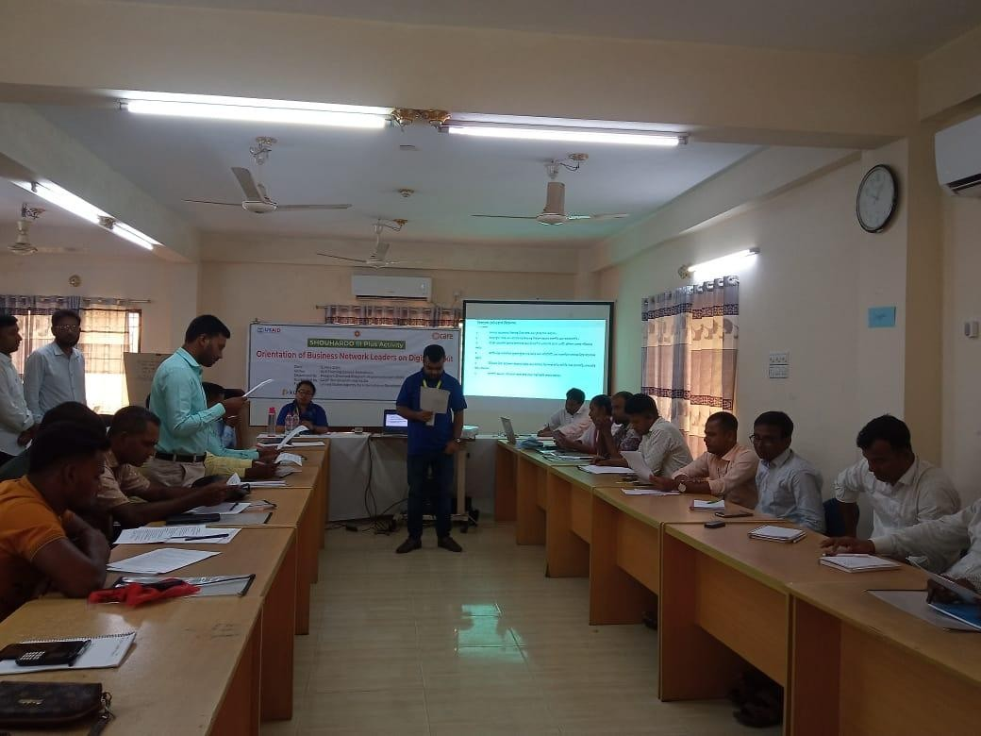

Habiganj Netrokona

### Business Network Formation and Meetings

After the BNL orientation the Network leaders went back and shared about this new initiative with other Model as well as Non model LSPs with the help of FFs and Kuza DC. Then with everyone’s agreement some of the Business Networks had their 1st meeting where they discussed it and came to a combined agreement on it’s operation, As of 25th May 2024, 8 Business Networks had their ﬁrst meeting with their Network members and shared about the initiative. In all the locations the initiative received a positive response and the members agreed on the bylaws.

Across the various Business Network meetings, common themes included discussions on the importance of networking for business growth, ﬁnancial transparency, and the selection of key roles such as vice-president and treasurer. Participants emphasized the beneﬁts of a strong network, including business expansion, community impact, and enhanced knowledge-sharing. Challenges faced commonly included coordinating meeting times due to conﬂicting schedules, ensuring member engagement, and clarifying the use of collected funds. Monthly fees were a recurrent topic, with varying amounts proposed and agreed upon in diﬀerent networks.

Uncommon discussions and challenges varied by location. Some meetings, such as in Sunamganj, addressed speciﬁc issues like transportation challenges for female participants and the need for more accessible meeting venues. Others, like in Kurigram, faced logistical issues such as late arrivals and ensuring eﬀective participation during learning sessions. Unique suggestions included avoiding market days for meetings, proposing evening sessions to accommodate busy schedules, and using multimedia learning methods to engage participants. Additionally, certain networks discussed inviting representatives from companies to future meetings to provide more value to the participants.

### Conclusion

Across multiple regions, various Business Network meetings have been conducted recently, reﬂecting a concerted eﬀort to bolster local entrepreneurial ecosystems. These meetings, led by dedicated BNLs, have seen enthusiastic participation from LSPs, with discussions covering bylaws, ﬁnancial management, and the beneﬁts of networking. Challenges such as time constraints and transportation issues have been acknowledged, prompting creative solutions like evening meetings and accessible venues. Notably, IPs and DCs are actively collaborating with BNLs to plan forthcoming Business Network meetings in other locations, underscoring a coordinated approach to foster entrepreneurship and community development.

### Strengthening Business Ecosystem

The Ecosystem Actor Meeting serves as a pivotal platform uniting key stakeholders to discuss challenges, explore opportunities, and foster collaboration for mutual growth. Participants will include representatives from private companies, government bodies, MFIs or Banks, and organizations oﬀering technical training relevant to our LSPs. The meetup aims to facilitate networking opportunities for our LSPs while also showcasing our LSPs and their customer base.

### Ecosystem Actor Meetups across 8 districts

In-Person Ecosystem Actor Meetups were conducted across 8 districts with representative joining from multiple companies, government organisations, Technical Institutions, etc.

|  |  |  |  |
| --- | --- | --- | --- |
| **Date** | **District** | **Venue** | **Attendees** |
| May 19,2024 | Jamalpur | DTRC, Unnayan Sangha, Jamalpur. | **CARE**: Aslam Bhai  **Implementing Partner**: ESDO- APM, POs and FFs  **Kuza**: Nahid, Saad, Nipun |
| May 19,2024 | Kurigram | TDH, Kurigram | **CARE**: Hedyat Da, Pavel Da and Susil Bhai **Implementing Partner**: MJSKS- PM, POs and all FFs  **Kuza**: Farhan, Masud and Taushik |
| May 20,2024 | Habiganj | Union Parishad Hall, Baniachong, Habiganj | **CARE**: Harun bhai  **Implementing Partner**: DAM- PM, POs and FFs  **Kuza**: Julhas, Anup |
| May 20,2024 | Kishoreganj | POPI PART,  Kishoreganj | **CARE**: Mitu Di  **Implementing Partner**: POPI- PM, POs and all FFs  **Kuza**: Zorna, Uhlayee, Saad |
| May 21, 2024 | Sirajganj | NDP Training  Centre, Bagbari, Sirajganj | **CARE**: Raﬁq Da, TM-SR  **Implementing Partner**: SKS- PM, POs, and all FFs  **Kuza**: Farhan, Nipun, Bonhi |
| May 23,2024 | Netrokona | SUS Training Center, Netrakona | **CARE**: Mitu Apa  **Implementing Partner**: POPI- PM, POs and FFs  **Kuza**: Saad, Uhlayee, Zorna |
| May 23,2024 | Gaibandha | SKS Inn, Gaibandha | **CARE**: Laizu Apa  **Implementing Partner**: SKS- PM, POs and FFs  **Kuza**: Shadman, Taushik |
| May 23,2024 | Sunamganj | FIVDB, Shantiganj, Sunamganj | **CARE**: Harunur Bhai  **Implementing Partner**: DAM- PM, POs and all FFs  **Kuza**: Kanik and Anup |

##### Summary of Events Across Eight Districts

From May 15 to May 23, 2024, various stakeholders, including district level representative from private companies, ﬁnancial institutions, government oﬃcials, and local service providers (LSPs), gathered across eight districts in Bangladesh—Jamalpur, Gaibandha, Habiganj, Kishoreganj, Sirajganj, Kurigram, Netrokona, and Sunamganj. The events aimed to address challenges faced by LSPs and explore potential assistance from both government and private entities.

##### Key Challenges discussed

* + - 1. **Challenges in Vaccine Procurement and Administration**
         1. Across all districts, LSPs highlighted delays in obtaining vaccines, particularly for Lumpy Skin Disease (LSD), and the high costs associated with private company vaccines.
         2. The lack of quality semen for artiﬁcial insemination (AI) in goats was a recurrent issue.

##### Financial Barriers and Loan Accessibility

* + - * 1. Lengthy loan approval processes and high-interest rates were commonly discussed. Many LSPs struggled to persuade banks for loans and faced challenges due to limited capital.
        2. Financial institutions like Bank Asia and NRBC Bank oﬀered loan services starting from a deposit of 100 Taka, with agricultural loans ranging from 40,000 to 50,000 Taka. Interest rates were noted to be around 13.55%.

##### Need for Better Training and Support

* + - * 1. LSPs consistently expressed the need for timely and relevant training from both government and private sectors. Many reported a lack of training on new technologies and best practices in agriculture.
        2. Commitments from entities like Laal Teer Livestock and SMC included providing union and village-level training sessions and certiﬁcation programs.

##### Infrastructure and Licensing Issues

* + - * 1. Transport and storage facilities, especially in Char areas, were inadequate, leading to diﬃculties in product availability and timely service delivery.
        2. Obtaining licenses for selling pesticides, fertilizers, and veterinary drugs remained a signiﬁcant hurdle.

##### Market Access and Product Quality

* + - * 1. There were challenges in accessing market-demanded products promptly and at fair prices. Issues with expired products and insuﬃcient commissions from companies on vaccine sales were also noted.
        2. Some stakeholders, like Bengal Meat, encouraged LSPs to avoid business syndicates and directly engage with them for better market access.

##### Key Commitments and Support Oﬀered

1. **Government Oﬃcials:**
   1. Promised to address vaccine shortages, provide date-wise vaccine schedules, and maintain continuous contact with Upazila Livestock Oﬃcers (ULOs).
   2. AI services were to be limited to government-selected technicians, with plans to assign one AI technician to every union.

##### Private Companies:

* 1. Lal Teer Livestock & other companies committed to providing extensive training sessions and supporting awareness campaigns to prevent diseases like LSD.
  2. Companies like SMC and Syngenta emphasized the need for better seed quality and committed to increasing the supply of demo seeds for testing.

##### Financial Institutions:

* 1. Oﬀered various loan packages to LSPs, emphasizing the need to open bank accounts to facilitate easier loan approval processes.

##### Reﬂections and Learnings

1. **Stakeholder Engagement:**
   1. Continued dialogue and engagement with stakeholders are crucial. Collecting contact information and scheduling follow-up discussions ensure sustained interest and commitment.

##### Speciﬁc and Actionable Commitments:

* 1. While many ecosystem actors attended the meetings, future events should focus on securing speciﬁc, actionable commitments rather than just marketing products.

##### Coordination and Timely Support:

* 1. Better coordination among stakeholders and timely delivery of products and services were acknowledged as essential for improving the overall ecosystem.

##### Feedback

1. **Participants:**
   1. LSPs and other ecosystem actors appreciated the opportunity to connect and discuss important issues collectively.

##### Stakeholders:

* 1. Recognized the need for better coordination and timely support, including product delivery and training sessions at the grassroots level.

In conclusion, the gatherings across the eight districts underscored the collaborative eﬀorts of stakeholders in tackling the agricultural challenges faced by local service providers (LSPs). Common challenges such as vaccine procurement delays, ﬁnancial obstacles, training deﬁciencies, infrastructure gaps, and market access concerns were thoroughly discussed. Stakeholders demonstrated commitment by oﬀering solutions and support in various forms. The feedback underscored the importance of ongoing dialogue and concerted action to create a more supportive environment for LSPs. These events served as pivotal moments for collective engagement, paving the way for enhanced collaboration and improvement within Bangladesh's agricultural sector.

Note: Detailed reports from all the eight district events are included in Annexure III.

|  |  |
| --- | --- |
|  | **Tahmima Begum** BNL, Sunamganj Tahirpur Sadar Business Network |
| During the ecosystem actor meeting on May 23rd, BNL leader Tahmima Begum expressed concerns about not receiving direct purchasing beneﬁts from the company. SMC Sunamganj District Manager Md Sohag Mia, present at the meeting, pledged that orders of 10,000 taka or more would be delivered directly to customers. He shared his contact details, and a few days later, Tahmima contacted him. Sohag Mia connected her with his sales representative, who then facilitated Tahmima's order of 4,600 taka. She received her delivery within a day, demonstrating the eﬀectiveness and responsiveness of the new system. | |

### Piloting Livestock Farmer Field & Business School

Kuza has partnered with CARE on digitizing the Farmer Field Business School (FFBS), a vital component of CARE's Pathways to Empowerment initiative, embodying a comprehensive approach to agricultural extension. Centered on principles of gender equality, market integration, and nutritional awareness,

The scope of work was determined in collaboration with the CARE Bangladesh team, **CARE USA team** and Kuza through a design workshop in November 2023. Through that workshop, the digitization was determined to be of three major modules of the FFBS global toolkit for piloting namely:

* + 1. Gender tools
    2. Livestock tools
    3. Marketing tools

Another topic, Nutrition, was decided to be cross-cutting throughout the modules. For the piloting phase, and considering the local context, a value chain for livestock was established, focusing on cows, goats, chickens, and ducks.

This workshop also drew a clear picture of the topics that needed to be covered across all the tools. A total of 39 modules were ﬁnalized for the piloting. In collaboration with the teams, kuza formulated the storyboards for the contents of each module and created the digital sessions across three diﬀerent digital platforms for eﬀective distribution,

These modules were prepared, curated and substantiated through step by step monitoring and contextualization. Each module comprises introduction, objective setting, case story, self reﬂection, highlights and a summary. These modules also have value chain centric information cards across all platforms to facilitate the participants with necessary information for their livestock. To make the training interactive for the participants, some of the modules also have activity guides and quizzes for all the sessions. A total of 10 model local service providers (Model LSP) were selected to be the facilitators for the digitized FFBS. These facilitators were trained through a four day long Training of Trainers by the technical team of SHOUHARDO III Plus activity and kuza mentors.

The technological part were conducted by kuza mentors which covered

1. Basic orientation on the usage of the digital devices
2. Troubleshooting of the devices
3. Demo run of the devices with contents

After successful completion of the training of the trainers, the ﬁeld activity rolled out for the participants. A total of 200 PEP farmers were selected based on their livestock rearing experience and capacity. Ten groups were formed based on the predetermined four value chains where each group got one assigned LSP as facilitators.





All the 39 modules were distributed into 10 sessions based on their technical alignment with

seasonality. Out of these 10 sessions, 3 sessions are completed.

**Short review of the sessions Session 1**

**Covered topics:**

1. 4.2. Participatory identiﬁcation and prioritization of production challenges
2. 3.1 Introducing Your Partner to the Program
3. 5.1 Introducing market concepts

A total of 198 farmers participated across all sessions, which took place between May 2, 2024, and May 8, 2024, with each session lasting approximately 3-5 hours. Overall, the sessions contributed to enhancing the knowledge and skills of participants in their respective livestock value chains.

The training sessions conducted by the LSPs received positive feedback from the farmer groups, as they were highly engaging throughout the sessions. Despite initial challenges and the nervousness of a few facilitators, interactions with the farmers and the support from the Field Facilitators and the Kuza Dedicated Coaches helped create a comfortable environment conducive to learning. The participants, particularly female farmers, appreciated the new learning approach and expressed eagerness to improve their current practices. The sessions included interactive activities such as quizzes and pairwise ranking, although the latter proved challenging initially for some participants. Discussions covered various topics including market challenges, gender roles, and the importance of involving partners in the program. The sessions concluded with pledges to enhance engagement and resourcefulness, demonstrating a commitment to collaborative learning and improvement. The LSPs were very grateful to the SHOUHARDO Technical Teams for conducting the ToT sessions that helped them facilitate these sessions very eﬀectively.

Despite some logistical and environmental challenges, such as conﬂicting schedules with rice harvesting, heavy rainfall and extreme heat, participants remained enthusiastic and committed to the training. Overall, the farmers found the sessions engaging and informative, appreciating the eﬀorts to simplify complex topics and provide practical learning experiences. They expressed optimism about the training's potential to improve their knowledge and practices in their livestock farming. The farmers also pledged continued support and rescheduled training sessions in the evenings to accommodate their busy schedules.

**Session 2**

Covered topics:

1. 4.4 Developing seasonal calendar
2. 4.6. Housing
3. 5.3 Conducting a market survey





198 farmers attended the training sessions across six districts. The second session emphasized

on seasonal calendar creation, livestock housing, and market surveying. Participants engaged actively in creating seasonal calendars, which helped them document essential tasks such as feed conservation. vaccination and disease control. While initial challenges were present, group activities facilitated better comprehension and successful calendar creation.

The livestock housing sessions underscored the importance of proper construction and maintenance to prevent disease. Participants shared real-life examples highlighting the consequences of inadequate housing, such as livestock losses due to poor shelter conditions during extreme weather events. These discussions provided practical insights and motivated participants to improve their livestock housing facilities.

Marketing sessions were particularly interactive, with a focus on market research and value addition. Participants recognized the importance of collaborating with reputed dealers and companies to gain a better understanding of market dynamics. Two participants were selected to lead market research eﬀorts, which will help the group make informed decisions about their products and market strategies.

Despite logistical challenges, such as late starts due to conﬂicting schedules with agricultural activities, the sessions maintained high engagement levels. Additional community members showed interest and joined the sessions, enriching the learning experience. The training eﬀectively enhanced participants' knowledge and skills in livestock farming, with ongoing support from Field Facilitators and Kuza Dedicated Coaches playing a crucial role. Participants are optimistic about applying the new knowledge to improve their farming practices.

Overall, the training sessions provided valuable insights into seasonal planning, housing improvements, and market strategies, equipping participants with practical tools to enhance their livestock value chains."

**Session 3**

Covered topics:

1. 4.9 Livestock feed and feeding strategy
2. 4.17. Assessing Food safety risks in animal feeds (Aﬂatoxin)
3. 5.8 Designing a Business Plan
4. 3.4. Livestock Group Case Study #3: Workload Sharing

"Training sessions across six districts were attended by a total of 195 farmers. The third session focused on key topics such as feeding strategy, feed preparation, business planning, and workload sharing. Participants actively engaged in these sessions, enhancing their knowledge and skills in various aspects of livestock farming.





Feed management sessions highlighted the importance of proper feed selection and storage to

prevent contamination, particularly with aﬂatoxin. Facilitators used real-life examples and demonstrations to illustrate the impact of contaminated feed on livestock health. Participants discussed and practiced silage preparation, ensuring consistent feed supply during the rainy season.

Participants were keen to improve their livestock feeding strategies by incorporating more minerals and proteins, recognizing the nutritional beneﬁts of vegetables. Practical demonstrations for making nutritious feed were well received, and the concept of aﬂatoxin was taken seriously, with participants committing to better food preservation practices.

Business planning sessions were interactive and provided practical insights. Participants recognized the need to collaborate with reputed dealers and conduct market research to understand market dynamics better. Although some found business planning complex, they showed a keen interest in learning and applying these concepts to their farming activities.

Gender inclusivity was promoted during the sessions, encouraging the sharing of household chores and active participation of women in farming and market activities. Discussions on workload sharing led to positive shifts in attitudes and increased support for equitable task distribution within households.

Despite logistical challenges, such as delays due to weather and local disturbances, the sessions maintained high engagement levels. Community members’ participation enriched the learning experience, demonstrating resilience and dedication.





## 4.0 Program Learnings

### Key Learnings & Takeaways

The implementation of the Local Service Provider (LSP) training under the SHOUHARDO III Plus program has yielded several key learnings. These insights are valuable for understanding the impact of the initiative and for guiding future development programs. Here are the main takeaways:

* + 1. **Importance of Tailored Training Programs:** Customised training programs that address the speciﬁc needs and contexts of LSPs are essential. By focusing on relevant skills in business development, entrepreneurship, and leadership, the program ensured that LSPs could immediately apply their learnings to improve their operations.
    2. **Eﬀective Use of Digital Tools:** Equipping LSPs with digital tools, particularly tablets, proved highly eﬀective. LSPs used these tablets for their own learning, accessing entrepreneurship training and Agribytes content. These digital resources not only beneﬁted the LSPs personally but also enabled them to engage their communities, sharing knowledge and promoting collective growth marking a stepping stone towards SMART Bangladesh.
    3. **Community Engagement and Peer Learning:** Creating a supportive network among LSPs facilitated peer-to-peer learning and the exchange of best practices. This cooperative & safe environment not only enhanced individual capabilities but also strengthened community ties and created a culture of continuous improvement and development.
    4. **Integration with Public and Private Sectors:** Bridging the gap between LSPs and actors in the public and private sectors through Ecosystem Actor meetups was instrumental. These interactions provided LSPs with opportunities to expand their networks, access new markets, and form strategic partnerships that enhanced their business prospects.
    5. **Diverse Roles and Functions of LSPs:** Recognizing the diverse roles of LSPs, such as vaccinators, seed agents, and collectors, allowed the program to cater to a wide range of services and needs within the community. This diversity helped in addressing various aspects of agricultural value chains, contributing to overall community resilience and food security.
    6. **Youth and Gender Inclusion:** Including a signiﬁcant proportion of youth and women among the LSPs was crucial. This inclusion ensured that the beneﬁts of the program were widespread and supported gender equity and youth empowerment, leading to a more inclusive and balanced community development.





* + 1. **Support for Sustainable Practices:** Promoting sustainable practices through Agribytes, a

platform with pre-loaded digital content on GAPs was eﬀective. These practices not only improved the eﬃciency and resilience of farming operations but also enhanced the long-term sustainability of community livelihoods, from some LSPs starting duck farming to others implementing sustainable practices.

* + 1. **Holistic Approach to Development:** The program’s holistic approach, integrating entrepreneurship, leadership, sustainable agriculture, peer to peer networking, and private sector engagement, maximised its impact. This comprehensive strategy ensured that various aspects of community development were addressed simultaneously, leading to more sustainable outcomes.
    2. **Practical Application and Real-World Impact:** LSPs’ ability to apply their training in real-world scenarios was a key success factor. The practical skills and knowledge gained from the program translated into tangible improvements in their business operations, leading to increased incomes and improved livelihoods.
    3. **Ongoing Support and Mentorship:** Continuous support and mentorship were critical in maintaining the momentum of the LSPs' growth. The program's emphasis on ongoing engagement helped LSPs navigate challenges, adapt to new information, and stay motivated.

The SHOUHARDO III Plus program’s implementation of LSP training has demonstrated that targeted, well-structured training and support can signiﬁcantly enhance the capabilities and resilience of local service providers. The integration of digital tools, emphasis on community and peer learning, strategic partnerships, and a holistic approach to development have all contributed to the program’s success. These learnings highlight the potential for scalable, impactful community development initiatives that can be adapted to various contexts for sustainable development.





### Challenges

Throughout the implementation of the Business Development, Entrepreneurship & Coaching program for the 450 LSPs spread across 8 districts, the LSPs candidly shared insights into the various challenges they encountered in their daily operations. These challenges encompass a wide range of aspects, including logistical issues, ﬁnancial constraints, and communication barriers. It is imperative for the program to meticulously take note of these challenges as they provide valuable input for reﬁning and optimising the support structure.

Addressing these challenges requires a thoughtful and strategic approach. The program must navigate through these obstacles with careful consideration, developing solutions that are not only eﬀective in the short term but also contribute to the long-term sustainability and success of the LSPs. By actively engaging and understanding the challenges faced by the LSPs, the program can tailor its support mechanisms to provide targeted and impactful assistance, fostering an environment conducive to the growth and development of agricultural entrepreneurship at the grassroots level.

* + 1. **Limited Access to Resources**: Many of the LSPs faced challenges related to limited access to resources such as land, ﬁnance, and modern technologies/equipment. This hindered their ability to scale their businesses and implement innovative practices. Some of the LSPs who wanted to scale their business by increasing their product portfolio couldn't achieve it due to lack of resources. Eﬀorts were made to address these challenges by providing guidance on resource optimization and exploring alternative ﬁnancing options that require minimal resources.
    2. **Limited Market Access**: Many LSPs struggled with consistently accessing reliable markets and securing fair prices for the produce they aggregate or for procuring inputs they need to supply. Majorly the Seed agents and Vaccinators were unable to meet the community needs due to unavailability of products in the market. This was exacerbated by factors such as lack of market information, limited transportation infrastructure, and inadequate market linkages. The program would have to address this challenge by providing market intelligence training, facilitating networking opportunities with potential buyers, and encouraging value addition to enhance market competitiveness.
    3. **Capacity and Skills Gap:** Some LSPs lacked adequate business management skills, including ﬁnancial planning, marketing, and record-keeping. In addition to this there is also a need for helping the LSPs in examining product-market ﬁt for the products they are dealing with. The SHO III+ entrepreneurship training and the One-on-One interactions with the Dedicated Coaches addressed some of these gaps and to enhance their capacity in these areas. The LSPs were also encouraged to engage in peer-to-peer learning and knowledge-sharing activities to bridge the skills gap.
    4. **Limited Support Systems**: The absence of strong support systems, both within the community and from formal institutions, was a challenge faced by many LSPs. This





included the lack of access to extension services and limited mentorship opportunities..

The program can aim to mitigate these challenges by facilitating partnerships with relevant stakeholders, establishing mentorship networks, and providing guidance on accessing support services.

* + 1. **Lack of Technical Skills:** There are some LSPs willing to start some business or expand the existing business but the lack of technical knowledge hinders the expansion. For ex, there are some vaccinators who also want to provide AI services but due to lack technical training and capital to avail that, hindering the business expansion.

Despite these challenges, the program persevered by employing a proactive and adaptive approach. The program team worked closely with the LSPs to address individual needs and overcome obstacles, ensuring that they received the necessary support to thrive in their agribusiness endeavours. The resilience and determination exhibited by the LSPs in the face of these challenges are a testament to their entrepreneurial spirit and the impact of the program in empowering them to overcome barriers and achieve success.

### Program Recommendations

Based on the experiences and outcomes of the Program, the following recommendations have been identiﬁed to further enhance similar initiatives and support the success of LSPs in entrepreneurship.

* + 1. **Strengthen Access to Resources**: Eﬀorts should be made to increase LSPs's access to land, ﬁnance, and modern technologies. This can be achieved through partnerships with ﬁnancial institutions, government programs, and organisations that provide resources speciﬁcally targeted at women and youth empowerment. Additionally, capacity-building initiatives should focus on resource optimization techniques and sustainable farming/livestock practices that require minimal resources.
    2. **Expand Market Access and Linkages**: The Program could work closely with Private sector partners and other ecosystem players to improve market access for LSPs by strengthening market linkages, providing market intelligence and information, and facilitating networking opportunities with potential suppliers, buyers and other value chain actors. This can be achieved through the establishment of market platforms, trade fairs, and buyer-seller forums, as well as the development of targeted marketing and branding strategies to promote women-led agribusinesses.
    3. **Foster Supportive Policies and Programs**: The Program could work closely with the Policymakers and government agencies to develop and implement supportive policies and programs that create an enabling environment for LSPs in the entrepreneurship ecosystem. This includes ensuring gender-responsive policies, promoting equal access to resources and opportunities, and providing incentives and support for women-led enterprises. Collaboration between government agencies, non-governmental organisations, and industry stakeholders is essential for the successful implementation of such initiatives.
    4. **Continuous Capacity Building and Mentorship:** The Program could plan for ongoing capacity building and mentorship programs tailored to the speciﬁc needs of LSPs. These programs should focus on developing business management skills, ﬁnancial literacy, marketing strategies, and leadership development. Mentorship initiatives, both formal and informal, should be encouraged to provide guidance, support, and networking opportunities for LSPs.
    5. **Promote Gender Equality and Challenge Societal Norms**: The Program should make conscious eﬀorts to challenge gender norms and promote gender equality in entrepreneurship. This can be achieved through awareness campaigns, community engagement, and the promotion of positive role models. Partnerships with community leaders, inﬂuencers, and media outlets can help shift societal perceptions and create an inclusive and supportive environment for women in entrepreneurship.
    6. **Establish Sustainable Funding Mechanisms**: Developing sustainable funding mechanisms is crucial to facilitate the growth of LSPs in their enterprises, ensuring the longevity and scalability of programs aimed at supporting them. By establishing sustainable funding models, we can empower LSPs to expand their businesses and enhance their lasting inﬂuence on communities.
    7. **Fostering a Peer support platform:** There’s already some best practices prevailing across diﬀerent locations among the LSPs. A platform needs to be further developed to provide an inclusive space for LSPs to learn, connect and collaborate from each other in a peer-network. The community of entrepreneurs should share their learning and experiences with each other to strengthen the ecosystem as a whole.

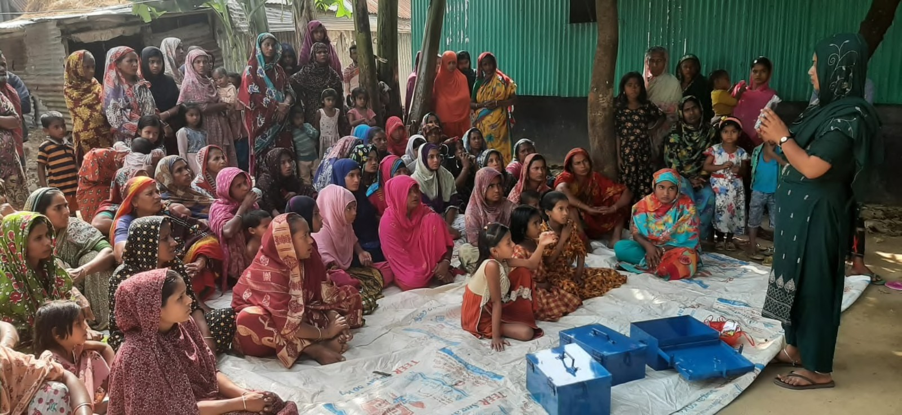

By implementing these recommendations, stakeholders can create a more supportive and enabling environment for LSPs, paving the way for their increased participation, growth, and success in the sector. It is through collective eﬀorts, collaboration, and targeted interventions that we can empower LSPs to become leaders and change-makers in business, contributing to sustainable development and inclusive economic growth.

### Program Sustainability

Sustainability is a crucial aspect of any successful program, and this program targeted at the LSPs program is no exception. To ensure the long-term impact and continued support for LSPs, it is essential to establish sustainability measures. These measures should focus on **building partnerships**, **securing funding**, and **fostering a strong alumni network**. By **nurturing collaborations with government agencies**, **non-governmental organisations**, **ﬁnancial institutions**, and **private sector stakeholders**, the program can tap into diverse resources and expertise. Seeking **sustainable funding mechanisms**, such as **establishing endowment funds** or **exploring social impact investment opportunities**, will provide ﬁnancial stability for the program's operations. Additionally, **developing a robust alumni network** will facilitate ongoing mentorship, knowledge exchange, and opportunities for continued growth and development.

* + 1. **Partnerships and Collaborations**: Establish partnerships with local organisations, government agencies, and private sector entities that share a common goal of empowering LSPs in the agricultural sector. Collaborate with these stakeholders to leverage resources, expertise, and networks, ensuring the program's long-term sustainability.
    2. **Institutional Integration:** Integrate the program into existing government programs or schemes to ensure continuity and alignment with broader strategies and policies. Seek endorsement and support from relevant governmental bodies, advocating for the inclusion of the program in their agendas.
    3. **Mentorship Network**: Develop a robust mentorship network by engaging successful entrepreneurs, industry experts, and alumni of the program. Encourage these mentors to provide ongoing guidance and support to current and future entrepreneurs, fostering a culture of mentorship within the program.
    4. **Alumni Engagement:** Establish an alumni network or support system to maintain a strong connection with the past LSPs. Organise regular events, workshops, and networking opportunities for alumni to share experiences, collaborate, and mentor new cohorts. Alumni can also serve as brand ambassadors, contributing to the program's sustainability through their continued involvement.
    5. **Capacity Building and Training:** Enhance the program's curriculum and training modules to meet evolving needs and emerging trends. Regularly assess the skills required by LSPs and tailor the program to address those needs eﬀectively.
    6. **Monitoring and Evaluation:** Implement a robust monitoring and evaluation framework to track the program's impact, identify areas for improvement, and ensure accountability. Regularly collect data on key performance indicators to measure the program's eﬀectiveness and inform decision-making for program enhancements.





* + 1. **Knowledge Sharing and Best Practices**: Disseminate program outcomes, success

stories, and best practices through various channels such as reports, case studies, workshops, and conferences. Share insights and lessons learned to inspire other organisations and stakeholders and encourage replication and adaptation of successful program elements.

* + 1. **Policy Advocacy:** Engage in advocacy eﬀorts to promote supportive policies and create an enabling environment for LSPs entrepreneurs in the agricultural sector. Collaborate with government agencies, policymakers, and advocacy groups to address gender-related barriers and advocate for gender-responsive policies, access to ﬁnance, and market opportunities.
    2. **Continuous Program Improvement:** Regularly assess the program's strengths, weaknesses, and impact through champion feedback, stakeholder consultations, and external evaluations. Use this information to make informed decisions, reﬁne program elements, and adapt to changing contexts and needs.

By incorporating these sustainability components, the Entrepreneurship development training & Coaching Program can be designed to thrive and continue making a lasting impact on the lives and businesses of LSPs in the rural sector.

## 5.0 Conclusion

The Entrepreneurship development training and Coaching initiative by Care Bangladesh through Kuza Biashara has been successful in equipping the LSPs with the necessary skills, knowledge, and support to thrive in the rural sector. The program's positive impact is evident in the improved business planning and increased empowerment of the LSPs. We express our gratitude to Care Bangladesh for their collaboration and support throughout the program.

The program has not only increased LSP’s understanding of business development and entrepreneurship but also **enhanced their leadership skills, self-conﬁdence, and overall empowerment**. These LSPs have emerged as inﬂuential leaders and role models within their communities, challenging gender norms and promoting inclusivity in the entrepreneurship ecosystem.

The program has **fostered networking and collaboration within the peers** and other partners creating a supportive ecosystem for the LSPs. The strengthened connections, partnerships, and knowledge-sharing opportunities have contributed to their improved business performance, increased productivity, and sustainable growth.

Moreover, the program has played a vital role in raising awareness and promoting gender equality in the LSP entrepreneurship ecosystem. By empowering the LSPs, especially women LSPs and showcasing their success stories, the program has highlighted the immense potential and contributions of these entrepreneurs in business..

As we reﬂect on the achievements and impact of the program, it's clear that the 450 LSPs have not only improved individual lives but also have the potential to bring positive changes within communities as a whole. The program's success stories, testimonials, and key insights highlight the importance of investing in the rural businesses of the LSPs and the signiﬁcant potential they hold.

Moving forward, it is essential to sustain and expand initiatives like this, ensuring continuous support, mentorship, and networking opportunities for these LSPs. By doing so, we can unlock their full potential, drive economic growth, and foster gender equality.

## 6.0 Acknowledgements

We would like to extend our heartfelt gratitude and appreciation to Care Bangladesh and other Implementing Partners (ESDO, POPI, MJSKS, DAM, SKS) for their unwavering support and encouragement throughout the journey of the LSPs. Your commitment to empowering entrepreneurs and fostering an entrepreneurial ecosystem has been instrumental in our success.

The success stories and remarkable progress achieved by the LSPs serve as a testament to the program's eﬀectiveness and its profound impact on their lives and communities. Our heartfelt gratitude goes to all LSPs, mentors, and partners for their unwavering dedication and collaboration throughout this transformative journey.

We express our sincere thanks to CARE Bangladesh for their guidance and expertise in implementing the program eﬀectively. Our heartfelt gratitude goes to Marc Nosbach, CoP of SHOUHARDO III+, for his overall leadership and guidance, as well as to Abdul Mannan Mazumder for strategic planning and guidance. We also deeply appreciate the support from Raﬁqul Islam, Mahfuz Ashraf, Hedyatul Islam, Khaledul Ahsan, Syeda Ashraﬁz Zaharia Prodhan, Zinat Ara Afroze, and Eyasin Ali Sarker in successfully implementing the program. Additionally, we extend special thanks to Sazzad Hossain, Ratan Debanth, Parvin Akhter, Zubaidur Rahman, and George Nokrek for their administrative and logistical support. Your valuable resources, guidance, and technical assistance have equipped us with the necessary knowledge and skills to thrive in the agricultural sector. Your continuous support has truly been a catalyst for our growth.

We extend our heartfelt gratitude to USAID for their steadfast support and funding for programs like SHOUHARDO , which aim to empower rural communities in Bangladesh. Through their commitment, USAID has played a pivotal role in fostering entrepreneurship and creating opportunities for individuals in marginalized communities. By enabling initiatives like SHOUHARDO to train and mobilize entrepreneurs as agents for last-mile service delivery, USAID has directly impacted the lives of 168,521 poor and extreme poor (PEP) households. Their partnership underscores a shared vision for sustainable development and poverty alleviation, empowering communities to build brighter futures for themselves and their families.

Lastly, we extend our deepest appreciation to all the LSPs, for their unwavering support and dedication to the program, the farmers, FFs and our staﬀ members. Their hard work, passion, and resilience have been the driving force behind our progress. We are honoured to be part of a community that values collaboration, innovation, and sustainable agriculture.

As we continue on this path of LSP empowerment, we remain grateful for the ongoing support and encouragement from Care Bangladesh. Your commitment to empowering entrepreneurs is making a signiﬁcant diﬀerence in the lives of individuals and communities. Together, we are shaping a more prosperous and sustainable future. We look forward to continued partnership and future opportunities to empower the rural LSPs.

## 7.0 Annexure I: Stories of Impact

With the support provided to the LSPs by the Kuza Dedicated Coaches, peer to peer learnings and the exposure they have received by participating in some of the events like the Orientation, Group Mentorship Sessions and other events conducted by CARE & the Implementing Partners, there is a noticeable change in their mind set and their perspective towards opportunities in their respective sector. Although it's still very early days, here are a few lived stories of change of LSPs.

**Mofazzal Hossen, Vaccinator, Jamalpur**

Mofazzal Hossen is an energetic individual deeply engaged in the livestock sector. As a veterinary doctor, he not only provides essential treatment but also specializes in artiﬁcial insemination. Beyond his professional duties, Mofazzal actively tends to a diverse array of animals including cows, ducks, poultry, and

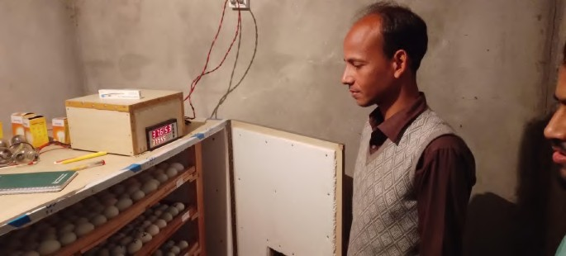ﬁsh.

Seeking to diversify his business ventures, Mofazzal recently embarked on a new endeavor by establishing a manual duck, poultry, and koel bird hatchery. With his resourcefulness and some assistance from existing hatcheries and online resources like YouTube, he transformed his traditional

hatching methods into a modern operation. Despite facing challenges like load shedding and the need for greater publicity, Mofazzal is tirelessly promoting his hatchery through various channels, including LSPs WhatsApp groups. With a capacity to hatch 2000 eggs, Mofazzal's hatchery now produces nearly 1000 ducklings, chickens, and koels each week, boasting an impressive survival rate of 70 percent. Remarkably, he accomplished this feat with an establishment cost of only 50,000 taka, demonstrating his resourcefulness and determination.

In addition to his hatchery, Mofazzal manages a sizable cowshed with a capacity for 20 cows, although he currently has only four. Specializing in cattle fattening, he strategically buys bulls three months before Eid-ul-Adha and sells them at qurbani hats, showcasing his keen business acumen. Looking to the future, Mofazzal aspires to establish a veterinary shop, with plans already in place for its location. Inspired by the SHOUHARDO Leadership Academy sessions, and the learnings from his experiences, Mofazzal is driven by the belief that he is destined for greater success. With his dedication, innovative spirit, and determination, Mofazzal is well on his way to realizing his dreams and leaving a lasting impact in the world of entrepreneurship.

### Akbor Ali, Vaccinator, Gaibandha

Mr. Akbor Ali is a highly respected ﬁgure in the Gazaria Union of Fulchari Upazila, known for his extraordinary contributions to the community. Initially trained as a village doctor after completing his secondary education in 2001, Ali's journey into entrepreneurship began when his father enrolled him in a paramedical college. In 2006, alongside his medical practice, he ventured into agribusiness, starting with the sale of fertilizers, pesticides, and seeds. Over time, Ali expanded his enterprise, seizing opportunities for growth and learning along the way.

In 2006, Ali's path took a new turn when he discovered a training program on vaccination and livestock diseases organized by the Rural Development Academy (RDA). Eager to broaden his skill set, he completed the training and became a certiﬁed vaccinator. Subsequently, he pursued further education, undertaking a course on artiﬁcial insemination at Bangladesh Agricultural University. Armed with expertise in both human and veterinary health, Ali established himself as a trusted provider of medical and agricultural services in his community.

Ali meticulously maintains his records to ensure transparency and accountability in his business dealings. With over 150 regular customers relying on him for agricultural inputs, he has become an integral part of the local farming ecosystem. Actively using his tablet and Agribytes videos, Ali engages with his clientele, sharing valuable insights and knowledge to empower fellow farmers.

Looking ahead, Ali has ambitious plans for expansion. Currently managing a substantial livestock inventory of 86 cows and 51 goats, he envisions establishing a large-scale livestock farm. Additionally, in partnership with his friends, he is involved in a thriving ﬁsh farming venture in Jamalpur district.

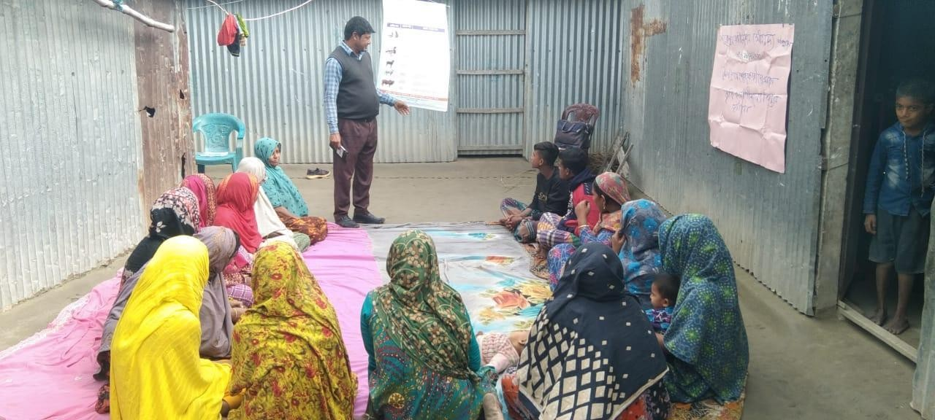

Akbor Ali is providing knowledge on cattle disease

### Mizanur Rahman, Vaccinator, Entrepreneur, Kurigram

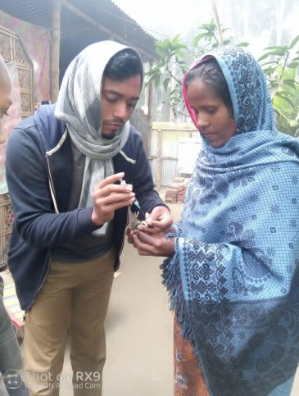Mizanur Rahman, a resident of Bepari Para, Char Rajibpur, is an entrepreneur with a diverse range of business ventures. From selling sanitary latrine products to dealing in masalas, fruits, and ﬁsh from his aquaculture ponds, Mizanur's entrepreneurial journey began in 2020. With determination and hard work, he built his sanitary products by hand and now sells an average of 20 sanitary slabs, 20 cement chimneys, and 30 pillars each month,

earning a commendable income of 20,000 taka. Inspired by the Leadership Academy, Mizanur has expanded his horizons and ventured into new business opportunities. Recently, he decided to establish a veterinary medicine and feed shop in his village, renting a room in the local bazaar for this purpose. To promote his new venture, Mizanur regularly organizes vaccination camps and informs villagers about his initiative, inviting them to participate.

Mizanur is eager to undergo training in order to enhance his skills and knowledge in the ﬁeld of livestock treatment and artiﬁcial insemination. He believes that this additional expertise will not only make him skillful in the sector but also unlock signiﬁcant income

opportunities. With his proactive approach and determination to succeed, Mizanur exempliﬁes the spirit of entrepreneurship and resilience, inspiring others in his community to pursue their dreams.

### Moushumi Khatun, Vaccinator, Sirajganj

Moushumi Khatun, a vaccinator from Chauhali Upazila in Sirajganj District. She deals with providing vaccination services in her community by visiting farmers as well as also providing them free consultation on some of the animal diseases. With a little awareness of the other areas of expansion, she always thought of doing more.

This is when she got into the Leadership academy contents on business and Agribytes for farming related content. Through those 15 business related sessions and the Agribytes sessions, Moushumi decided to start a Poultry farm. With the support of FFs and Kuza

Dedicated Coach, she took the ﬁrst step and established her own chicken farm, starting with 28 turkeys and chickens.

In the journey she gathered more learnings on animal care and productivity. Currently she not only sells eggs and chicken but also encourages others in the community to visit and learn to start a similar business. She aims to take the business to the next level in upcoming months by adding more chickens and turkeys.

### Md. Sirajul Hossain, Vaccinator, Gaibandha

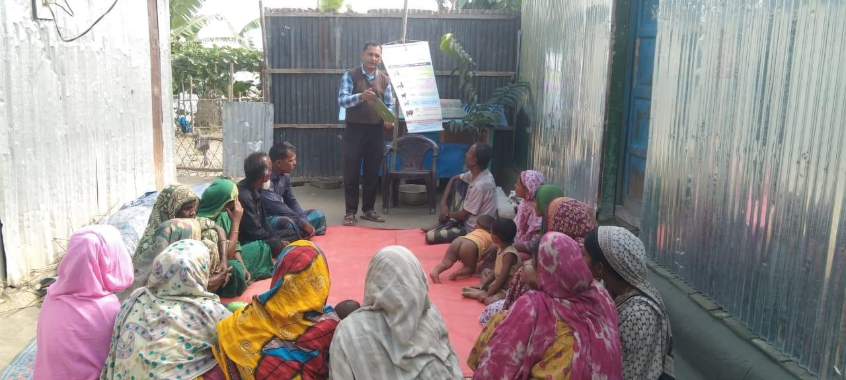Md. Sirajul Hossain, a vaccinator from Gaibandha district started his journey in early 2009, when he got associated with a government project to eradicate avian inﬂuenza. His involvement and interaction with the farmers encouraged him to become a livestock vaccinator, which he started in 2013. Later in 2018, he became a program participant under the

SHOUHARDO Program and received advanced training in livestock management from the Department of Agriculture and Livestock.

Today, on a day-to-day basis he visits at least 7-8 farms for vaccination, in addition to this he also conducts farmer training on vaccination and disease prevention in his community. After joining the Leadership academy he experienced an improvement in his training through the knowledge and the video resources.

As a next step now he plans to start his own veterinary shop in his locality to scale the business. He also wants to strengthen his hold in the community through conducting more training sessions and bringing awareness in the livestock community on best animal care practices.

### Babul Ahmed, Entrepreneur, Rajarhat, Kurigram

Babul Ahmed is a dedicated entrepreneur from Rajarhat Upazila in Kurigram district. He's been running online services and a photocopy shop for about twelve years. He has been involved with CARE Bangladesh initiatives for the past three to four years, and due to his leadership skills and an attitude of learning, he was selected as a Model LSP for the SHOUHARDO Leadership development program.

After actively participating in sessions at the SHOUHARDO Leadership Academy, he started discussing possible business opportunities in his locality and started understanding the market demands. In February, Babul identiﬁed a demand for items like chairs, tables, microphones, plates, bowls, and tents for the events in his area. With this understanding, he formulated a plan to provide these items on rent for various events, with a focus on stage decorations as well. To start this new business, Babul rented another shop alongside his current one. He's currently ﬁxing up and decorating this new space to get ready for his new business. Though starting a new business isn't easy, Babul needs about four lakh taka to start, and he only has half of that saved up. To get the rest, he's applied for a loan from a local NGO to help him kickstart his new journey and he is hopeful to start this business in the near future.

### Md Helal Mia, Vaccinator, Netrokona

Md Helal Mia is one of the LSP- Vaccinators from the Haor region of Netrokona. His journey began when after his training he decided to vaccinate the animals in his village to prevent "Khora Rog," or cow diseases. And this developed a strong bond between his farmers.

"One of the most important things I learned from the sessions is to look back on what I've done before and compare it to what I'm doing now. By doing this, I can always make sure I'm on the right track and ready for whatever comes my way. Managing My Cash Flow & Credit” session helped me to understand the need of tracking my income and expenses to understand I am in proﬁt or loss." This not only improved his understanding of cash ﬂow but also gave him discipline to start savings. He started saving a part of his income to utilise for his new venture.

Meanwhile, he identiﬁed the need for a pharmacy in his community. So, after saving a certain amount, he transformed a section of his house into a shop to sell vaccines for animals as well as medicines for humans. After realising the potential to expand this business he is now applying for a loan from a nearby bank to set up his pharmacy in the local market.

Through this new initiative Helal Mia is hopeful to attract more customers and make a steady income from this business.

### Mijan, Entrepreneur, Netrakona

Mijan is a 20-year-old collector in the Haor region, lives in a remote village in Gazipur, Khaliajuri upazila. After passing class 8, he started doing some odd jobs. Then he was introduced to the SHOUHARDO program and started as an LSP-Collector.

Due to his commitment and potential he was selected to be a part of the SHOUHARDO Leadership Program. His learning journey began with understanding basic concepts of business. During these sessions he realised that if he moves his shop to the local market yard he can get more customers. He then relocated his shop which gave him a signiﬁcant reach to a larger customer base as well as more income. With time, his daily earnings saw a signiﬁcant boost, from 400-500 Tk to around 600-700 Tk.

Mijan, now started selling ﬁsh in the weekly market as well which is operated 2 days a week. Looking ahead, he aims to expand his reach to two additional markets nearby. The program not only helped him in his business understanding but also gave him conﬁdence to think big.

### Md Amin, Vaccinator, Sunamganj

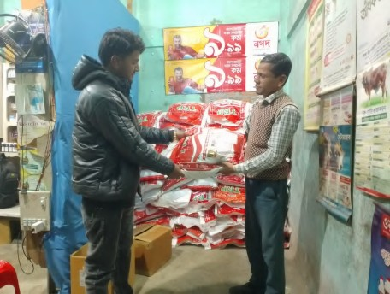Md. Amin, a dedicated vaccinator hailing from Sunamganj, is one of the very active model LSPs in the community. He has always been driven by exploring new business opportunities. It has also seen during the mentorship sessions where he brings diverse insights into the discussions shows his capacity to scale business.

Already running a successful pharmacy in Bangla Bazar, Md. Amin identiﬁed a gap in the market for cattle feed. After realising a clear market demand he reached out to ACI

Company and procured quality feeds. Within a mere 15 days, he managed to sell 10 sacks, each fetching Tk 750 making a proﬁt of Tk 140 on each bag sold.

The story of Md Amin highlights the importance of identifying market gaps to start any business as well as taking quick actions. When he shared his story in the GSM it also encouraged other LSPs and made him an example for others.

### Md Azhar Ali, Entrepreneur, Kurigram

Md Azhar Ali, an entrepreneur from Kurigram, used to deal with seed selling. Last season, his seed-selling business faced setbacks, forcing him to close his shop. This was the time when he became a part of this program. Although he failed in his earlier business, he was looking for some opportunities to get started.

During this period he interacted with a lot of farmers and understood a clear need among local farmers during the "Boro season," he planned a new business idea—to oﬀer irrigation services to address their challenges.

With this plan he secured permission from the electricity oﬃce to install an irrigation pump and launched his new venture, providing essential watering services to the farmers in his locality. And in the ﬁrst season itself he irrigated ﬁfty bighas of land which gave him conﬁdence on building a business on this idea.

Excited by the success of the ﬁrst season, for the upcoming season he aims to double the impact and irrigate hundred bighas of land. He also shared that with the money he is making from this, he will restart his old business to oﬀer a range of products to the same farmer base.

### Sujon, Seed Agent, Jamalpur

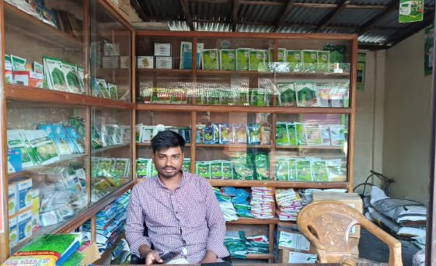Sujon is a seed agent from Sadhur Para in BakshiGanj, Jamalpur. He supports his family's agricultural activities alongside his seed business. As a seed agent, he manages the procurement and sale of seeds, fertilizers, and pesticides sourced from various dealers representing diﬀerent companies. The knowledge gained from his participation in the Kuza Academy has signiﬁcantly impacted Sujon's strategic approach to business growth.

After learning from the “Understanding your market” session, he recognized the seasonal variations in seed demand compared to the consistent need for fertilizers, Sujon identiﬁed an opportunity to capitalize on this market trend. He now plans to invest in storing larger quantities of manure and undergo specialized training for its preparation and storage. To make the most of the space in his shop, Sujon intends to stock a diverse range of fertilizers highly in demand by the local farmers. He has already begun the process of securing the necessary investments to expand his business. As Sujon prepares to embark on this new phase of growth and innovation, he serves as an inspiration to budding entrepreneurs in BakshiGanj and beyond.

### Mukul, Kurigram

Mukul, a dedicated resident of Char Rajibpur in Kurigram, has been serving his community as a vaccinator for over a decade. After joining the SHOUHARDO Leadership program, he discovered a wide range of knowledge on several value chains through the educational videos of Kuza Agribytes.

After going through these videos, Mukul

started a new journey this year by planting maize on approximately two acres of land. However, his maize ﬁeld fell prey to insects of Stem Borer soon after planting.

From the tips he learned from Kuza Agribytes, Mukul acted quickly to deal with the problem in his maize ﬁeld and followed the recommended process. Due to which he successfully tackled the issue and saw good results in his crop. Feeling encouraged by the success, Mukul is now thinking about expanding his business. With the money he earned from his maize farming, he wants to grow his entrepreneurial ventures even more, aiming for more diversity and growth.

.

As Mukul plans his next steps, he serves as a role model for the other LSPs, motivating his community to chase their dreams and reach their goals. With his dedication to excellence, Mukul achieves success in the farming community of Char Rajibpur.

### Raju, Vaccinator, Jamalpur

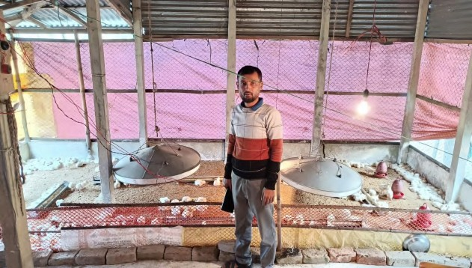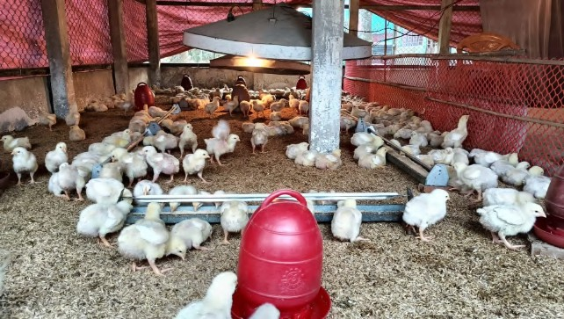

Raju is a vaccinator from Panchbaria, Islampur in Jamalpur district. He is primarily engaged in animal treatment and artiﬁcial insemination (AI) services as well as cultivating land belonging to his family.

In 2020, Raju ventured into chicken farming and the Mobile Banking(Bkash)business. However, the COVID-19 pandemic negatively impacted his ventures, leading to their eventual closure. Despite these challenges, Raju found renewed determination and mental strength after joining the SHOUHARDO Leadership Academy and interacting with other fellow LSPs. . He decided to restart his chicken farm and, in Jan 2024, he started a new farm with 500 broiler chickens. After a month of nurturing, he successfully sold the chickens and earned an approximate proﬁt of 25,000 taka. This advancement gave him more conﬁdence to expand his business.

Moving forward, Raju plans to raise another 500 chickens on his farm this month. He is also exploring the possibility of establishing a cow farm in the future. Despite past challenges, Raju maintains a positive outlook and is optimistic about the growth prospects of his agricultural enterprises.

### Forid Mia, Kishoreganj

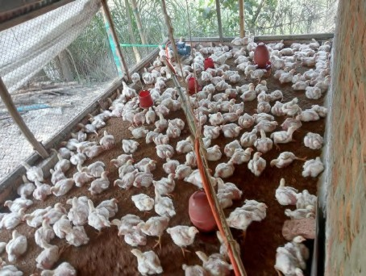Forid Mia, is a Model LSP of Austagram Sadar Union in Austagram Upazila operates as a seed agent in his community. Beside his seed business, he also

manages a successful grocery store, meeting the daily needs of his community

After completing sessions at the Leadership Academy, Forid Mia understood the need of business expansion. While going through several value chains in agribytes, the poultry farming caught his attention. To begin with, recently he started a poultry farm behind his seed shop, initially just with 100 chickens. His decision to venture into poultry

farming demonstrates his vision for the future and his determination to expand his business.

### Najmul Areﬁn, Vaccinator, Gaibandha

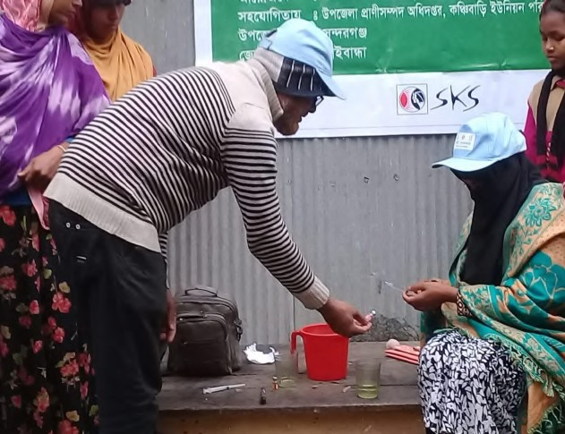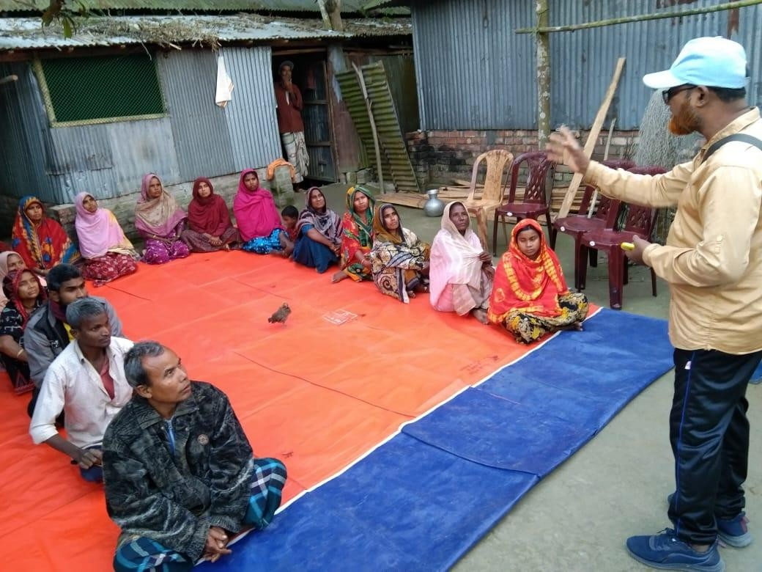

Najmul Areﬁn, a dedicated vaccinator from Gaibandha is very interested in promoting inclusive growth within his community. Recognizing the potential for positive change through empowerment, he has taken proactive steps to uplift the women of his community.

To improve the livelihoods of women in Kanchibari Union under Sundarganj Upazila, Najmul started training and capacity development programs using resources from SHOUHARDO Leadership Academy, including tablets and educational videos from Agribytes. He selected 26 interested female members from 11 villages and gave them thorough training on poultry vaccination, both for chickens and ducks.

Through this initiative, he not only brought awareness on the importance of vaccination for the poultry birds but also gave these women a new source of income. This shows his commitment towards community development as well as women empowerment.

### Razia, Entrepreneur, Sunamganj

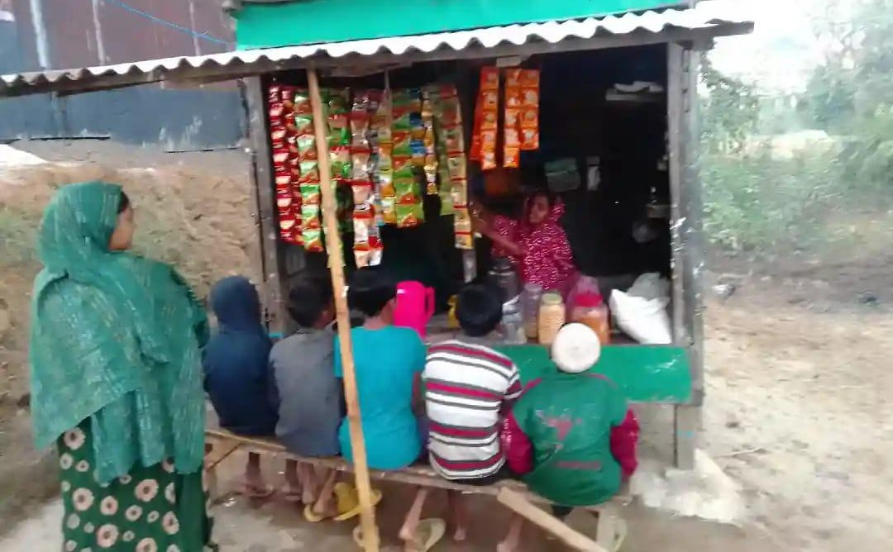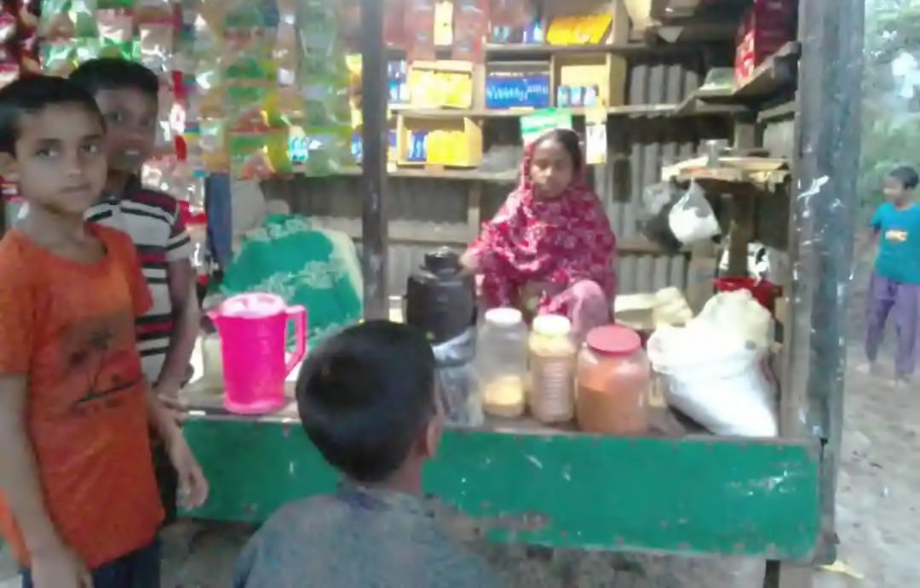

Razia is a true entrepreneur living in Binnerbondh, Tahirpur Upazila, Sunamganj district. Being a single parent she faced a lot of ﬁnancial constraints. She started as a vaccinator under the SHOUHARDO program but couldn’t make enough money to support the livelihood of her family. During one of the sessions in the Leadership academy program she shared her challenges with the Kuza DC and also discussed the pros and cons of starting a small grocery shop in her neighbourhood.

After a thorough discussion she decided to give it a try. Using the knowledge gained from the SHOUHARDO Leadership Academy, she found the conﬁdence to start small. She practically applied the knowledge she gathered from the session and tried to understand the demand of people. She carefully selected items that are popular with children and essential for her community. And recently started her grocery shop.

Razia's determination and courage inspire others. She shows that with hard work and support, even tough times can be overcome. With the right guidance, even in tough situations, entrepreneurship can ﬂourish, and make our dreams come true.

#### Soju Mia, Seed Agent, Netrakona

In the Haor area of Madan Upazila, Kadam Sree Union, Lsp Soju Mia began an incredible journey that changed his life and business. Soju Mia, initially known as a seasonal seed agent with a shop situated beside the market mosque, found inspiration from the SHOUHARDO III Plus Program and planning to expand his current business

*‘One day our PO, dedicated coach and one of my brothers Sona mia, who is another LSP of our union, visited my shop beside the Sokal Bazar Jame Mosque and suggested that I expand my business from which i could earn an extra proflt. The suggestion attracts me to start a hat and Arabic book perfume business that will run well in my shop because my shop is beside the ancient and historical mosque.’*

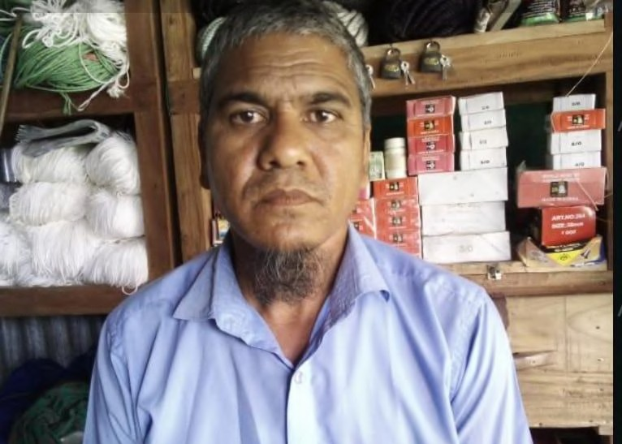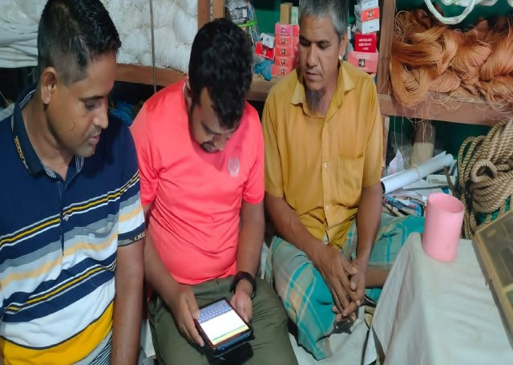

After becoming a part of this new initiative, Soju Mia eagerly attended the SHOUHARDO Leadership Academy. Inspired with the session knowledge, he used his dedicated coach’s guidance to diversify his shop into hats, attars, sifara, and Arabic books. He also made a business plan during GSM3 and reﬁned it through guidance from Kuza Dedicated Coach. Recently, he opened a bank account with Bank Asia and discussed a loan 30000- 50000 taka to kickstart his journey. Soju’s transformation from a seasonal seed agent to a visionary entrepreneur reﬂects the power of seizing opportunities, and utilising the resources of Leadership Academy.

### Pinku Sarkar, Vaccinator, Netrakona

Pinku Sarkar, a 24-year-old from Sadar Union, Khaliajuri Upazila, decided to spread his learnings after completing the

15 sessions of the SHOUHARDO Leadership Academy. He began his journey from being a local service provider to becoming a selective trainer in duck and chicken disease analysis, sharing his knowledge with local farmers. Additionally, he received payment for conducting these sessions from a local NGO. Recognizing his expertise and eﬀorts, he was selected to conduct 10 sessions in his union and would receive an allowance of BDT 6,500tk from the same local NGO.

Pinku joined the Leadership Academy seeking guidance and found immense value in the GSM sessions. He reﬂects, *“I beneflted a lot from SHOUHARDO Leadership Academy when I attended the GSM sessions. Taking insights from our dedicated coach at GSM, I am able to use them when I take the sessions myself. This improved my presentation skills, recognition of a trainer as well as my income, which is now slightly higher than before.”* With his knowledge and growing recognition, Pinku improved his service standards and communication with customers, which increased his income and customer engagement. This ﬁnancial stability helped him to explore new business opportunities. Today, he also inspires young entrepreneurs in Khaliajuri Upazila and creates positive change in their communities.

### Rehena Begum, Entrepreneur, Sirajganj

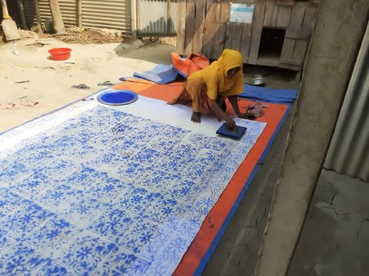Rehana, is a Sanchay Sathi from Sirajganj district under the SHOUHARDO Program

While deeply engaged in her Nakshikata sewing business, Rehana saw an opportunity for a new business. While going through the Leadership Academy sessions she thought—”why not start a small business selling custom-made clothing tailored speciﬁcally for Nakshikatha enthusiasts''

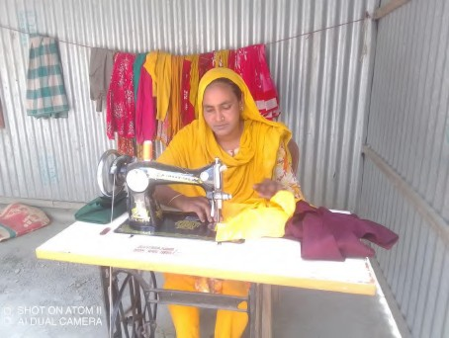Just through this simple idea she not only expanded her customer base but also added a new product line to engage the existing customers better.

With this newly expanded business horizon Rehana not only secured a source of income but also inspired many women around her in the locality. As the festive season is here, she is very hopeful to make a good business during this time

### Kamrul Hasan, Vaccinator, Sirajganj

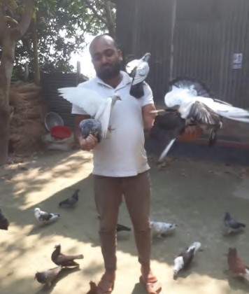Kamrul Hasan, a dedicated vaccinator lives in Rajapur, Belkuchi, is not only passionate about his profession but also has a deep love for rearing pigeons and rabbits. What began as a simple hobby has grown into a grand vision—a collective livestock farm where various animals coexist harmoniously under one roof.

Kamrul joined the SHOUHARDO Leadership Academy and was motivated to pursue his aspiration to expand his enterprise. In one of the sessions, he discovered the idea of SWOT analysis—a strategic tool used to identify strengths, weaknesses, opportunities, and threats in a business. Equipped with the knowledge gained from the sessions, Kamrul began applying SWOT analysis to his growing farming business With careful attention to detail, he evaluated the strengths of his diverse livestock, recognized potential weaknesses, identiﬁed opportunities for growth, and carefully considered potential threats.

Through the understanding he got from the exercise, he made some

strategic decisions in his farm and identiﬁed the tool as very helpful. He now aims to utilise the proﬁts earned from the existing business to start a new venture for which he is exploring potential business opportunities as well as trying to identify the customer’s challenges.

### Golam Mostofa, Seed Agent, Sirajganj

Golam Mostofa is from Datta Kandi, Omerpur, Chauhali, who sells seeds, transformed his small shop into a smart learning centre. When he became a part of this program he started enjoying the new learning process as well as got exposed to a wealth of knowledge.

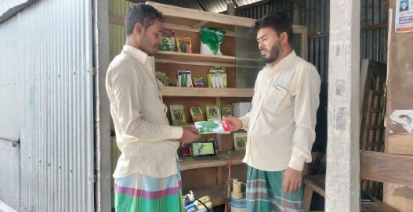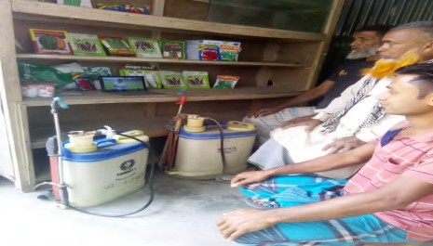

His shop, once a place of routine transactions, now transformed into a hub of knowledge. Golam used his tab not only to educate himself but also to share the information with his customers. As they discussed seeds and farming practices, Golam brings out his tab and shows the videos in agribyte. Through this new initiative Golam is now able to engage his customers better. This not only increased his sales but also helped the farmers in adopting new technology and best practices. He is now not only a seller but also a source of information for many farmers. Through his eﬀorts and dedication, Golam not only revolutionized his seed-selling business but also brought changes within his community. The learning of the SHOUHARDO Leadership Academy inspires others to embrace the innovation for sustainable agricultural practices.

### Jasimuddin, Vaccinator, Sirajganj

Jasimuddin, is a 24-year-old from Chauhali Upazila in Sirajganj. Despite being a student pursuing his Honors degree, Jasimuddin has already made a name for himself as a dedicated vaccinator. His journey in vaccination began with a course on AI at Patuakhali University of Science and Technology, where he learnt this to serve his community and secure a source of income for him. Keen on expanding his knowledge, Jasimuddin explored courses oﬀered by the youth development department, further enhancing his expertise. In Oct’23, he joined the SHOUHARDO Leadership program as a vaccinator & participated actively in all the activities.

This was the time while going through several available resources in agribytes, Jasimuddin came across a video on Quick Compost Preparation, sparking a new interest in producing compost fertilizer. After watching the videos he has done a small pilot in his backyard on compost making. With the successful execution of the pilot now he is planning to take some ﬁnancial assistance from banks to launch his full ﬂedged compost production operations. He is already in touch with the IP and the Kuza DC seeking help to secure a loan to start this new business. Jasimuddin's story shows how education and curiosity can open new paths.

## Annexure II: BNL Meetings

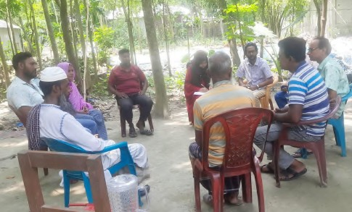The 8 Business Network who ﬁnished their 1st meeting:

**Khas Kaulia Business Network, Sirajganj Date:** 15th May 2024

**Network Name:** Khas Kaulia Business Network

**BNL Names:** Monirul Islam

**Number of Participants:** 7 (all males), 6 were present

**Participants:** BNLs, PO, 2 FFs, DC

##### Background

* + 1. Nipun and Bonhi attended the ﬁrst Business Network meeting in Chouhali Upazila, Sirajganj. Two BNL meetings were scheduled on the same day for convenience due to distance and transportation issues.
    2. BNL Monirul Islam along with their FF, Masud Bhai, coordinated the meetings.
    3. Upon arrival, the DCs found Monirul occupied with his shop and many customers. He mentioned that managing time for such meetings is challenging due to his busy shop schedule but assured his commitment to building his network. They reached the venue by 10 am, although the meeting was scheduled for 10:30 am; however, it commenced at

11 am and concluded around 1 pm. The PO of Chouhali joined in the meeting. The meeting was held at the house of a non-model LSP, with a total of 7 LSPs in the union, 6 of whom were present.

##### Session Overview

1. **Attendance:** One LSP was absent due to being in another union with his products. Another LSP joined late due to work commitments.
2. **Opening Remarks:** The PO delivered a short speech, followed by introductions from Nipun Bhai, myself, and all participants.
3. **Business Networking Discussion:** We discussed the concept of business networking, the formation of the committee, and the responsibilities of members, using key points from the orientation PPT. Monirul Bhai explained the process, with support from Nipun Bhai and me.
4. **Feedback Session:** One LSP initially likened the network to a "Shomobay Somiti (Co-operative Association)." We clariﬁed the business networking concept, highlighting beneﬁts such as business expansion, nationwide product sales, community beneﬁts, and stronger bonds.
5. Concerns about increased competition were addressed by Monirul Bhai, with our support, emphasizing the network's overall advantages.

##### Key Insight

1. One LSP mentioned that it sounded like a kind of "Shomobay Somiti (Co-operative Association)." Monirul, Nipun, and Bonhi then clariﬁed the concept of business networking again with examples. Once the LSPs understood this, they expressed interest, noting





positive aspects such as business expansion, nationwide product sales, community

beneﬁts, and stronger bonds.

1. One LSP raised a concern about increased competition from shared knowledge, but Monirul, with support from Nipun and Bonhi, explained the network's other beneﬁts.
2. Time constraints were highlighted as a signiﬁcant challenge, with coordinating schedules proving diﬃcult due to conﬂicting commitments.
3. One LSP suggested avoiding market days and proposed evening meetings as a potential solution to better accommodate everyone's availability.
4. After discussing the matter, Nipun and Bonhi encouraged the participants to choose their vice-president and treasurer. It took some deliberation, but they eventually made their selections. Since there were no other Model LSPs, these positions were ﬁlled from the non-model LSPs.

##### Challenges:

1. A few LSPs appeared inattentive during the leadership session, likely due to the late timing.

##### Action Items:

1. Each member committed to adding at least one new member to their network.
2. They agreed to start collecting funds from the following meeting.
3. From the next meeting onwards, they decided to take responsibility for note-taking themselves, instead of relying on the FF.
4. They planned to discuss a new business idea in the next meeting.

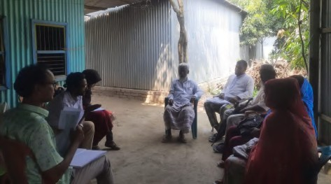**Bagutia Business Network, Sirajganj Date:** 15th May 2024

**Network Name:** Bagutia Business Network

**BNL Name:** Not speciﬁed

##### No. of Participants: 5

**Participants:** BNL, Non-Model LSP, FF, Kuza DC

##### Background:

The meeting took place in Char Salimabad, Bagutia Union. There were discrepancies in the attendance as only three LSPs were initially present, with two more anticipated to join later. The PO was absent from this meeting.

##### Session Overview:

**Introductions and Opening Remarks:** Participants introduced themselves, and BNL Mousumi apa delivered a short speech on BNL and her role, with Nipun providing additional explanation to support her.

1. **Network Building:** The main discussion revolved around building and operating the network, including the selection process for the vice-president and treasurer. The DCs elaborated on the roles of BNL, vice-president, and treasurer.





1. **Understanding each other:** The members then utilised the time for introducing each

other and their works as well as aspirations like one of the LSPs shared his interest for starting a poultry incubation.

1. **Financial Transparency:** Discussed monthly expenses, allocation of funds, and maintaining ﬁnancial transparency.
2. **Future Engagements:** Discussed involving other members as well as adding new members who can add value to the network.

##### Key Insights

1. The primary focus was on building and operating the network. Participants engaged in discussions regarding the selection process for the vice-president and treasurer.
2. Participants engaged in discussions regarding the formation and operation of the network, emphasizing the importance of selecting suitable candidates for key positions such as the vice-president and treasurer.
3. Abu Salam, a non-model LSP and a vaccinator, proposed a business idea to start a poultry incubation commercially, emphasizing its potential for the upazila.
4. Due to lack of clarity on the member list the election of Vice President and Treasurer kept hold until the next meeting.
5. The crucial discussions on the bylaws including the membership fee, frequency of meeting, etc also planned to be discussed in the next meeting.

##### Challenges Faced:

1. There was confusion surrounding the accuracy of the business network list, with both the PO and FF unsure about its completeness.

##### Action Items:

1. The participants committed to arranging the next meeting as soon as possible, with the selection of the vice-president and treasurer scheduled for discussion.
2. The issue regarding the accuracy of the business network list needs to be addressed and resolved through discussion.

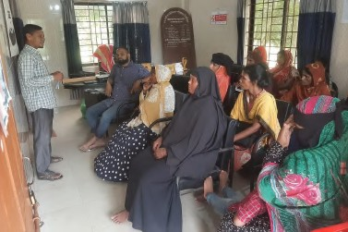**Lakshmipur Business Network, Sunamganj Date:** 18th May 2024

**Network Name:** Lakshmipur Business Network

**BNL Name:** Md Amin

**No. of Participants:** 19 (including 17 Female)

**Participants:** BNL, Model & Non-model LSP, FF, Kuza DC

##### Session Overview:

1. The meeting, arranged by BNL Md Amin, commenced at 4:00 p.m. at the Lakshmipur Union Parishad, following a brief delay due to inclement weather.





1. Despite his concurrent responsibilities at a vaccination center and a pharmacy, BNL Md

Amin diligently guided the session, expounding on the essence of the BNL network to the assembled LSPs.

1. Of the 21 registered LSPs, 19 were present, with two individuals unavailable due to illness and prior commitments.
2. The session kicked oﬀ with a discussion on the network's Bylaws, during which Anup provided assistance to BNL Md Amin, ensuring clarity and comprehension among the LSPs.
3. Subsequently, the positive implications of the network were elucidated, illustrating potential opportunities for nationwide product distribution, business expansion, and enhanced knowledge-sharing.
4. Female participants highlighted transportation challenges, suggesting convening meetings within close proximity to adjacent villages.
5. The decision was made to reconvene at the month's end for further discussions.

##### Key Insights:

1. A unanimous commitment was demonstrated towards forming a robust business ecosystem within the Lakshmipur Business Network.
2. The election of a vice-president and treasurer underscored collective dedication to the network's governance.
3. All new members adhering to regular participation and network rules were warmly welcomed.
4. Consensus was reached to deposit 50 taka monthly into the fund, under BNL Md Amin's guidance.
5. The viewing of the "Mind Set Matters" video from the Leadership Academy session generated considerable interest among non-model LSPs.

##### Challenges:

1. Female participants emphasized challenges related to transportation, suggesting a need for more accessible meeting venues to accommodate attendees from neighboring villages.

##### Action Items:

1. Organize future meetings in locations easily accessible to participants from nearby villages to mitigate transportation challenges.
2. Implement the agreed-upon monthly contribution of 50 taka per member to the network fund to ensure sustainable ﬁnancial support for network activities.

##### Bolloverkash Satota Business Network, Kurigram Date: 21/05/2024

**Network Name:** Bolloverkash Satota Business Network

**BNL Name:** Al Amin

**Number of Participants:** 28 (including 6 females)





**Participants:** BNL, 3 Model LSPs, Non-Model LSP, PO, FF, Kuza DC, Union Parishad Chairman

##### Background

1. The agenda for the meeting was discussed in advance with FF and BNL.
2. Initial discussions on various aspects of the network were held by BNL with some LSPs.
3. FF and BNL briefed other LSPs about the business network through face-to-face meetings and phone calls prior to the meeting.

##### Session Overview

1. **Welcome and Introduction:** PO Taleb Bhai welcomed everyone with an introductory session.
2. **Importance of Networking:** Discussed the beneﬁts of networking for LSPs, including business growth and community impact.
3. **Bylaws Discussion:** Covered roles of the president, vice-president, and treasurer, terms of oﬃce, code of conduct, conﬂict resolution, and ﬁnancial management.
4. **Financial Transparency:** Discussed monthly expenses, allocation of funds, and maintaining ﬁnancial transparency.
5. **Future Engagements:** Discussed involving representatives from various companies in future meetings.
6. **Kuza Leadership Academy Session:** Discussed the ﬁrst session on "Mindset Matters," including types of mindsets and how to change them, presented by model LSPs.

##### Key Insights

1. Participants showed active interest and participation.
2. All members agreed to collect 100 taka per member monthly as a membership fee due to rising costs.
3. The meeting's logistical arrangements were good, held at the Union Parishad Hall.
4. Participants were attentive and recognized the meeting's importance.
5. Commitment to timely and spontaneous participation in future meetings.
6. Elections for the vice-president and treasurer were conducted: Model LSP Aminul Islam was elected as vice-president, and non-model LSP Ahila, a Sanchay-Sathi, was elected as treasurer.
7. Frequency of monthly meetings was discussed.
8. BNL and FF demonstrated sincere and well-planned meeting arrangements.
9. Discussions on inviting company representatives to future meetings were held.
10. Community engagement activities for the upcoming month were discussed and planned for the next meeting.
11. Members engaged well in the "Mindset Matters" section, with non-model LSPs excited about the new concept and multimedia learning method.

##### Challenges

1. The meeting was delayed due to late arrivals.





1. Diﬃculty in ensuring everyone could see and hear the Kuza Leadership Academy

sessions using a single device. Future meetings will form small groups with model LSPs to improve this.

##### Action Items

1. Some members will invite a BSP company to upcoming meetings.
2. All members will deposit their membership fees to the treasurer at the next meeting.
3. The next meeting is scheduled for 22/06/2024, considering the upcoming Eid.

##### Barovita Business Network, Kurigram Date: 23/05/2024

**Network Name:** Barovita Business Network

**BNL Name:** Ekramul

**Number of Participants:** 20 (including 3 females)

**Participants:** BNL, 3 Model LSPs, Non-Model LSP, PO, FF, DC, Union Parishad Chairman

##### Background

* 1. The agenda for the meeting was discussed in advance with FF and BNL.
  2. FF and BNL briefed other LSPs about the business network through face-to-face meetings and phone calls prior to the meeting.

##### Session Overview

1. **Welcome and Introduction:** PO Fajlul Bhai welcomed everyone with an introductory session.
2. **Importance of Networking:** Discussed the beneﬁts of networking for LSPs, including business growth and community impact.
3. **Bylaws Discussion:** Covered roles of the president, vice-president, and treasurer, terms of oﬃce, code of conduct, conﬂict resolution, and ﬁnancial management.
4. **Financial Transparency:** Discussed monthly expenses, allocation of funds, and maintaining ﬁnancial transparency.
5. **Future Engagements:** Discussed involving representatives from various companies in future meetings.

##### Key Insights

1. Participants showed active interest and participation.
2. All members agreed to collect 50 taka per member monthly as a membership fee.
3. The meeting's logistical arrangements were good, held at the Union Parishad Hall.
4. Participants were attentive and recognized the meeting's importance.
5. Commitment to timely and spontaneous participation in future meetings.





1. Elections for the vice-president and treasurer were conducted: Model LSP Monju from

Cohort 1 was elected as vice-president, and non-model LSP Rasheda, a Sanchay-Sathi, was elected as treasurer.

1. Frequency of monthly meetings was discussed.
2. BNL and FF demonstrated sincere and well-planned meeting arrangements.
3. Discussions on inviting company representatives to future meetings were held.
4. Community engagement activities for the upcoming month were discussed and planned for the next meeting.

##### Challenges

1. The meeting started late due to late arrivals.
2. The learning session of Kuza Academy could not be conducted due to time constraints.

##### Action Items

1. Some members will invite a BSP company to upcoming meetings.
2. All members will deposit their membership fees to the treasurer at the next meeting.
3. The next meeting is scheduled for 22/06/2024.

##### Bidhyanando Business Network, Kurigram Date: 23/05/2024

**Network Name:** Bidhyanando Smart Business Network

**BNL Name:** Md. Babul Ahmed

**Number of Participants:** 16 (including 5 females) **Participants:** BNL, 3 Model LSPs, Non-Model LSP, APM, PO, FF, DC, Union Parishad Member

##### Background

1. The agenda for the meeting was discussed in advance with FF and BNL.
2. Initial discussions on various aspects of the network were held by BNL with some LSPs.
3. FF and BNL briefed other LSPs about the business network through face-to-face meetings and phone calls prior to the meeting.

##### Session Overview

1. **Welcome and Introduction:** FF Mizanur welcomed everyone with an introductory session.
2. **Importance of Networking:** Discussed the beneﬁts of networking for LSPs, including business growth and community impact.
3. **Bylaws Discussion:** Covered roles of the president, vice-president, and treasurer, terms of oﬃce, code of conduct, conﬂict resolution, and ﬁnancial management.
4. **Financial Transparency:** Discussed monthly expenses, allocation of funds, and maintaining ﬁnancial transparency.





1. **Future Engagements:** Discussed involving representatives from various companies in

future meetings.

1. **Kuza Leadership Academy Session:** Discussed the ﬁrst session on "Mindset Matters," including types of mindsets and how to change them, presented by model LSPs and BNL.

##### Key Insights

1. Participants showed active interest and participation.
2. All members agreed to collect 50 taka per member monthly as a membership fee. It was discussed that any changes to the fee must be approved in a meeting.
3. The meeting's logistical arrangements were good, held in a room of the Union Parishad.
4. Participants were attentive and recognized the meeting's importance.
5. Commitment to spontaneous participation in future meetings.
6. Elections for the vice-president and treasurer were conducted: Model LSP Dipok from Cohort 1 was elected as vice-president, and non-model LSP Protima, a Sanchay-Sathi, was elected as treasurer.
7. Frequency of monthly meetings was discussed.
8. BNL and FF demonstrated sincere and well-planned meeting arrangements.
9. Discussions on inviting company representatives to future meetings were held.
10. Community engagement activities for the upcoming month were discussed and planned for the next meeting.
11. Members engaged well in the "Mindset Matters" section, with non-model LSPs excited about the new concept and multimedia learning method.

##### Challenges

1. Diﬃculty ensuring everyone could see and hear the Kuza Leadership Academy sessions using a single device. In future meetings small groups will be formed with model LSPs to improve this.

##### Action Items

1. Some members will invite a BSP company to upcoming meetings.
2. All members will deposit their membership fees to the treasurer at the next meeting.
3. The next meeting is scheduled for 23/06/2024.

##### Shimulbari Naodanga Business Network, Kurigram

**Date:** 25/05/2024

**Network Name:** Shimulbari Naodanga Business Network

**BNL Name:** Md. Jahid Mia

**Number of Participants:** 15 (including 2 females)





**Participants:** BNL, 6 Model LSPs, Non-Model LSP, PO, FF, DC. This network covers two unions,

so it includes model LSPs from both. One model LSP was absent due to a family illness.

##### Background

1. The meeting agenda was discussed in advance with FF and BNL.
2. FF and BNL provided an overview of the business network to other LSPs via phone calls before the meeting.

##### Session Overview

1. **Welcome and Introduction:** PO Fajlul Bhai opened the meeting with a welcome speech and introductory session.
2. **Importance of Networking:** Highlighted the advantages of networking for LSPs, including business growth and community impact.
3. **Bylaws Discussion:** Reviewed the roles of the president, vice-president, and treasurer, terms of oﬃce, code of conduct, conﬂict resolution processes, and ﬁnancial management.
4. **Financial Transparency:** Discussed how funds will be allocated and the importance of maintaining transparency in ﬁnancial transactions.
5. **Future Engagements:** Considered involving representatives from various companies in future meetings.

##### Key Insights

1. Participants were highly engaged and actively contributed to the discussions.
2. It was unanimously agreed that each member would contribute 100 taka monthly as a membership fee.
3. The logistical arrangements were excellent, with the meeting held at the local Government Primary School.
4. Attendees were attentive and acknowledged the signiﬁcance of the meeting.
5. There was a commitment to punctual and spontaneous participation in future meetings.
6. Elections were held for the positions of vice-president and treasurer: Model LSP Hamidul from Cohort 1 was elected as vice-president, and Non-Model LSP Tahmina, a Sanchay-Sathi, was elected as treasurer.
7. The frequency of monthly meetings was discussed.
8. BNL and FF organized the meeting meticulously and sincerely.
9. The possibility of inviting company representatives to future meetings was discussed.
10. While community engagement activities were not planned for the upcoming month, there was a consensus to develop these plans in the next meeting.
11. Members pledged to expand the network by bringing one new member each to the next meeting.

##### Challenges

1. The meeting started late due to late arrivals.
2. Due to time constraints and extreme heat, it was not possible to conduct a session of the Kuza Leadership Academy. However, there were verbal discussions on the topics.





##### Action Items

1. Members will attempt to invite a BSP company to future meetings.
2. All members will submit their membership fees to the treasurer at the next meeting.
3. The next meeting is scheduled for 24/06/2024.

##### Kaligonj Smart Business Network, Kurigram Date: 25/05/2024

**Network Name:** Kaligonj Smart Business Network

**BNL Name:** Sree Sumon Kumar

**Number of Participants:** 26 (including 6 females). The union has a total of 34 LSPs. The 8 absent LSPs were busy with crop harvesting, and 2 were absent due to family issues. All model LSPs were present.

**Participants:** BNL, PO, 2 FF, DC

##### Background

1. The meeting agenda and timing were discussed in advance with BNL and FF.
2. BNL and FF briefed all participants on the agenda prior to the meeting.

##### Session Overview

1. **Opening Remarks:** BNL Sumon Kumar thanked everyone for their participation and introduced PO, DC, and 1 FF. He then invited the PO to speak.
2. **PO's Welcome Speech:** The PO welcomed everyone, described the programs arranged under SHOUHARDO III Plus activities, introduced the Kuza platform to non-model LSPs, and discussed the network's objectives.
3. **Business Network Session:** A session was conducted on the purpose and beneﬁts of the business network, emphasizing how it can strengthen LSP businesses and their contributions to the community.
4. **Oﬃcer Elections and Fees Discussion:** A detailed discussion was held to select the vice-president and treasurer, and to determine a monthly fee. The handling of collected funds was also discussed.
5. **Bylaws Discussion:** The roles of the president, vice-president, and treasurer were explained, along with other bylaws.
6. **Next Meeting Arrangements:** The date and agenda for the next meeting were ﬁxed, and the guest for the next meeting was decided.
7. **Leadership Academy Session:** BNL conducted a session on "Mindset Matters."

##### Key Insights

1. Participants were punctual, with 26 out of 34 present.
2. Participants showed a positive attitude towards the network.
3. There was a brief hesitation during the vice-president selection, but the issue was resolved amicably.





1. The treasurer was selected among the Sanchay Sathi.
2. Members agreed on a monthly fee of 100 taka.
3. The treasurer will remind members about the monthly fee via phone calls.
4. Participants agreed to recharge 30 taka on the treasurer’s phone for fee collection reminders.
5. Meetings will be held on the 25th of every month.
6. The next meeting will include an invitation to the Upazila Assistant Agriculture Oﬃcer (UAAO).
7. Participants were somewhat inattentive during the leadership session, as it was held past 1:30 PM.

##### Challenges

1. Two LSPs suggested a 50 taka monthly fee instead of 100 taka.
2. There was some confusion about how the collected money would be used.
3. A few LSPs appeared drowsy during the meeting.

##### Action Items

1. Members will invite the UAAO to the next meeting.
2. The next meeting is scheduled for 25/06/2024.





## Annexure III: Ecosystem Actor Meetup

# Jamalpur

May 19, 2024 at DTRC, Unnayan Sangha, Jamalpur

##### Participants:

**Private Companies:** Shohel Rana (MDO, A R Malik Seed), Abu Masud (AM, ACME-Veterinary), Ariful Islam (Sr. TSO, Brac Seed), Rashedur Rahaman (PO-MMS, SMC).

**Financial Institutions:** Rashikul Islam, DM, Agent Banking, Bank Asia.

**Government Oﬃcials:** Dr. Rasel Mahmud, Extension Oﬃcer, DLO.

**CARE:** Aslam Hossain Talukder, TM-SR.

**ESDO:** Md. Nazrul Islam (APM), Rabindra Nath Sarker (PO, Islampur), Md. Raihen Kabir Chowdhury (PO, Bakshiganj), 2 Field Facilitators (FF).

**Kuza:** Nahid Saleheen (DC, Jamalpur), Saad Muhammad (DC, Netrokona), Abdus Sobhan Nipun (DC, Sirajganj).

**Local Service Providers (LSPs):** Key individuals who work directly with farmers to provide agricultural inputs and services. 9 were present in the meeting.

##### Group Discussion:

Facilitated team exercises to recognize and address issues. The activity brought out many challenges faced by LSPs, helping them identify their next steps and potential assistance from govt and private companies.

##### Challenges Commonly Faced by LSPs:

* + 1. **Insuﬃcient Training Opportunities:** Many LSPs reported a need for more extensive and frequent training sessions to stay updated with best practices and emerging techniques.
    2. **Competition:** High competition among LSPs, especially in densely populated areas, poses a challenge for individual business growth.
    3. **Supply Chain Issues:** Delays in receiving essential supplies like vaccines, medicine, seeds, and pesticides, and high costs from private suppliers aﬀect the timely delivery of services.
    4. **Communication Gaps:** Eﬀective communication with local authorities (e.g., Upazila Livestock Oﬃcers) are often lacking, which can hinder the timely procurement of necessary materials and support.

##### Commitments and oﬀerings from various stakeholders:

1. **A R Malik Seed**
   1. **Supply products according to demand:** Provide the demanded amount if LSP informs at least one week in advance.
   2. **Credit Sales Support:** Provide 15-30 days of credit support for keeping a good relationship





* 1. **Product Returns:** Allow product returns for LSP with good relationships; establish

a medium(dealer) to manage product returns for expired seeds

* 1. **Mini-Pack Seeds:** Conﬁrm that high-priced hybrid vegetable seeds will be available in mini- packs upon agent requests
  2. **Farmer Assistance:** Oﬀer support at farmer meetings.

##### BRAC Seed

* 1. **Timely Product Delivery:** Ensure on-time delivery of products.
  2. **No Credit Sales:** Continue the policy of no credit sales to retailers.
  3. **Rural Training:** Provide rural training upon proper contact.
  4. **Quality Assurance:** Maintain the commitment to providing high-quality products.
  5. **Mini-Pack Seeds:** Continue the availability of seeds in mini-packs.
  6. **Skill Development Training:** Oﬀer skill development training if required by LSPs.

##### ACME Laboratories

* 1. **Conferences and Training:** Conduct conferences on dairy, poultry, and veterinary medicine, and provide treatment knowledge through ULO staﬀ
  2. **Vet Health Apps:** Promote the Vet Health Apps for comprehensive veterinary support, including disease solutions and prescription systems.
  3. **Expired Product Returns:** Manage the return of date-expired products from vaccinators.
  4. **Contact Information:** Distribute ACME representatives’ contact details for easy communication and support.

##### SMC (Social Marketing Company)

* 1. **Sanitation and Health:** Continue providing sanitation and child/women treatment services.
  2. **Monimix Sales:** Focus on the sale of Monimix for brain development in children, supported by USAID.
  3. **Vitamin and Mineral Demand Generation:** Fund activities to promote vitamins and minerals for children’s development.

##### Bank Asia

* 1. **Agricultural Loans:** Provide agricultural loans at Islampur and Bakshiganj with a maximum of BDT 50,000.
  2. **Documentation and Land Ownership:** Require clear documentation and land ownership for large loans.
  3. **Interest Rates:** Currently, loans are provided at 13.55% interest, the previous government oﬀering of 4% is no longer valid.
  4. **Loan Accessibility:** Ensure easy access to loans for cattle rearing, contingent on having existing property or cattle.
  5. **Group Loan Initiatives:** Facilitate loans for groups of 10-15 people based on collective property or agriculture-related assets.

##### Government Oﬃcials (Extension Oﬃcer DLO)

* 1. **Support for LSPs:** Recognize the role of LSPs in providing services at the union level.
  2. **Information Collection:** Collect comprehensive data on cattle, including pictures, for eﬀective monitoring and sales.
  3. **Vaccination Awareness:** Promote awareness about vaccination for cattle to prevent diseases like FMD and LSD.
  4. **Network Building:** Establish strong connections with ULOs and other oﬃcials to ensure the timely provision of vaccines and services.
  5. **Emergency Support:** Provide emergency support during pandemics and other crises.
  6. **Rural Meetings and Training:** Organize regular meetings and training sessions in rural areas to support farmers.

##### Reﬂections and learnings:

1. **Importance of Early Planning:** Eﬀective communication and early planning are essential for managing seasonal demand and ensuring timely delivery of products.
2. **Training and Capacity Building:** Continuous training and education for farmers and LSPs are essential for adopting best practices and new technologies.
3. **Strengthening Technology:** Integrating technology, such as digital tools and apps, can signiﬁcantly enhance service delivery and operational eﬃciency.
4. **Financial Support:** Accessible ﬁnancial services and clear documentation processes are vital for getting loans and supporting agricultural investments and growth.

##### Feedback:

1. Participants praised the support initiatives, such as ACME's Vet Health Apps and training programs, BRAC Seed's commitment to quality, and A R Malik’s supportive policies.
2. The introduction of mini-pack seeds by both A R Malik and BRAC Seed was well-received as it helps small farmers access high-quality seeds.
3. More proactive communication and seasonal product planning are needed to overcome the product unavailability challenge.
4. Enhanced support for product returns from the companies to streamline the process and improve LSP satisfaction.
5. Better access to ﬁnancial products and documentation process on loan requirements from Bank Asia.
6. More frequent and comprehensive rural training sessions to continually update farmers on best practices and help to build a stronger business network.

# Kurigram

May 19. 2024 at TDH, Kurigram

##### Participants:

**Private Companies:** Director (AFAD), PM (ESDO), ,

Representative (Ispahani Agro limited), Representative (AR Malik seed), Representative (Lal teer seed), Representative (Renata Animal health)

**Financial Institutions:** Assistant Branch Manager (NRBC Bank)

**Government Oﬃcials:** DD-AI, DD-DAE

**CARE:** Sushil, TM-SR.

**MJSKS:** Md. Mainul Islam (PM, MJSKS), Jibon (APM, MJSKS), 5 FFs (MJSKS), 4

POs, MEL oﬃcer

**Kuza:** Taushik Lahiri (DC, Kurigram & Gaibandha), Masud Rana (DC, Kurigram)

**Local Service Providers (LSPs):** Key individuals who work directly with farmers to provide agricultural inputs and services. 18 were present in the meeting.

##### Group Discussion :

Facilitated team exercises to recognize and address issues. The activity brought out many challenges faced by LSPs, helping them identify their next steps and potential assistance from govt and private companies.

##### Challenges Faced by LSPs:

**Challenges faced by Seed Agents:**

1. Production interruption due to weather.
2. Not getting the right seed at the right time.
3. High price of seeds.
4. Farmers are not getting the right price for their produce.
5. Money is not available if the product is given on credit.

##### Challenges faced by Vaccinators:

1. The problem of vaccine carriers.
2. Lack of training for marginal farmers.
3. Farmers are not getting the proper price of milk.
4. Chilling centre not available.
5. Poor communication system.

##### Challenges faced by Entrepreneur & Sanchay-Sathi:

1. Lack of capital.
2. Lack of support from government oﬃces and private oﬃces.
3. Lack of timely supply of goods.

##### Commitments and oﬀerings from various stakeholders:

1. **Ispahani Agro:**
   1. Ensuring supply as per demand of products by providing dealerships in remote areas.
   2. Regular farmer meetings will be held in remote areas to make farmers aware.
   3. Committed to speak to higher authority regarding smaller pack size.
   4. Guaranteed to return expired products.
   5. Ordered products will be delivered within 48 hours.

##### AR Malik Seed:

* 1. Mini pack size they have already started and will maintain its consistency.
  2. Guaranteed delivery of ordered products within 48 hours.
  3. Will Organise regular farmer meetings.
  4. Increase the number of product demo plots.
  5. Regularly visit the area of LSPs.
  6. Organise regular ﬁeld days.
  7. If necessary, we will give goods on credit, but it will be for a maximum of 30 days.
  8. Guaranteed to return expired products.

##### Lal Teer Seed:

* 1. Increase the number of demo plots.
  2. Ensuring supply of mini pack size.
  3. Guaranteed to return expired products.
  4. Ensure delivery of ordered products as soon as possible.

**Seed Dealer:** A. Hakim Master who is also a model LSP who was invited as seed dealer in this meeting assured other LSPs to sell the product at very limited proﬁt.

##### Renata Ltd:

* 1. Ensure cooperation in diagnosis through self-developed apps.
  2. Ensure travel of representatives to the areas of LSPs.
  3. Ensure delivery of goods as soon as possible.
  4. Ensuring organisation of regular workshops with livestock farmers.

##### NRBC Bank:

* 1. Loan arrangement on easy terms.
  2. Low processing fees.
  3. Sukhi Bangla project for women.
  4. Various ﬁnancial assistance arrangements
  5. Initiate discussions with higher authorities to increase loan amount.

##### ESDO NGO:

* 1. Ensuring cooperation through credit schemes if micro credit is needed.
  2. Ensure cooperation and training through various development sectors by keeping a list of LSPs.

##### AFAD NGO:

* 1. Being a women based NGO they have assured to work with female LSPs.

##### DD-AI (DLO):

* 1. Ensuring adequate vaccine supply.
  2. Ensure timely supply of vaccine from Upazila Livestock oﬃce.
  3. Assurance of discussions to start milk processing centres in remote areas through various non- government companies.
  4. He advised the LSPs to bring his area under 100% vaccine coverage.
  5. Ensuring regular training through Upazila Livestock Oﬃce.

##### DD-DAE:

* 1. Measures taken to ensure availability of various agricultural services to farmers in remote areas.
  2. Taking measures to organise regular training programs or yard meetings through the Upazila Agriculture Oﬃce.
  3. Measures taken to ensure cooperation in obtaining government agricultural subsidies.
  4. He advised all LSPs to use their invented apps Khamari.

##### Reﬂection & Learning :

1. **Importance of Early Planning:** Eﬀective communication and early planning are essential for managing seasonal demand and ensuring timely delivery of products.
2. **Training and Capacity Building:** Continuous training and education for farmers and LSPs are essential for adopting best practices and new technologies.
3. **Strengthening Technology:** Integrating technology, such as digital tools and apps, can signiﬁcantly enhance service delivery and operational eﬃciency.
4. **Financial Support:** Accessible ﬁnancial services and clear documentation processes are vital for getting loans and supporting agricultural investments and growth.

##### Feedback:

1. Participants welcomed the DAE oﬃce for developing apps keeping farmers in mind.
2. They also thanked Renata Company for developing the apps. LSPs expressed interest in using these apps to gain more eﬃciency in the agriculture sector.
3. Participants thanked AR Malik Seed and Lal Teer Seed Company for supporting them by making mini packs. They hope Ispahani Agro will also bring mini packs to the market very soon.
4. More proactive communication and seasonal product planning are needed to overcome the product unavailability challenge.
5. Enhanced support for product returns from the companies to streamline the process and improve LSP satisfaction.
6. Better access to ﬁnancial products and documentation process on loan requirements from NRBC Bank
7. More frequent and comprehensive rural training sessions to continually update farmers on best practices and help to build a stronger business network.

# Habianj

20th May 2024, District Livestock Oﬃce, Hobiganj

##### Participants:

**Private Companies:** ACI-Health,BRAC, Metal Seed, Aftab Seed

**Financial Institutions:** Representatives from Bank Asia

**Government Oﬃcials:** District Livestock Oﬃcer,District Artiﬁcial Insemination Technician. DD Agriculture, District Youth Development Oﬃcer, Assistant Director Social Service

**CARE:** Harunur Rashid- TMSR, Care)

**POPI:** Md. Sanwar Hossain ( PM, DAM ), POs, FFs

**KUZA:** Julhash, Anup Kumar ( Dedicated coach,Kuza )

**Local Service Providers (LSPs):** Key individuals who work directly with farmers to provide agricultural inputs and services. 12 were present in the meeting.

##### Group Discussion:

Facilitated team exercises to recognize and address issues. The activity brought out many challenges faced by LSPs, helping them identify their next steps and potential assistance from govt and private companies.

##### Challenges Commonly Faced by LSPs:

1. There is a delay in obtaining vaccines.
2. Insuﬃcient supply and price increase of Lumpy Skin Disease vaccine.
3. Lack of better quality semen for goats AI.
4. High costs of private company vaccines as well as no credit sell options available.
5. Insuﬃcient commissions from companies on vaccine sales.
6. Challenges in obtaining proper value and services.
7. Costly drug-selling licenses.
8. Challenge in transport and storage facilities in Char areas.
9. Diﬃculty in obtaining an abundant supply of products.
10. Challenges in arranging licenses for selling pesticides and fertilizers.
11. Struggle to access market-demanded or updated products promptly at a fair price.
12. Lack of timely access to government advice, grants, and training.
13. Lack of getting timely and demandable training from Private companies.
14. Sometimes companies can’t take back the expired products.
15. Processing time for loan approval is lengthy.
16. As a Sanchay Sathi it is diﬃcult to persuade banks for loans.
17. No service charge available for the PCSBAs for ANC and PNC services.
18. High cost of medicine.
19. No good linkage with pharmaceutical companies.
20. Because of limited capital, they cannot store more products.
21. Couldn’t get proper and demandable training.

##### Commitments and oﬀerings from various stakeholders:

1. **DLO Commitments:**

##### Vaccines:

* + 1. Addressing the shortage of LSD vaccines.
    2. Providing vaccines on a date-wise schedule by the ULO.
    3. Maintaining continuous contact with Upazila Livestock Oﬃcers (ULO).

##### AI Technicians:

* + 1. AI services limited to government-selected technicians.
    2. Planning to assign one AI technician to every union.

##### Training and Budget:

* + 1. Acknowledging budget issues for providing local training.
    2. Recommending rechecking vaccine administration in the ﬁeld

##### Distribution:

* + 1. Moving towards block-wise vaccination services for better timely distribution.

##### DD Agriculture:

* 1. Addressed issues with Bangabandhu seeds and poor seed management.
  2. Oﬀered assistance and shared contact details.

##### Youth Development & Social Service Oﬃcers:

* 1. Highlighted training programs and social services available.
  2. Committed to assisting with skills development and shared contact details.

##### Representative’s Commitments:

* 1. **Seed Pricing and Availability**
     1. Ensuring seeds are available at fair prices.
     2. Allowing registered dealers to collect seeds at ﬁxed prices.
     3. Providing discounts through dealers.
     4. Will think about Kuza One App advertising through the BNL.

##### Dealer Support:

* + 1. Oﬀering dealership commissions through alternative methods.
    2. Can buy products from selected dealers at a low cost.

##### SMC Representative Commitments:

* 1. Providing training for PCSBA certiﬁcation through Family Planning.
  2. Requirement of a drug license to sell SMC products
  3. Arranging training for selected LSPs.

##### Bank Asia Representative Commitments for overall LSPs who require for Loans:

* 1. **Loan and Account Services:**
     1. Oﬀering loan services starting from a deposit of 100 Taka.
     2. Providing loans up to 1 lakh Taka for agricultural or business purposes.
     3. Starting SME loans from 1 lakh Taka.
     4. Oﬀering ﬁxed deposit loans up to 90% of the deposit value.
     5. Everyone is requested to open a deposit to any bank. Then it is easy to get loans.
     6. Agri loans starting from 40000 to 50000 Taka to get it need only the Agriculture Card.
     7. Recently Bank interest on Loans Rate is 13.55%

##### Reﬂections and learnings:

1. **Commitment and Follow-up:** TM-SR's commitment to providing toolkits to BNL by June 10, 2024, required immediate post-session planning. This highlights the importance of setting clear deadlines and scheduling follow-up meetings to maintain momentum and ensure commitments are met.
2. **Stakeholder Engagement:** Engagement with stakeholders, such as the Divisional Manager of Laal Teer Seed, revealed the need for continued dialogue beyond the initial meeting. Collecting contact information and scheduling subsequent discussions are crucial for maintaining interest and securing concrete commitments.
3. **Speciﬁc Commitments from Ecosystem Actors:** While all invited Ecosystem Actors attended, many focused primarily on marketing their products rather than making speciﬁc commitments. Future meetings should emphasize securing actionable support and commitments from participants, ensuring that the needs of LSPs are addressed.

##### Feedback:

1. **Participants:** LSP as well as all the Ecosystem Actors appreciated the chance to connect and talk about important issues with each other.
2. **Stakeholders:** Acknowledged the need for better coordination and timely support and providing products on time as well as arrangement of training session at root level.

# Kishoreganj

20 May 2024, POPI Part, Kishoreganj

##### Participants:

**Private Companies:** Md. Jaynal Hossain (PO-FO, SMC), Mamunur Rashid (TM, Livestock, Lal Teer), Md. Omar Faruque (RM, Seed, Laalteer), Satyendra Nath Mitra (PC, WLCR, Popi project) **Financial Institutions:** Md. Aftab Uddin (Relationship manager, Bank Asia), Mrs. Kakoli (representative of chamber of commerce, Kishoreganj)

**Government Oﬃcials:** Dr. Suvash Chandra (District livestock oﬃcer, Kishoreganj), Fahima Akter Fahim (Upazila Agriculture oﬃcer, Kishoreganj)

**CARE:** Mitu rani chowdhury (TMSR, Care), Tanzila Nur Nitu (Development Trainee, care, Kishoreganj)

**POPI:** Md. Kamrul Hossen ( PM, POPI), Nazrul Islam (Project Oﬃcer, Nikli, POPI), Tawhidul Islam (Project Oﬃcer, Itna, POPI), Aleja (Project Oﬃcer, Austragram, POPI), Sakhauddin Sujon (Project Oﬃcer, Mithamain, POPI), Field Facilitator Md. Edi Amin

**KUZA:** Zorna Akter ( Dedicated coach,Kuza), Uhlayee Marma ( Dedicated coach,Kuza), Saad Mohammad ( Dedicated coach, Kuza )

**Local Service Providers (LSPs):** Key individuals who work directly with farmers to provide agricultural inputs and services. 19 were present in the meeting.

##### Group Discussion:

Facilitated team exercises to recognize and address issues. The activity brought out many challenges faced by LSPs, helping them identify their next steps and potential assistance from govt and private companies.

##### Challenges Commonly Faced by LSPs:

1. There is a delay in obtaining vaccines.
2. Insuﬃcient supply and price increase of Lumpy Skin Disease vaccine.
3. Lack of better quality semen for goats AI.
4. High costs of private company vaccines as well as no credit sell options available.
5. Insuﬃcient commissions from companies on vaccine sales.
6. Challenges in obtaining proper value and services.
7. Costly drug-selling licenses.
8. Challenge in transport and storage facilities in Char areas.
9. Diﬃculty in obtaining an abundant supply of products.
10. Challenges in arranging licenses for selling pesticides and fertilizers.
11. Struggle to access market-demanded or updated products promptly at a fair price.
12. Lack of timely access to government advice, grants, and training.
13. Lack of getting timely and demandable training from Private companies.
14. Sometimes companies can’t take back the expired products.
15. Processing time for loan approval is lengthy.
16. As a Sanchay Sathi it is diﬃcult to persuade banks for loans.





1. No service charge available for the PCSBAs for ANC and PNC services.
2. High cost of medicine.
3. No good linkage with pharmaceutical companies.
4. Because of limited capital, they cannot store more products.
5. Couldn’t get proper and demandable training.

##### Commitments and oﬀerings from various stakeholders:

1. **DLO Commitments:**

##### Vaccines:

* + 1. Addressing the shortage of LSD vaccines.
    2. Providing vaccines on a date-wise schedule by the ULO.
    3. Maintaining continuous contact with Upazila Livestock Oﬃcers (ULO).

##### AI Technicians:

* + 1. AI services limited to government-selected technicians.
    2. Planning to assign one AI technician to every union.

##### Training and Budget:

* + 1. Acknowledging budget issues for providing local training.
    2. Recommending rechecking vaccine administration in the ﬁeld.

##### Distribution:

* + 1. Moving towards block-wise vaccination services for better timely distribution.

##### Laal Teer livestock

* 1. **Training and oﬀers:**
     1. We will provide many union and village level training on various diseases and their cure. Also we provide various training for the livestock owners at the root leve. So if anyone needs this support from us we can arrange. We are also asking for some employees at the grassroot level who will work with us in the rural areas. If anyone is interested then he can contact me.
     2. There is a lack of import of the LSD vaccines. They will help arrange awareness campaigns to prevent this disease.
     3. We are committed to you if you need any kind of training we will arrange it anywhere you want.

##### Agricultural DAO Commitments:

* 1. **Seed Supply:**
     1. Ensuring timely access to Boro, Aamon, and hybrid seeds through BADC dealers.

##### Training:

* + 1. Providing ongoing mechanical maintenance training and additional sessions post- Eid.
    2. Ensuring contact with the UAO for access to training.





##### Representative’s Commitments:

* 1. **Seed Pricing and Availability:**
     1. Ensuring seeds are available at fair prices.
     2. Allowing registered dealers to collect seeds at ﬁxed prices.
     3. Providing discounts through dealers.
     4. Will think about Kuza One App advertising through the BNL.

##### Dealer Support:

* + 1. Oﬀering dealership commissions through alternative methods.
    2. Can buy products from selected dealers at a low cost.

##### SMC Representative Commitments:

* 1. Providing training for PCSBA certiﬁcation through Family Planning.
  2. Requirement of a drug license to sell SMC products.
  3. Arranging training for selected LSPs.

##### Bank Asia Representative Commitments for overall LSPs who require for Loans:

* 1. **Loan and Account Services:**
     1. Oﬀering loan services starting from a deposit of 100 Taka.
     2. Providing loans up to 1 lakh Taka for agricultural or business purposes.
     3. Starting SME loans from 1 lakh Taka.
     4. Oﬀering ﬁxed deposit loans up to 90% of the deposit value.
     5. Everyone is requested to open a deposit to any bank. Then it is easy to get loans.
     6. Agri loans starting from 40000 to 50000 Taka to get it need only the Agriculture Card.
     7. Recently Bank interest on Loans Rate is 13.55%

##### Reﬂections and learnings:

1. **Commitment and Follow-up:** TM-SR's commitment to providing toolkits to BNL by June 10, 2024, required immediate post-session planning. This highlights the importance of setting clear deadlines and scheduling follow-up meetings to maintain momentum and ensure commitments are met.
2. **Stakeholder Engagement:** Engagement with stakeholders, such as the Divisional Manager of Laal Teer Seed, revealed the need for continued dialogue beyond the initial meeting. Collecting contact information and scheduling subsequent discussions are crucial for maintaining interest and securing concrete commitments.
3. **Speciﬁc Commitments from Ecosystem Actors:** While all invited Ecosystem Actors attended, many focused primarily on marketing their products rather than making speciﬁc commitments. Future meetings should emphasize securing actionable support and commitments from participants, ensuring that the needs of LSPs are addressed.





##### Feedback:

1. **Participants:** LSP as well as all the Ecosystem Actors appreciated the chance to connect and talk about important issues with each other.
2. **Stakeholders:** Acknowledged the need for better coordination and timely support and providing products on time as well as arrangement of training sessions at root level.

# Sirajganj

21 May 2024, NDP Training Centre, Sirajganj

##### Participants:

**Private Companies**: Md Imrul kayes (Manager, Bengal meat) .Satyajit Biswas (SMO, ACI) Md. Saddam Hossain (SMO, ACI) Sagor Ali (SPO, Syngenta) . Md Mahmudul Bari (PEFO, SMC, Sirajganj)

**Financial Institutions**: Md. Rakibul Islam (Oﬃcer, Bank Asia) Md. Yusuf Ali (Agent, Bank Asia) Md Masud Rana (STO, Tensa). Md Firuzul Islam (TEO, Tensa), .Kazi Masuduzzam (DD, NDP), .Md. Raisuddin (BDC, BRAC),

**Government Oﬃcials:** -Dr. Md Omar Faruk (DLO, Sirajganj), Babul Kumar Sutradhar (DD, Agriculture, Sirajganj)

**CARE:** - Md Ruhul Amin (TMSR, Care), Md Ahsan Faruk (Sr. oﬃcer, MEL)

**SKS:** A. K.M. Abdul Motin ( PM, SKS ) Md Abdul Kader (APM, SKS ) Most. Nasima Khatun (PO, SKS) Taposh Saha (PO, SKS ) Ranjita Rani (PO, SKS ) Md Sazzad Wahid (MPEO, SKS ) Mst Sabina Yasmin (FF, SKS ) Md Shaharia Hasan (FF, SKS ) Nazrul Islam (FF, SKS ) Rasheduz Zaman (AFO, SKS) **KUZA:** Abdus Sobhan Nipun ( Dedicated coach,Kuza ), Nura Aslina Bonni ( Dedicated coach, Kuza)

**Local Service Providers (LSPs):** Key individuals who work directly with farmers to provide agricultural inputs and services. 16 were present in the meeting.

##### Group Discussion:

Facilitated team exercises to recognize and address issues. The activity brought out many challenges faced by LSPs, helping them identify their next steps and potential assistance from govt and private companies.

##### Challenges Commonly Faced by LSPs:

1. There is a delay in obtaining vaccines.
2. Insuﬃcient supply and price increase of Lumpy Skin Disease vaccine.
3. Lack of better quality semen for goats AI.
4. High costs of private company vaccines as well as no credit sell options available.
5. Insuﬃcient commissions from companies on vaccine sales.
6. Challenges in obtaining proper value and services.
7. Costly drug-selling licenses.
8. Challenge in transport and storage facilities in Char areas.
9. Diﬃculty in obtaining an abundant supply of products.
10. Challenges in arranging licenses for selling pesticides and fertilizers.





1. Struggle to access market-demanded or updated products promptly at a fair price.
2. Lack of timely access to government advice, grants, and training.
3. Lack of getting timely and demandable training from Private companies.
4. Sometimes companies can’t take back the expired products.
5. Processing time for loan approval is lengthy.
6. As a Sanchay Sathi it is diﬃcult to persuade banks for loans.
7. No service charge available for the PCSBAs for ANC and PNC services.
8. High cost of medicine.
9. No good linkage with pharmaceutical companies.
10. Because of limited capital, they cannot store more products.
11. Couldn’t get proper and demandable training.

##### Commitments and oﬀerings from various stakeholders:

1. **DLO Commitments:**

##### Vaccines:

* + 1. Addressing the shortage of LSD vaccines.
    2. Providing vaccines on a date-wise schedule by the ULO.
    3. Maintaining continuous contact with Upazila Livestock Oﬃcers (ULO).

##### AI Technicians:

* + 1. AI services limited to government-selected technicians.
    2. Planning to assign one AI technician to every union.

##### Training and Budget:

* + 1. Acknowledging budget issues for providing local training.
    2. Recommending rechecking vaccine administration in the ﬁeld.

##### Distribution:

* + 1. Moving towards block-wise vaccination services for better timely distribution.

##### SMC Representative:

* 1. If the PM of SKS oﬃcially signs, SMC will be able to provide various assistance to the LSPs.SMC products can be delivered to every village.

##### Bengal Meat Representative:

* 1. Encouraged LSPs to avoid business syndicates and sell directly to Bengal Meat.Promoted the use of improved breeds of cows.
  2. LSPs should encourage farmers to contact Bengal Meat directly for sales and support.

##### Syngenta Representative:

* 1. Advised not to solely rely on the company and to test seeds independently.
  2. Suggested increasing seed ﬂoor exposure and quality checking by giving demo seeds to farmers.Seed companies will try to increase the supply of demo seeds to farmers.
  3. Clariﬁed that there is no opportunity to change the rule that prohibits selling seeds from other companies alongside Syngenta seeds.





##### District Livestock Oﬃcer (DLO):

* 1. **Pharmacy Licenses:** The DLO encouraged all LSPs to obtain a premix license for their pharmacies. He assured them of his support in this matter.
  2. **ID Cards for Vaccine Collection:** Addressing concerns about vaccine access in other upazilas, the DLO urged everyone to obtain ID cards from the Upazila oﬃce and oﬀered his assistance.
  3. **AI Training Costs:** Although the District Livestock Oﬃce cannot provide AI training, the DLO suggested contacting private organizations and oﬀered his help if needed.
  4. **Vaccine Availability:** The DLO recommended maintaining regular contact with the district and upazila livestock oﬃces to stay informed about vaccine availability and assured his support.
  5. **Contact Information:** The DLO shared his mobile number with everyone and encouraged them to call him if they need any assistance.

##### Deputy Director (DD) of Agriculture:

* 1. **New Technology in Agriculture**: The DD emphasized the importance of increasing the use of new technology in agriculture.
  2. **Vermicompost Production:** He highlighted the success of vermicompost production in Sirajganj Sadar and encouraged LSPs to adopt this practice. He assured them of the necessary support and guidance on how to make vermicompost.
  3. **Online Business and Increased Production:** The DD emphasized the importance of online business and provided suggestions for increasing agricultural production.
  4. **Seed Sale Licenses:** The DD advised maximum caution in seed production and stated that licenses will be issued after seeds are tested by the Department of Agriculture.
  5. **Retail Fertilizer Seller ID Cards:** In response to a query, the DD clariﬁed that issuing new ID cards to retail fertilizer sellers is not possible.
  6. **Pesticide License Holders Selling Seeds:** The DD mentioned that while the law does not explicitly allow pesticide license holders to sell seeds without a separate license, some exemptions will be given

##### Bank Asia Representative Commitments for overall LSPs who require for Loans:

* 1. **Loan and Account Services:**
     1. Oﬀering loan services starting from a deposit of 100 Taka.
     2. Providing loans up to 1 lakh Taka for agricultural or business purposes.
     3. Starting SME loans from 1 lakh Taka.
     4. Oﬀering ﬁxed deposit loans up to 90% of the deposit value.
     5. Everyone is requested to open a deposit to any bank. Then it is easy to get loans.
     6. Agri loans starting from 40000 to 50000 Taka to get it need only the Agriculture





Card.

* + 1. Recently Bank interest on Loans Rate is 13.55%

##### Reﬂections and learnings:

1. **Commitment and Follow-up:** TM-SR's commitment to providing toolkits to BNL by June 10, 2024, required immediate post-session planning. This highlights the importance of setting clear deadlines and scheduling follow-up meetings to maintain momentum and ensure commitments are met.
2. **Stakeholder Engagement:** Engagement with stakeholders, such as the Divisional Manager of Laal Teer Seed, revealed the need for continued dialogue beyond the initial meeting. Collecting contact information and scheduling subsequent discussions are crucial for maintaining interest and securing concrete commitments.
3. **Speciﬁc Commitments from Ecosystem Actors:** While all invited Ecosystem Actors attended, many focused primarily on marketing their products rather than making speciﬁc commitments. Future meetings should emphasize securing actionable support and commitments from participants, ensuring that the needs of LSPs are addressed.

##### Feedback:

1. **Participants**: LSP as well as all the Ecosystem Actors appreciated the chance to connect and talk about important issues with each other.
2. **Stakeholders**: Acknowledged the need for better coordination and timely support and providing products on time as well as arrangement of training session at root level.
3. **Organizers (IP PM):** Noted that more time is needed to cover all agenda items thoroughly.

# Netrokona

23 May 2024, SUS Training Hall Room, Netrokona

##### Participants:

**Private Companies:** Bizit Roy- Sales Oﬃcer Laal Teer Livestock Netrokona , Kbd Zahirul Islam - DM Laal Teer Seed, Abdullah Al Mamun- PO SMC, The representatives from NGO is Nazrul Islam- Project Co Ordinator SUS.

**Financial Institutions:** Abdul Motaleb- District Manager, Bank Asia

**Government Oﬃcials:** Md. Humayun Ahmed- DLO, DLS and Md A. Awal - APD, DAE Netrokona.

**CARE:** TM - SR Mitu Chowdhury,

**POPI:** PM Kamrul Islam, PO-Mdadan Md. Abu Sayeed, PO Kalmakanda Mynul Haque, Morshed Alam, Khaliajuri, 1 FF

**KUZA:** Dedicated Coach Saad Mohammad, Uhlayee Marma, Zorna Akter.

**Local Service Providers (LSPs):** Key individuals who work directly with farmers to provide agricultural inputs and services. 14 were present in the meeting.

##### Group Discussion:

Facilitated team exercises to recognize and address issues. The activity brought out many challenges faced by LSPs, helping them identify their next steps and potential assistance from govt and private companies.

##### Challenges Commonly Faced by LSPs:

1. Insuﬃcient training opportunities at ﬁeld level.
2. Delays in receiving government-provided vaccines.
3. High costs of private company vaccines as well as no credit sell options available.
4. There is a shortage of demandable vaccines.
5. Challenges in obtaining proper value and services.
6. Costly drug-selling licenses.
7. Less Commission on vaccines from private companies.
8. Diﬃculty in obtaining an abundant supply of products.
9. Challenges in arranging licenses for selling pesticides and fertilizers.
10. Struggle to access market-demanded or updated products promptly at a fair price.
11. Lack of timely access to government advice, grants, and training.
12. Lack of getting timely and demandable training from Private companies.
13. Sometimes companies couldn’t take back the date failed products.
14. Need to bring the necessary medicines from nearest pharmacy where the price is high
15. No good linkage with SMC for this need to collect the smc products at a high Price.
16. Transportation problem is another barrier also having a small capital we Couldn't store more products.
17. As a Schanchay Sathi it is diﬃculty to make good relation with Bank and Bank representative showing less interest on giving Agri Loans.
18. Couldn’t get proper and demandable training from SMC.

##### Commitments and oﬀerings from various stakeholders:

1. **DLO Commitments:**

##### Vaccines:

* + 1. Addressing the shortage of PPR and FMD vaccines.
    2. Collecting over 20 lakh doses.
    3. Providing vaccines on a date-wise schedule by the ULO.
    4. Maintaining continuous contact with Upazila Livestock Oﬃcers (ULO).

##### AI Technicians:

* + 1. AI services limited to government-selected technicians.
    2. Planning to assign one AI technician to every union.

##### Training and Budget:

* + 1. Acknowledging budget issues for providing local training.
    2. Recommending rechecking vaccine administration in the ﬁeld.

##### Distribution:

* + 1. Moving towards block-wise vaccination services for better timely distribution.

##### Laal Teer livestock

* 1. **Training and oﬀers:**
     1. We will provide many union and village level training on various diseases anf their cure. Also we provide various training for the livestock owners at the root leve. So if anyone needs this support from us we can arrange. We are also asking for some employees at the root level who will work with us in the rural areas. If anyone is interested then you can contact him.
     2. We provide a 7 days training to the LSP vaccinators AI technician who did any course from anywhere. We will give them a chance to regain a certiﬁcate from our company as a certiﬁed AI technician from Laal Teer.
     3. We provide a 1 month AI technician course at a fair price only at 31500 BDT. After completing the course he can buy a Nitrogen Can at a fair price.
     4. We are committed to you if you need any kind of training we will arrange it anywhere you want.

##### Seed Pricing and Availability:

* 1. Ensuring seeds are available at fair prices.
  2. Supplying speciﬁc demandable seeds like Tia Corolla and Tia Supper.
  3. Allowing registered dealers to collect seeds at ﬁxed prices.
  4. Providing discounts through dealers.
  5. Will think about Kuza One App advertising through the BNL.
  6. Credit sales are not available but they will be arranged if someone badly need.
  7. We will take back the date of failed products from ﬁelds. Normally we have no date failed products on the market.

##### Dealer Support:

* 1. Oﬀering dealership commissions through alternative methods.
  2. Can buy products from selected dealers at a low cost.

##### Agricultural DAO Commitments:

* 1. **Seed Supply:**
     1. Ensuring timely access to Boro, Aamon, and hybrid seeds through BADC dealers.

##### Training:

* + 1. Providing ongoing mechanical maintenance training and additional sessions post-Eid.
    2. Ensuring contact with the UAO for access to training.

##### Fair Pricing:

* + 1. Maintaining fair prices through mobile courts.
    2. Addressing price discrepancies in the ﬁeld.

##### Organic Vegetables and Loans:

* + 1. Promoting organic vegetable cultivation.
    2. Supporting agricultural loans with a ﬁxed interest rate of 4%.This SME loans for Agriculture is started from 40000 to 1 Lakh if needed

Note: He indicates that there is no speciﬁc price tag on the Private companies seeds packages And he put these questions to the Laal Teer company's representative.

##### SMC Representative Commitments:

* 1. **Training and Certiﬁcation:**
     1. Providing training for PCSBA certiﬁcation through Family Planning.
     2. Oﬀering a three-day training session.
     3. Supporting marketing eﬀorts for certiﬁed individuals.

##### Drug License:

* + 1. Requirement of a drug license to sell SMC products.
    2. Arranging training for nine persons from each district, speciﬁcally from Netrokona this year.

##### Support Services:

* + 1. Ensuring no license issue for selling Fullcare, safety kits, and Monimix products.

##### Bank Asia Representative Commitments for overall LSPs who require for Loans:

* 1. **Loan and Account Services:**
     1. Oﬀering loan services starting from a deposit of 100 Taka.
     2. Providing loans up to 1 lakh Taka for agricultural or business purposes.
     3. Starting SME loans from 1 lakh Taka.
     4. Oﬀering ﬁxed deposit loans up to 90% of the deposit value.
     5. Everyone is requested to open a deposit to any bank. Then it is easy to get loans.
     6. Agri loans starting from 40000 to 50000 Taka to get it need only the Agriculture Card.
     7. Recently Bank interest on Loans Rate is 13.55%





##### Reﬂections and learnings:

1. **Commitment and Follow-up:** TM-SR's commitment to providing toolkits to BNL by June 10, 2024, required immediate post-session planning. This highlights the importance of setting clear deadlines and scheduling follow-up meetings to maintain momentum and ensure commitments are met.
2. **Stakeholder Engagement:** Engagement with stakeholders, such as the Divisional Manager of Laal Teer Seed, revealed the need for continued dialogue beyond the initial meeting. Collecting contact information and scheduling subsequent discussions are crucial for maintaining interest and securing concrete commitments.
3. **Speciﬁc Commitments from Ecosystem Actors:** While all invited Ecosystem Actors attended, many focused primarily on marketing their products rather than making speciﬁc commitments. Future meetings should emphasize securing actionable support and commitments from participants, ensuring that the needs of LSPs are addressed.
4. **Advertising and Marketing Opportunities:** The interest shown by the TSM of Laal Teer Livestock in advertising on Kuza One underscores the potential for collaborative marketing eﬀorts. However, detailed follow-up discussions are necessary to translate this interest into actionable plans.

##### Feedback:

1. **Participants**: LSP as well as all the Ecosystem Actors appreciated the chance to connect and talk about important issues with each other.
2. **Stakeholders**: Acknowledged the need for better coordination and timely support and provide market demands products on time as well as arrangement of some informative training sessions on root level.





# Gaibandha

23rd May 2024, SKS Inn, Gaibandha

##### Participants:

**Private Companies:** TSM Laal Teer Livestock, DM Laal Teer Seed, PO SMC, Project Oﬃcer of BRAC UDP and representatives from World Vision, SDRS and TMSS.

**Financial Institutions:** The President of Gaibandha District Chamber of Commerce, NRBC Bank’s District Manager

**Government Oﬃcials:** UAO Fulchari, DLO.

**CARE:** TM - SR Laizu Begum,

**SKS:** Abdul Matin, PO-Saghata Md. Mamun Hossain, PO Fulchari Nishi Akter , SKS FF

**KUZA:** Dedicated coaches Taushik Lahiri, Shadman Mahbub

**Local Service Providers (LSPs):** Key individuals who work directly with farmers to provide agricultural inputs and services. 15 were present in the meeting.

##### Group Discussion:

Facilitated team exercises to recognize and address issues. The activity brought out many challenges faced by LSPs, helping them identify their next steps and potential assistance from govt and private companies.

##### Challenges Commonly Faced by LSPs:

1. There is a delay in obtaining vaccines.
2. Insuﬃcient supply and price increase of Lumpy Skin Disease vaccine.
3. Lack of better quality semen for goats AI.
4. High costs of private company vaccines as well as no credit sell options available.
5. Insuﬃcient commissions from companies on vaccine sales.
6. Challenges in obtaining proper value and services.
7. Costly drug-selling licenses.
8. Challenge in transport and storage facilities in Char areas.
9. Diﬃculty in obtaining an abundant supply of products.
10. Challenges in arranging licenses for selling pesticides and fertilizers.
11. Struggle to access market-demanded or updated products promptly at a fair price.
12. Lack of timely access to government advice, grants, and training.
13. Lack of getting timely and demandable training from Private companies.
14. Sometimes companies can’t take back the expired products.
15. Processing time for loan approval is lengthy.
16. As a Sanchay Sathi it is diﬃcult to persuade banks for loans.
17. No service charge available for the PCSBAs for ANC and PNC services.
18. High cost of medicine.
19. No good linkage with pharmaceutical companies.
20. Because of limited capital, they cannot store more products.





1. Couldn’t get proper and demandable training.

##### Commitments and oﬀerings from various stakeholders:

1. **DLO Commitments:**

##### Vaccines:

* + 1. Addressing the shortage of LSD vaccines.
    2. Providing vaccines on a date-wise schedule by the ULO.
    3. Maintaining continuous contact with Upazila Livestock Oﬃcers (ULO).

##### AI Technicians:

* + 1. AI services limited to government-selected technicians.
    2. Planning to assign one AI technician to every union.

##### Training and Budget:

* + 1. Acknowledging budget issues for providing local training.
    2. Recommending rechecking vaccine administration in the ﬁeld.

##### Distribution:

* + 1. Moving towards block-wise vaccination services for better timely distribution.

##### Laal Teer livestock

* 1. **Training and oﬀers:**
     1. We will provide many union and village level training on various diseases and their cure. Also we provide various training for the livestock owners at the root level. So if anyone needs this support from us we can arrange. We are also asking for some employees at the root level who will work with us in the rural areas. If anyone is interested then he can contact me.
     2. There is a lack of import of the LSD vaccines. They will help arrange awareness campaigns to prevent this disease.
     3. We are committed to you if you need any kind of training we will arrange it anywhere you want.

##### Agricultural DAO Commitments:

* 1. **Seed Supply:**
     1. Ensuring timely access to Boro, Aamon, and hybrid seeds through BADC dealers.

##### Training:

* + 1. Providing ongoing mechanical maintenance training and additional sessions post-Eid.
    2. Ensuring contact with the UAO for access to training.

##### Representative’s Commitments:

* 1. **Seed Pricing and Availability:**
     1. Ensuring seeds are available at fair prices.
     2. Allowing registered dealers to collect seeds at ﬁxed prices.
     3. Providing discounts through dealers.
     4. Will think about Kuza One App advertising through the BNL.

##### Dealer Support:

* + 1. Oﬀering dealership commissions through alternative methods.
    2. Can buy products from selected dealers at a low cost.

##### SMC Representative Commitments:

* 1. Providing training for PCSBA certiﬁcation through Family Planning.
  2. Requirement of a drug license to sell SMC products.
  3. Arranging training for selected LSPs.

##### Inputs from other NGOs:

* 1. SDRS is opening freezer services at Balasi. They oﬀered collectors from Char areas to reach out to them to obtain the services.
  2. A mobile collection point can be set up to address the issues of collectors.
  3. Setting up collection points in remote areas.

##### NRCB Bank Representative Commitments for overall LSPs who require for Loans:

* 1. **Loan and Account Services:**
     1. Oﬀering loan services starting from a deposit of 100 Taka.
     2. Providing loans up to 1 lakh Taka for agricultural or business purposes.
     3. Starting SME loans from 1 lakh Taka.
     4. Oﬀering ﬁxed deposit loans up to 90% of the deposit value.
     5. Everyone is requested to open a deposit to any bank. Then it is easy to get loans.
     6. Agri loans starting from 40000 to 50000 Taka to get it need only the Agriculture Card.
     7. Recently Bank interest on Loans Rate is 13.55%

##### Feedback:

1. Participants: LSP as well as all the Ecosystem Actors appreciated the chance to connect and talk about important issues with each other.
2. Stakeholders: Acknowledged the need for better coordination and timely support and providing products on time as well as arrangement of training session at root level.

# Sunamganj

May 23. 2024 at Latifa Community Centre ,Sunamganj

##### Participants:

**Private Companies:** Lal Teer Seed (DM) SMC (DM) A.R. Malik Seed (DM), Metal Seed (DM) **Financial Institutions:** Bank Asia Dowarabazar Branch Manager and Madhumati Bank Tahirpur Branch Manager

**Government Oﬃcials:** DLO and DAO.and Youth Development oﬃcer and Social Service Oﬃcer

**CARE:** TM - SR Harunur Rashid

**MJSKS:** PM Sanwar Hossain(DAM), Bodruzzam Roni PO(Dowarabazar) Mizanur Rahman PO (Tahirpur), 2 FF

##### Kuza: Anup Kumar Ghosh and Supportive dedicated Coach Julhas Uddin

**Local Service Providers (LSPs):** Local Service Providers (LSPs): Key individuals who work directly with farmers to provide agricultural inputs and services. 9 were present in the meeting.

##### Group Discussion:

Facilitated team exercises to recognize and address issues. The activity brought out many challenges faced by LSPs, helping them identify their next steps and potential assistance from govt and private companies.

##### Challenges Commonly Faced by LSPs:

1. Government-provided vaccines are not available on time
2. Lack of ﬁeld level training
3. Prices of medicines and vaccines of private companies are high
4. Government vaccines do not work if applied.
5. Vaccines are not available on demand
6. Low commission on private company vaccines
7. Challenges in obtaining proper value and services.
8. Mini Packet Seeds are not available.
9. Buying seeds from dealers is less proﬁtable.
10. Dealer seeds have low germination capacity.
11. Diﬃculty in obtaining an abundant supply of products.
12. Lack of timely access to government advice, grants, and training.
13. Lack of getting timely and demandable training from Private companies.
14. Cannot purchase product from SMC company sales representative.
15. Commission facility is not available on purchase of products from Blue Star Pharmacy.
16. Lack of training from SMC.
17. As a Schanchay Sathi it is diﬃcult to make good relations with Bank and Bank representatives showing less interest in giving Agri Loans.

##### Commitments and oﬀerings from various stakeholders:

1. **A R Malik Seed**
   1. **Delivery Condition:** Company representatives will deliver only for orders of at least 20,000 Taka.
   2. **Group Orders:** Multiple traders can combine orders to meet the minimum requirement.
   3. **Seminars/Meetings:** Representatives will participate in union-level meetings/seminars upon request.

##### Metal Seed Commitment:

* 1. **Product Availability:** No mini packets for rice seeds; only 2 kg packets are available.
  2. **Delivery Condition:** Company representatives will deliver for orders of at least 10,000 Taka.

##### Lal Teer Commitment:

* 1. **Meetings:** Participation in local meetings upon notiﬁcation**.**
  2. **Delivery Condition:** Company representatives will deliver for orders of at least 10,000 Taka.
  3. **Product Plans**: Plans to introduce mini packets to the market soon.

##### SMC (Social Marketing Company)

* 1. **Sanitation and Health:** Continue providing sanitation and child/women treatment services.
  2. **Mother Rally:** Can organize mother rallies in villages with a paediatrician present.
  3. **Product Purchase:** Minimum order of 2,000 Taka to buy products directly from SMC.
  4. **Advertising:** SMC Monimix Plus will be advertised through the network, with discussions ongoing with Care Bangladesh.

##### Bank Asia

* 1. **Agricultural Loans:** Provide agricultural loans at Islampur and Bakshiganj with a maximum of BDT 50,000.
  2. **Documentation and Land Ownership:** Require clear documentation and land ownership for large loans.
  3. **Interest Rates:** Currently, loans are provided at 13.55% interest, the previous government oﬀering of 4% is no longer valid.
  4. **Loan Accessibility:** Ensure easy access to loans for cattle rearing, contingent on having existing property or cattle.
  5. **Group Loan Initiatives:** Facilitate loans for groups of 10-15 people based on collective property or agriculture-related assets.

##### Government Oﬃcials (Extension Oﬃcer DLO)

* 1. **Support for LSPs:** Recognize the role of LSPs in providing services at the union level.
  2. **Information Collection:** Collect comprehensive data on cattle, including pictures, for eﬀective monitoring and sales.
  3. **Vaccination Awareness:** Promote awareness about vaccination for cattle to prevent diseases like FMD and LSD.
  4. **Network Building:** Establish strong connections with ULOs and other oﬃcials to ensure the timely provision of vaccines and services.
  5. **Emergency Support:** Provide emergency support during pandemics and other crises.
  6. **Rural Meetings and Training:** Organize regular meetings and training sessions in rural areas to support farmers.

##### Agricultural Extension Oﬃcer Commitment:

* 1. **Seed Purchase:** Seeds can be bought from marginal level SMEs or dealers in each upazila.

##### Loan Facilities:

* + 1. Agricultural machinery loans.
    2. SME loans.
    3. 9-month loans for cattle rearing.
    4. 6-month loans for paddy cultivation.
    5. 3-month loans for vegetable cultivation.
    6. Agricultural loans at a 4% interest rate (5 lakhs for livestock rearing and 50,000 Taka for SME loans).

##### Youth Development Commitment:

* 1. **Training Opportunities:** Various training programs available for livestock rearing, poultry rearing, and skills development.
  2. **Training Packages:** 1-month, 3-month, and 6-month training programs with certiﬁcates and allowances.

##### Reﬂections and learnings:

1. **Importance of Early Planning:** Eﬀective communication and early planning are essential for managing seasonal demand and ensuring timely delivery of products.
2. **Training and Capacity Building:** Continuous training and education for farmers and LSPs are essential for adopting best practices and new technologies.
3. **Strengthening Technology:** Integrating technology, such as digital tools and apps, can signiﬁcantly enhance service delivery and operational eﬃciency.
4. **Financial Support:** Accessible ﬁnancial services and clear documentation processes are vital for getting loans and supporting agricultural investments and growth.

##### Feedback:

1. Participants praised the support initiatives, such as ACME's Vet Health Apps and training programs, BRAC Seed's commitment to quality, and A R Malik’s supportive policies.
2. The introduction of mini-pack seeds by both A R Malik and BRAC Seed was well-received as it helps small farmers access high-quality seeds.
3. More proactive communication and seasonal product planning are needed to overcome the product unavailability challenge.
4. Enhanced support for product returns from the companies to streamline the process and improve LSP satisfaction.
5. Better access to ﬁnancial products and documentation process on loan requirements from Bank Asia.
6. More frequent and comprehensive rural training sessions to continually update farmers on best practices and help to build a stronger business network.